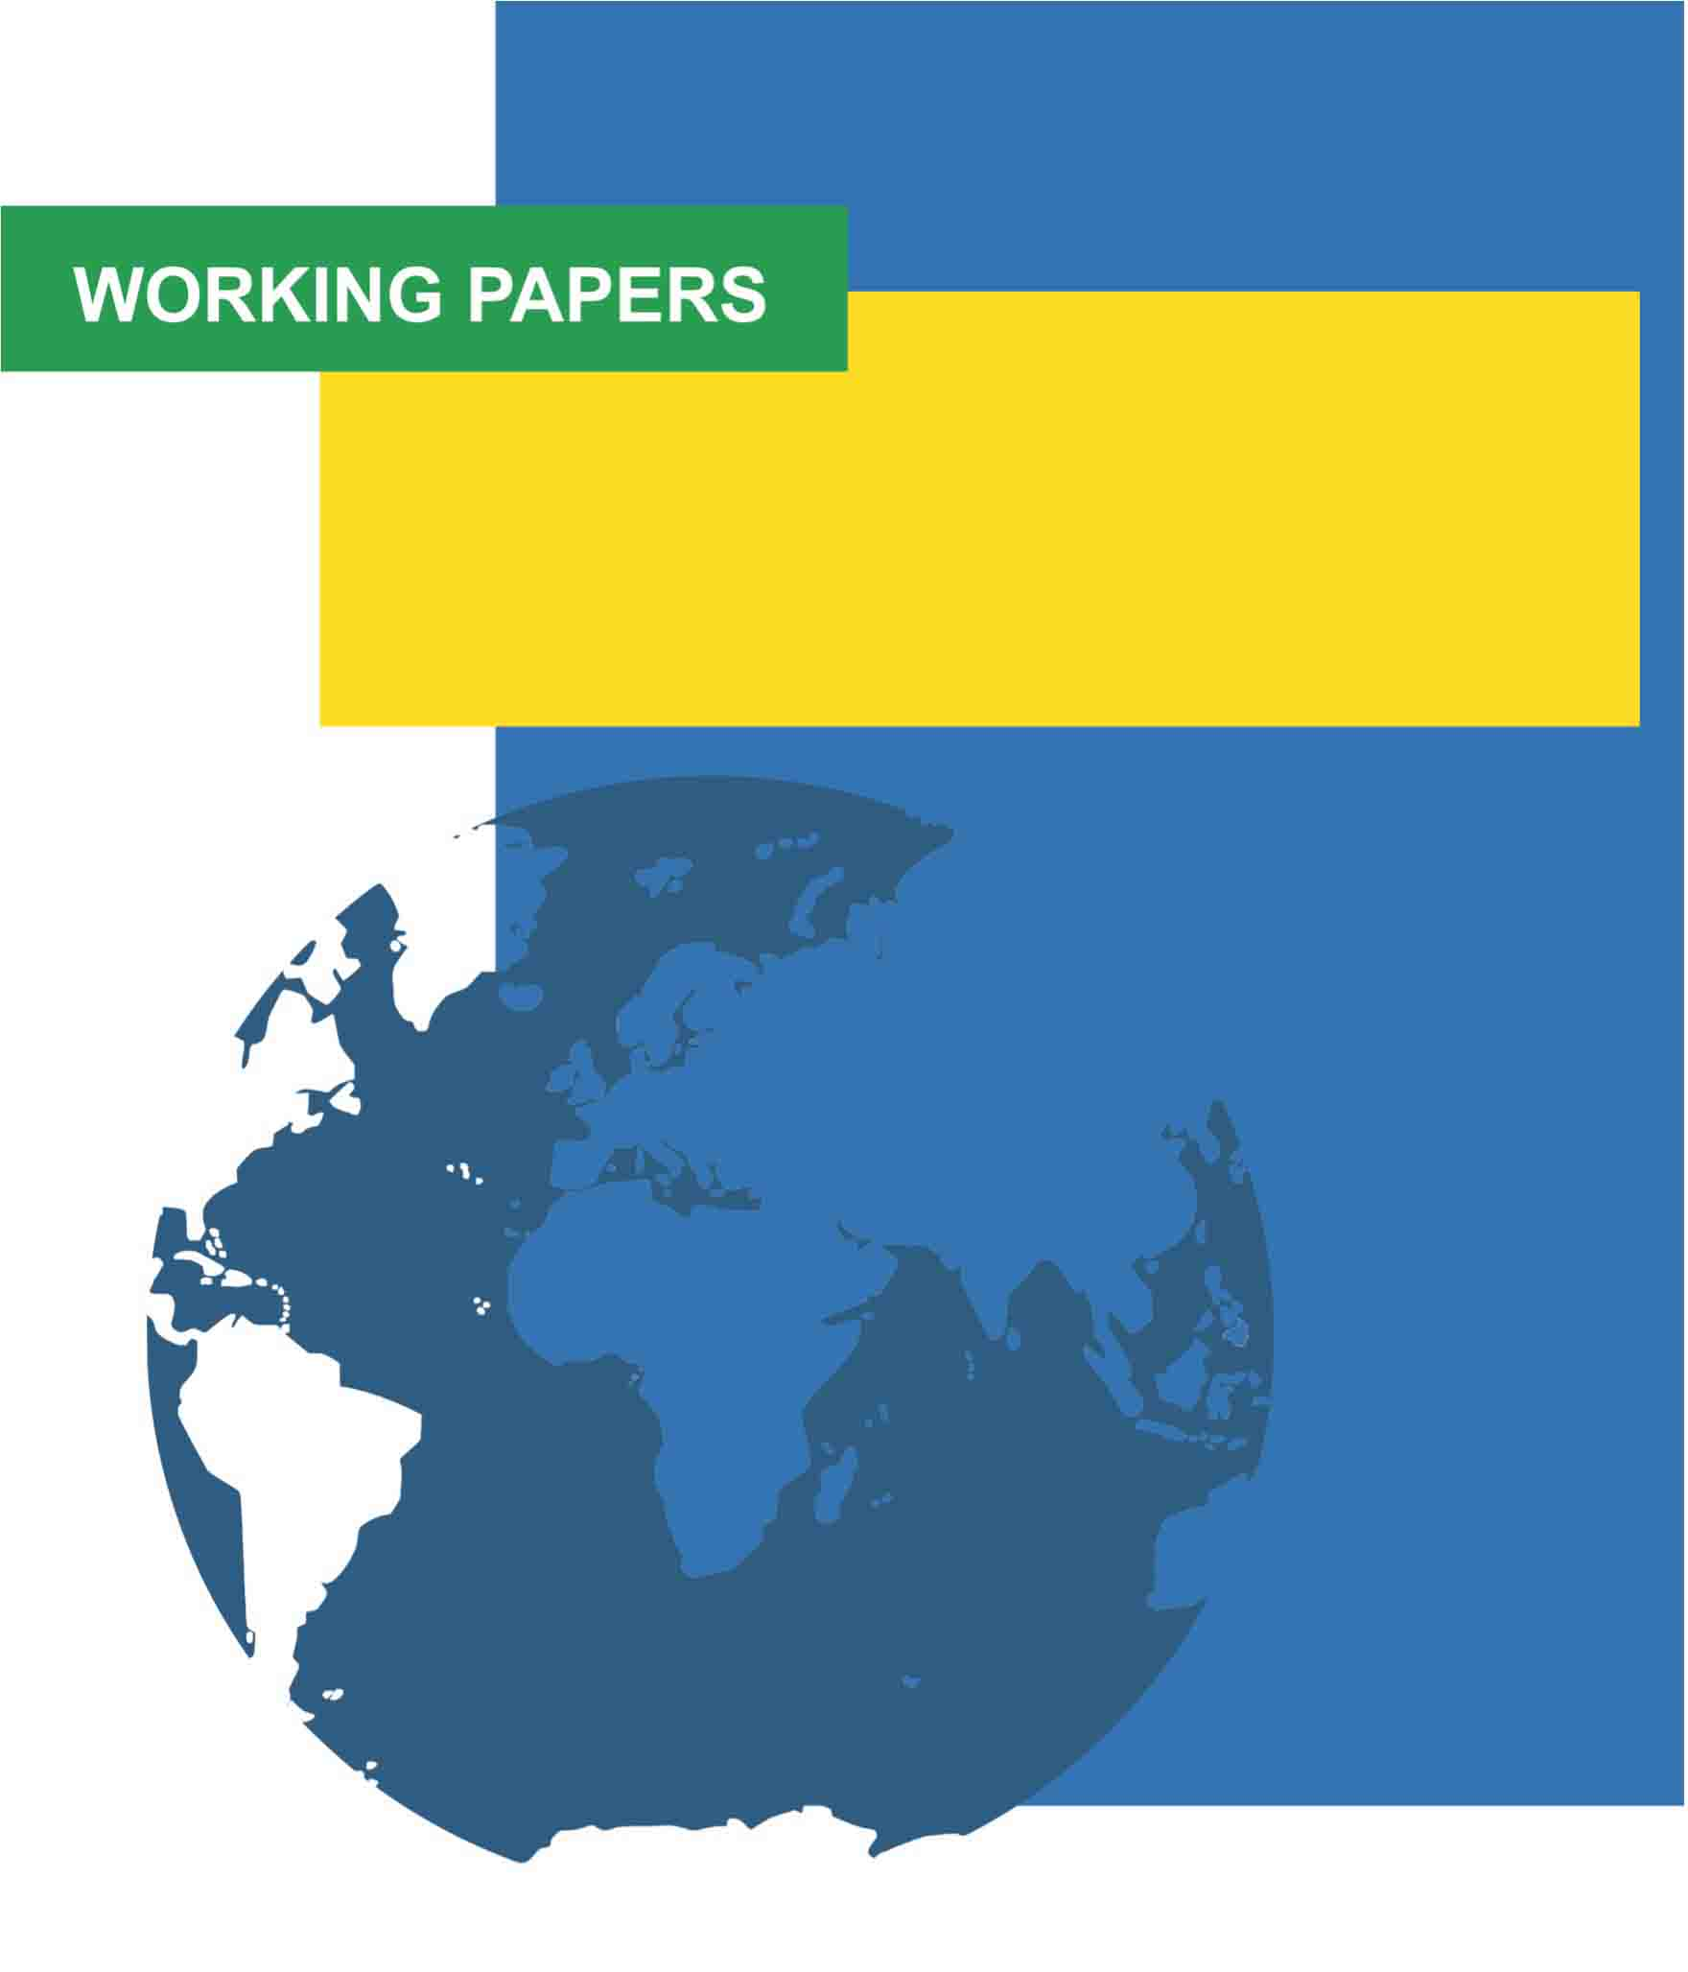

Paper title
Author 1 full name & Author 2 full name
Working Paper No. YYYY/##
Month YYYY

The Working Papers Series is produced jointly by the
Toronto Metropolitan Centre for Immigration and Settlement (TMCIS)
and the CERC in Migration and Integration
www.torontomu.ca/centre-for-immigration-and-settlement
www.torontomu.ca/cerc-migration

Working Paper
No. YYYY/##

Paper title
Author 1 full name
Institution

Author 2 full name
Institution

Series Editors: Anna Triandafyllidou and Usha George

The Working Papers Series is produced jointly by the Toronto Metropolitan Centre for Immigration and Settlement (TMCIS) and the CERC in Migration and Integration at Toronto Metropolitan University.
Working Papers present scholarly research of all disciplines on issues related to immigration and settlement. The purpose is to stimulate discussion and collect feedback. The views expressed by the author(s) do not necessarily reflect those of the TMCIS or the CERC.
For further information, visit www.torontomu.ca/centre-for-immigration-and-settlement and www.torontomu.ca/cerc-migration.

ISSN: 1929-9915

Creative Commons Attribution-Noncommercial-No Derivative Works 2.5
Canada License

Abstract

Abstract text

Table of Contents

Abstract i
Font Style and Size 1
Headings 1
Spacing 1
Footer 1
Margins 1
Quotations 1
References 1

Font Style and Size

Document – Arial, Size 11
Footnote – Arial, Size 10
Page Number – Arial, Size 11
Tables & Charts – Arial, Size variable

Headings

Heading Level 1 – Bold, Arial, Size 11
Heading Level 2 – Bold, Italic, Arial, Size 11
Heading Level 3 – Indented, Bold, Italic, Arial, Size 11
Heading Level 4 – Indented, Italic, Arial, Size 11

Spacing

Single spacing throughout
Insert 2 blank lines (space) before new headings
Insert 1 blank line (space) after headings
Insert 1 blank line (space) after bulleted lists

Footer

Page number – center alignment

Margins

2.54 cm margins
Align the body of the paper in full justification

Quotations

Indent quotes of more than 40 words and bullet points

References

Hyperlinks removed/deactivated
Hanging indent
Left justified
APA guidelines

