Slide 1 - Welcome
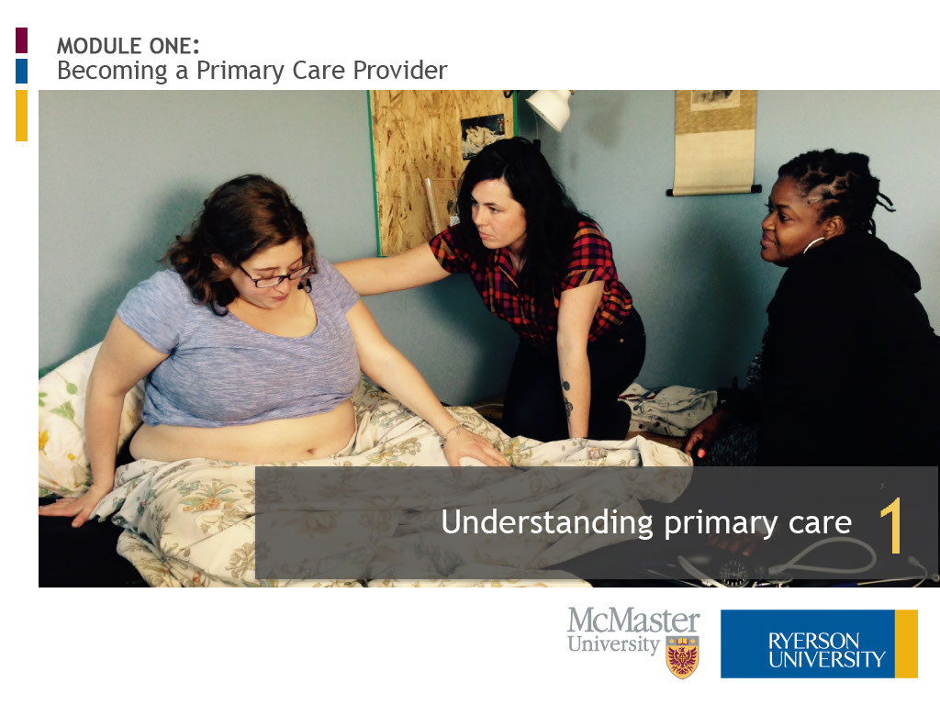
Slide notes
Hello. My name is Elizabeth Allemang and I am an Associate Professor in the Midwifery Education Program at Ryerson University.
Welcome to “Understanding Primary Care,” the first lesson of three in Module One, “Becoming a Primary Care Provider.” Let’s begin.
Text Captions

MODULE ONE:
Becoming a Primary Care Provider

Understanding primary care

Slide 2 - Please enter your name

Slide notes
Text Captions

Please enter your name below:

Welcome

Slide 3 - Introduction
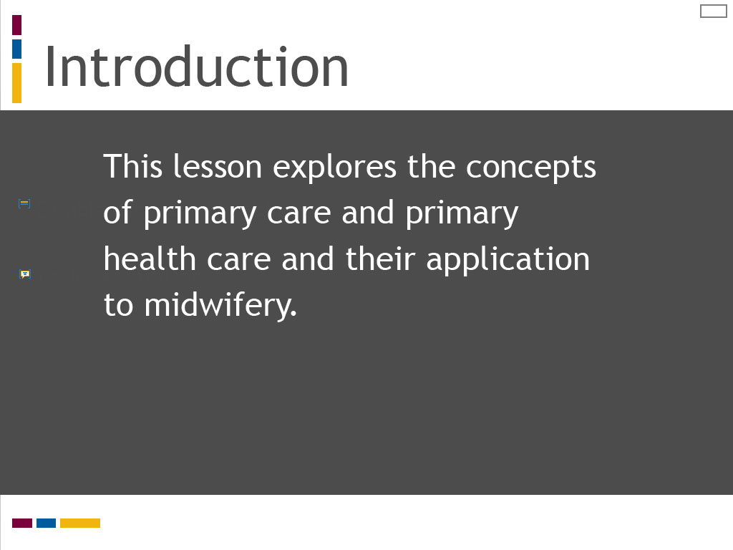
Slide notes
In this lesson, we explore the concepts of primary care and primary health care and consider how they apply to the practice of midwifery.
In this lesson we will explore theories of clinical decision making and care planning in health education and practice.
We will deconstruct two distinct methods for processing clinical decisions and care plans,
and apply these to the practice of midwifery.
Text Captions

Introduction

This lesson explores the concepts of primary care and primary health care and their application to midwifery.

Slide 4 - Learning Outcomes
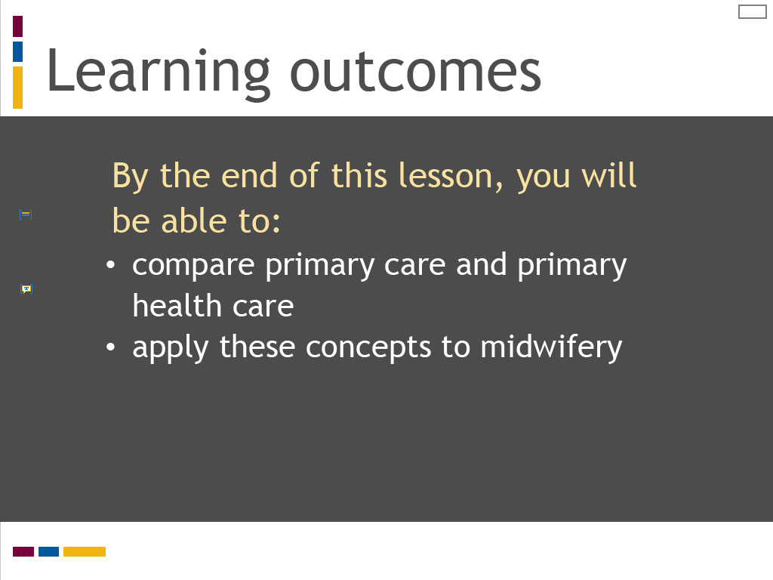
Slide notes
The learning outcomes for this lesson are summarized on the screen. Take a moment to review these before proceeding.
The learning outcomes for this lesson are summarized on the screen.
Take a moment to review these and proceed when you are ready.

Text Captions
Learning outcomes
By the end of this lesson, you will be able to:
- compare primary care and primary health care
- apply these concepts to midwifery

Slide 5 - A midwife is...
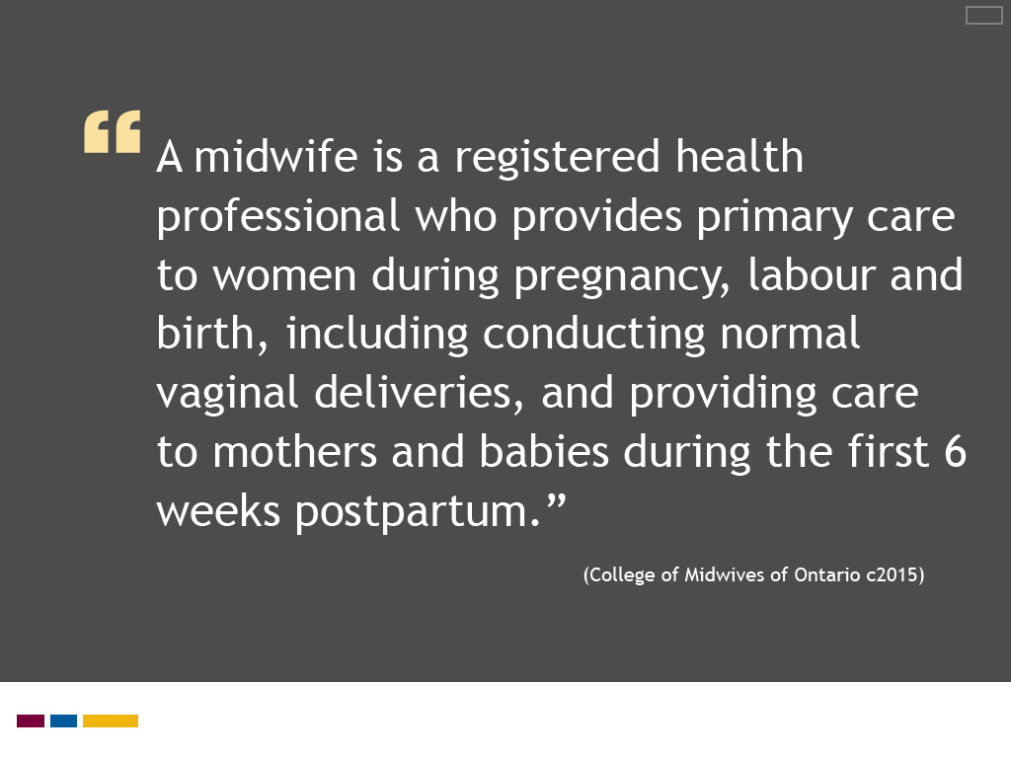
Slide notes
The College of Midwives of Ontario, the regulatory body for the Ontario midwifery profession,
provides this concise statement about what a midwife is on its website.
It is typical of the ways in which Ontario registered midwives are portrayed.
(You can find it by selecting “Public” on the College’s main webpage and then choosing the “About Midwifery” tab.)
By analyzing this statement, we get some understanding of the nature of midwives’ work and their role in the health care system.
Take a moment to review the statement. Can you identify four factors that describe what an Ontario registered midwife is?
You will next have the opportunity to respond to this question, which you can then compare to a correct answer.
Text Captions

A midwife is a registered health professional who provides primary care to women during pregnancy, labour and birth, including conducting normal vaginal deliveries, and providing care to mothers and babies during the first 6 weeks postpartum.”
(College of Midwives of Ontario c2015)

Slide 6 - Reflection Question 1: What is an Ontario registered midwife?
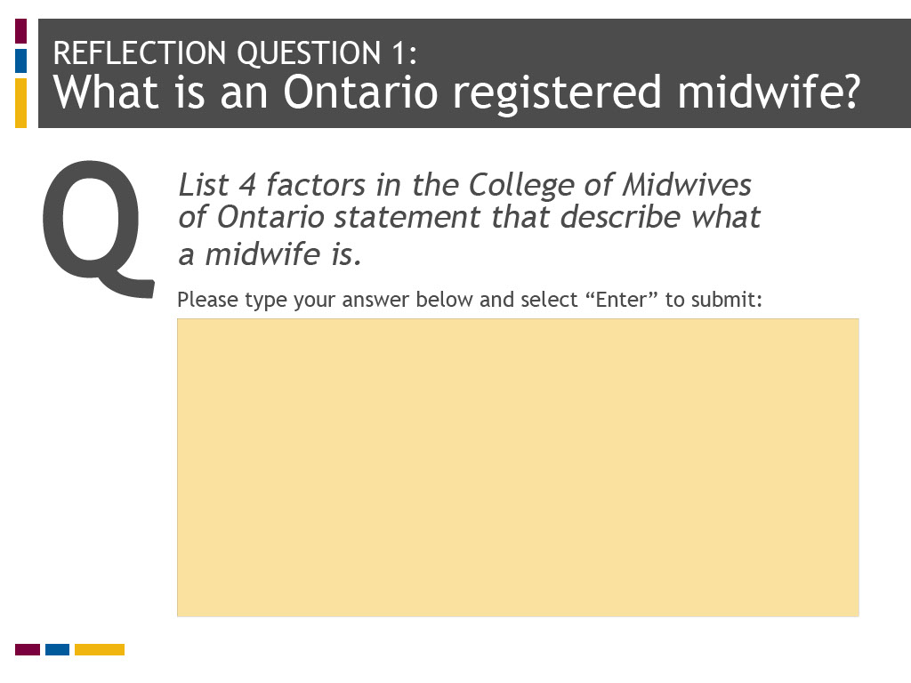
Slide notes
Text Captions

REFLECTION QUESTION 1:
What is an Ontario registered midwife?

List 4 factors in the College of Midwives of Ontario statement that describe what a midwife is.

Slide 7 - Reflection Answer 1
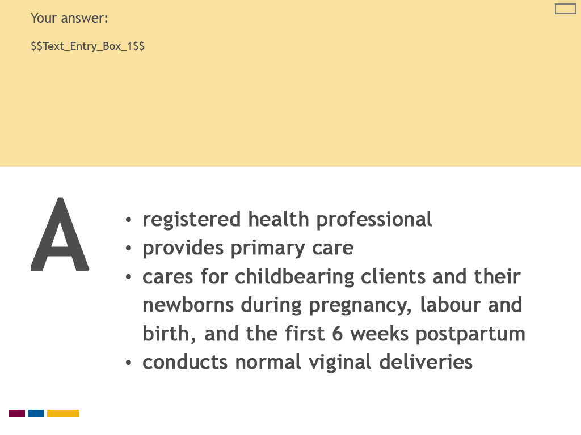
Slide notes
Text Captions

A

Your answer:
- registered health professional
- provides primary care
- cares for childbearing clients and their newborns during pregnancy, labour and birth, and the first 6 weeks postpartum
- conducts normal viginal deliveries

Slide 8 - What is primary care?

Slide notes
The College statement may seem clear and self-evident on first glance.
It tells us that midwives are registered health professionals who are regulated under Ontario health law.
Their work encompasses care for childbearing clients during pregnancy, labour and birth, and with their newborns during the first six weeks postpartum.
Midwives’ scope of practice focuses on normal vaginal deliveries. Their care is described as “primary” care.
The word primary is commonly understood to mean first. How does this concept translate into practice?
What is it about the work of midwives that makes it “primary” care? Can you explain what primary care means?
The three styles of decision making described by Dr. Austin are reasoning from first principles,
rule-based decision making, and pattern recognition.
In this lesson, we will examine two of these decision making methods more closely – reasoning from first principles and pattern recognition.
A rule-based approach refers to the use of structured tools to guide decision making,
such as evidence-based practice protocols or clinical practice guidelines.
This method is popular in health care to standardize clinical practice.
We will look more at how rule-based tools can support your learning of clinical decision making and care planning in Lesson 3 of this module,
“Learning to Make Clinical Decisions and Care Plans.”
In this lesson, we are interested in exploring methods that require clinical reasoning and critical analysis.
Theories of decision making classify methods for processing decisions and plans into two broad categories: analytic and non-analytic.
As will be explained, reasoning from first principles is an analytic method of decision making, whereas pattern recognition is a non-analytic method.
(Rule-based decision making could possibly be captured under the non-analytic category, as it is designed to enhance pattern recognition.)
To illustrate how analytic and non-analytic processing styles operate in clinical practice,
we will examine each method separately as a series of distinct steps, which are then applied to a simulated case of postpartum bleeding.
Deconstructing decision making and care planning in this way can help to demystify these processes for learners and their teachers.
Text Captions

What is primary care?

Slide 9 - Definition

Slide notes
Primary and care are commonly used words in the English language and they are not difficult to define as distinct terms,
as illustrated by these excerpts taken from the Oxford Dictionary of English.
When we try to put them together, however, things become more complicated.
The College of Midwives of Ontario, the regulatory body for the Ontario midwifery profession,
provides this concise statement about what a midwife is on its website.
It is typical of the ways in which Ontario registered midwives are portrayed.
(You can find it by selecting “Public” on the College’s main webpage and then choosing the “About Midwifery” tab.)
By analyzing this statement, we get some understanding of the nature of midwives’ work and their role in the health care system.
Take a moment to review the statement. Can you identify four factors that describe what an Ontario registered midwife is?
You will next have the opportunity to respond to this question, which you can then compare to a correct answer.
Text Captions

primary adjective 1. of chief importance; principal.”

care noun 1. the provision of what is necessary for the health, welfare, maintenance, and protection of someone or something.”
(Oxford Dictionary of English 2010)

Slide 10 - Definition
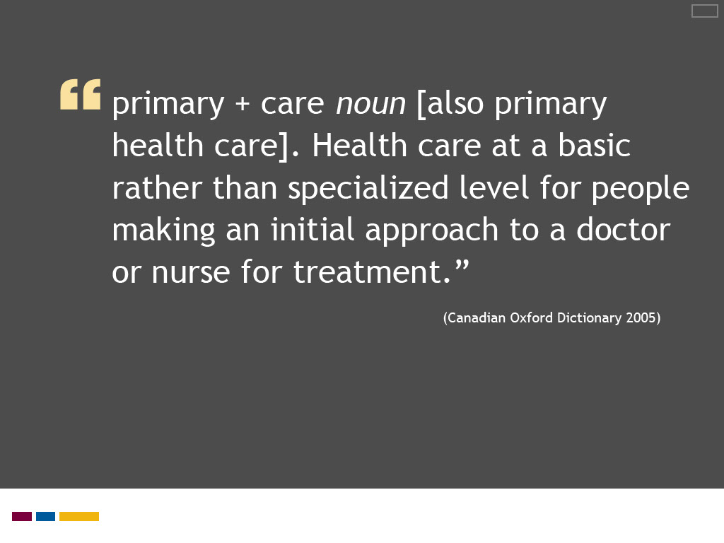
Slide notes
Here is a simple definition of primary care taken from the last edition of the Canadian Oxford Dictionary.
What does it tell us about the meaning of primary care?
It tells us that primary care and primary health care are equivalent concepts and they are terms used to describe health care.
Primary care means care for basic health needs, as distinct from those requiring specialized care.
Primary care is provided at an initial point of contact between individuals and the health care system.
And primary care is provided by health care practitioners, here referred to as a doctor or a nurse.
Most definitions identify the family physician as the primary care provider, although there is sometimes recognition of other members of the multi-disciplinary health care team.
Note the absence of the midwife in this definition. We will reflect more on this later in this lesson.
Primary and care are commonly used words in the English language and they are not difficult to define as distinct terms,
as illustrated by these excerpts taken from the Oxford Dictionary of English.
When we try to put them together, however, things become more complicated.
The College of Midwives of Ontario, the regulatory body for the Ontario midwifery profession,
provides this concise statement about what a midwife is on its website.
It is typical of the ways in which Ontario registered midwives are portrayed.
(You can find it by selecting “Public” on the College’s main webpage and then choosing the “About Midwifery” tab.)
By analyzing this statement, we get some understanding of the nature of midwives’ work and their role in the health care system.
Take a moment to review the statement. Can you identify four factors that describe what an Ontario registered midwife is?
You will next have the opportunity to respond to this question, which you can then compare to a correct answer.
Text Captions

primary + care noun [also primary health care]. Health care at a basic rather than specialized level for people making an initial approach to a doctor or nurse for treatment.”
(Canadian Oxford Dictionary 2005)

Slide 11 - Comparing primary care and primary health care
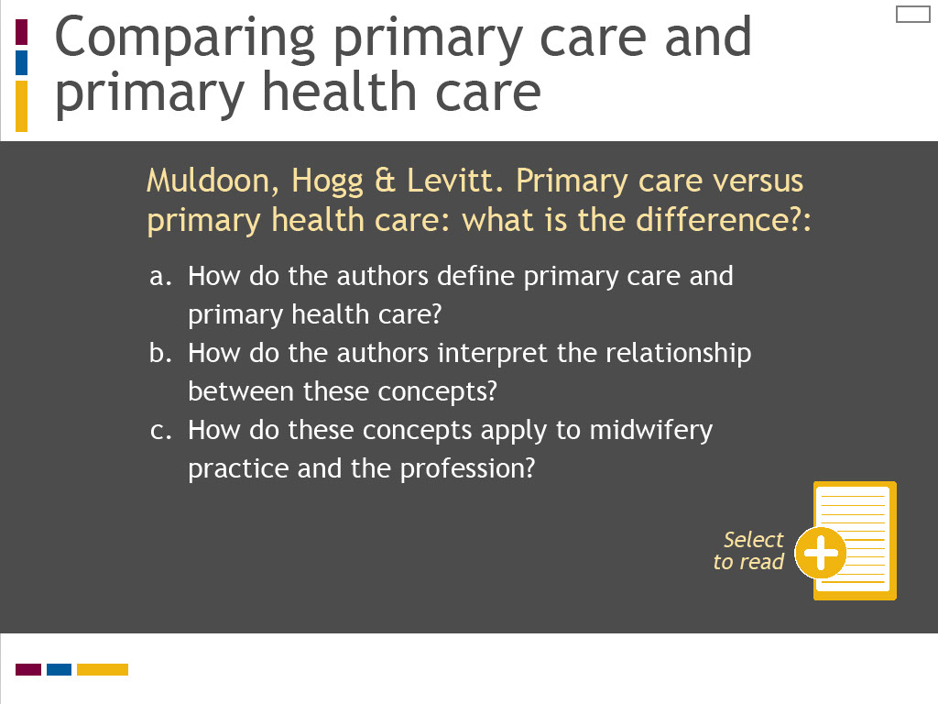
Slide notes
To understand more about the meanings of primary care and primary health care, I would like you to review the article
“Primary care versus primary health care: what is the difference?” published in the Canadian Journal of Public Health in 2006.
In this article, the authors analyze a series of Canadian and international definitions to define and compare primary care and primary health care.
Select the reading icon to access this article. While reviewing the article, reflect on the questions listed on this screen.
I would like to highlight several strategies that may help you to learn and practice clinical reasoning.
The first strategy relates to the skills of observation and listening.
These are two essential tools in the clinical reasoning process, which can sometimes be overlooked in favour of technological or clinical procedures.
The Yale University School of Nursing has created an innovative program for nursing students
that links the skills of observation and listening to problem-solving and assessment.
In the “Looking Is Not Seeing and Listening Is Not Hearing” program,
students study art appreciation at the Yale Centre for British Art and sound at the Yale School of Music
to sharpen their observation and listening skills as preparation for clinical assessment.
This program is described in the Yale School of Nursing and Alumni Association publication Yale Nursing Matters.
To read more about this program and understand how you can use sound and art to sharpen your observation and listening skills,
link to this publication by selecting the additional reading icon.
Text Captions

Comparing primary care and primary health care

Select to read
Muldoon, Hogg & Levitt. Primary care versus primary health care: what is the difference?:

- How do the authors define primary care and primary health care?
- How do the authors interpret the relationship between these concepts?
- How do these concepts apply to midwifery practice and the profession?

Slide 12 - Muldoon, Hogg & Levitt 2006 definition
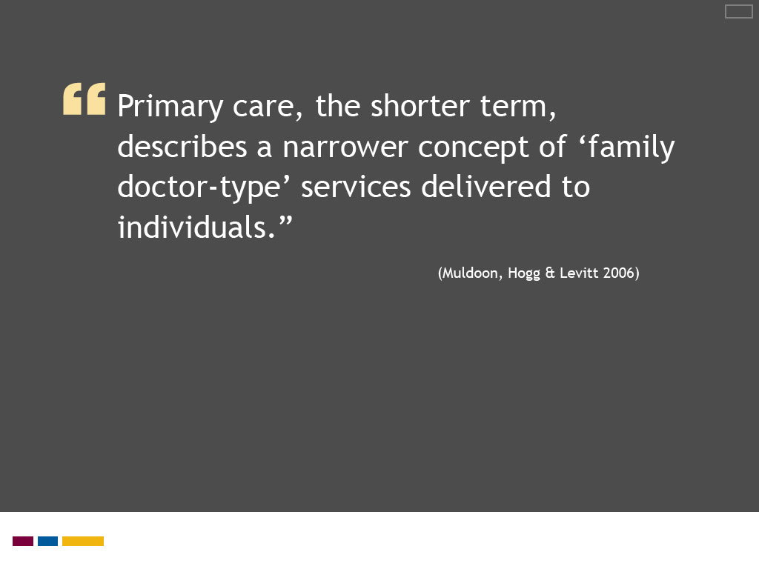
Slide notes
Here is how Muldoon, Hogg and Levitt define primary care, which they describe as the “narrower concept.”
This definition for primary care is very bare-bones. Its meaning is not necessarily transparent when taken out of context from the article.
Muldoon, Hogg and Levitt use the term “family doctor-type services” to mean that primary care is first level care at the point of entry to the health care system.
In their article, they explain that primary care is a level that coordinates specialist care, is wellness rather than disease orientated, and provides care over time.
As is common in primary care literature, they see the family physician as the quintessential primary care provider.
The scope of practice for family medicine is consistent with entry level, generalist care over the life cycle, a common defining feature of primary care.
Here is a simple definition of primary care taken from the last edition of the Canadian Oxford Dictionary.
What does it tell us about the meaning of primary care?
It tells us that primary care and primary health care are equivalent concepts and they are terms used to describe health care.
Primary care means care for basic health needs, as distinct from those requiring specialized care.
Primary care is provided at an initial point of contact between individuals and the health care system.
And primary care is provided by health care practitioners, here referred to as a doctor or a nurse.
Most definitions identify the family physician as the primary care provider, although there is sometimes recognition of other members of the multi-disciplinary health care team.
Note the absence of the midwife in this definition. We will reflect more on this later in this lesson.
Primary and care are commonly used words in the English language and they are not difficult to define as distinct terms,
as illustrated by these excerpts taken from the Oxford Dictionary of English.
When we try to put them together, however, things become more complicated.
The College of Midwives of Ontario, the regulatory body for the Ontario midwifery profession,
provides this concise statement about what a midwife is on its website.
It is typical of the ways in which Ontario registered midwives are portrayed.
(You can find it by selecting “Public” on the College’s main webpage and then choosing the “About Midwifery” tab.)
By analyzing this statement, we get some understanding of the nature of midwives’ work and their role in the health care system.
Take a moment to review the statement. Can you identify four factors that describe what an Ontario registered midwife is?
You will next have the opportunity to respond to this question, which you can then compare to a correct answer.
Text Captions

Primary care, the shorter term, describes a narrower concept of ‘family doctor-type’ services delivered to individuals.”
(Muldoon, Hogg & Levitt 2006)

Slide 13 - Muldoon, Hogg & Levitt 2006 definition
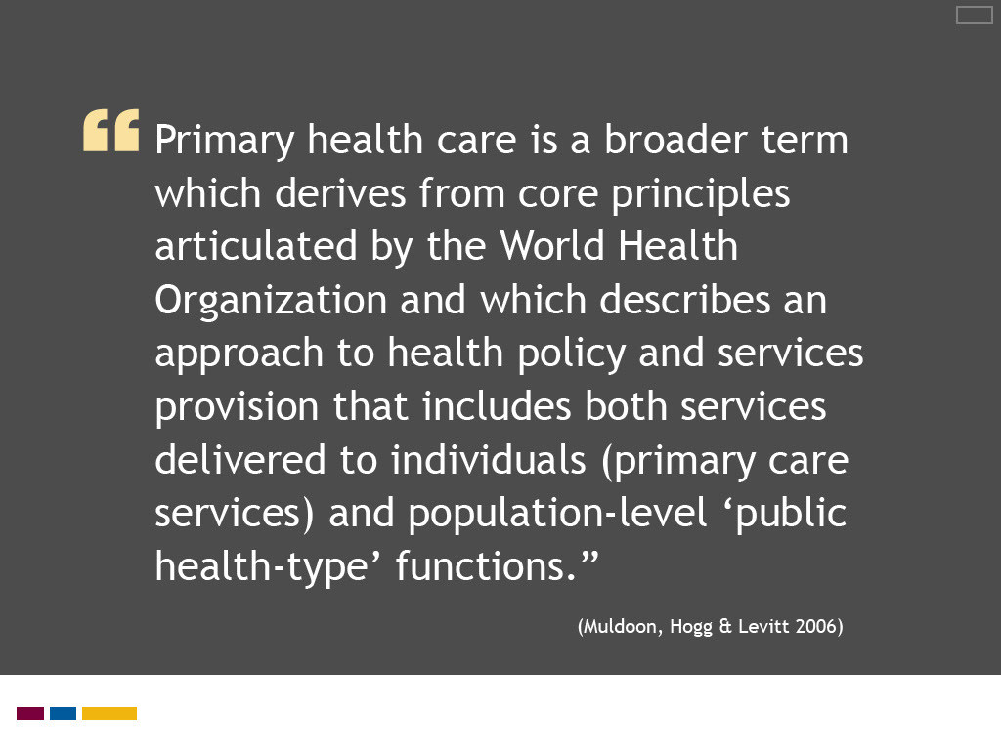
Slide notes
Muldoon, Hogg and Levitt describe primary health care as a distinct and broader concept than primary care.
They define primary health care as encompassing public health policy and services, in addition to the entry level services of primary care.
They identify the core principles of the World Health Organization’s 1978 Declaration of Alma-Ata
as integral to primary health care, which are described further in their article.
These principles include universal access to health care, care organized and adapted to community needs and priorities,
interdisciplinary collaboration, health education, health promotion and illness prevention.
Here is a simple definition of primary care taken from the last edition of the Canadian Oxford Dictionary.
What does it tell us about the meaning of primary care?
It tells us that primary care and primary health care are equivalent concepts and they are terms used to describe health care.
Primary care means care for basic health needs, as distinct from those requiring specialized care.
Primary care is provided at an initial point of contact between individuals and the health care system.
And primary care is provided by health care practitioners, here referred to as a doctor or a nurse.
Most definitions identify the family physician as the primary care provider, although there is sometimes recognition of other members of the multi-disciplinary health care team.
Note the absence of the midwife in this definition. We will reflect more on this later in this lesson.
Primary and care are commonly used words in the English language and they are not difficult to define as distinct terms,
as illustrated by these excerpts taken from the Oxford Dictionary of English.
When we try to put them together, however, things become more complicated.
The College of Midwives of Ontario, the regulatory body for the Ontario midwifery profession,
provides this concise statement about what a midwife is on its website.
It is typical of the ways in which Ontario registered midwives are portrayed.
(You can find it by selecting “Public” on the College’s main webpage and then choosing the “About Midwifery” tab.)
By analyzing this statement, we get some understanding of the nature of midwives’ work and their role in the health care system.
Take a moment to review the statement. Can you identify four factors that describe what an Ontario registered midwife is?
You will next have the opportunity to respond to this question, which you can then compare to a correct answer.
Text Captions

Primary health care is a broader term which derives from core principles articulated by the World Health Organization and which describes an approach to health policy and services provision that includes both services delivered to individuals (primary care services) and population-level ‘public health-type’ functions.”
(Muldoon, Hogg & Levitt 2006)

Slide 14 - A confusion of terms
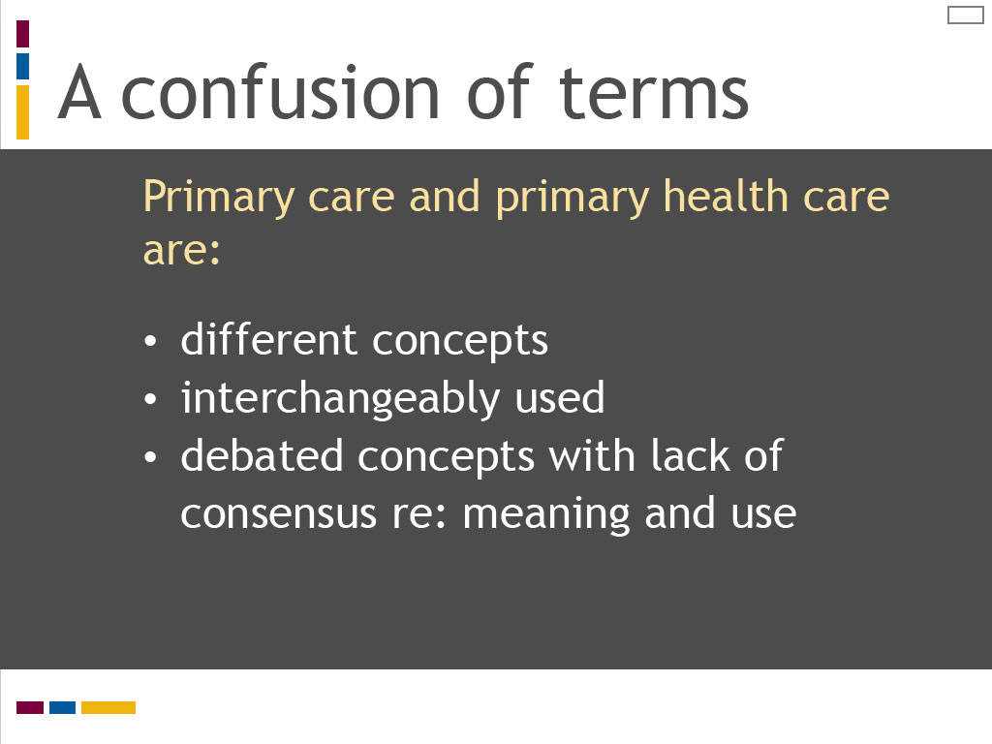
Slide notes
In their comparative analysis of primary care and primary health care,
Muldoon, Hogg and Levitt come to several conclusions about the meaning and relationship of these concepts that are summarized on this screen.
They argue primary care and primary health care are distinct concepts that are often used interchangeably.
They highlight the debate and lack of consensus in Canada regarding the meaning and use of these terms.

To understand more about the meanings of primary care and primary health care, I would like you to review the article
“Primary care versus primary health care: what is the difference?” published in the Canadian Journal of Public Health in 2006.
In this article, the authors analyze a series of Canadian and international definitions to define and compare primary care and primary health care.
Select the reading icon to access this article. While reviewing the article, reflect on the questions listed on this screen.
I would like to highlight several strategies that may help you to learn and practice clinical reasoning.
The first strategy relates to the skills of observation and listening.
These are two essential tools in the clinical reasoning process, which can sometimes be overlooked in favour of technological or clinical procedures.
The Yale University School of Nursing has created an innovative program for nursing students
that links the skills of observation and listening to problem-solving and assessment.
In the “Looking Is Not Seeing and Listening Is Not Hearing” program,
students study art appreciation at the Yale Centre for British Art and sound at the Yale School of Music
to sharpen their observation and listening skills as preparation for clinical assessment.
This program is described in the Yale School of Nursing and Alumni Association publication Yale Nursing Matters.
To read more about this program and understand how you can use sound and art to sharpen your observation and listening skills,
link to this publication by selecting the additional reading icon.
Text Captions

A confusion of terms

Primary care and primary health care are:

- different concepts
- interchangeably used
- debated concepts with lack of consensus re: meaning and use

Slide 15 - Distinct and overlapping features of primary care
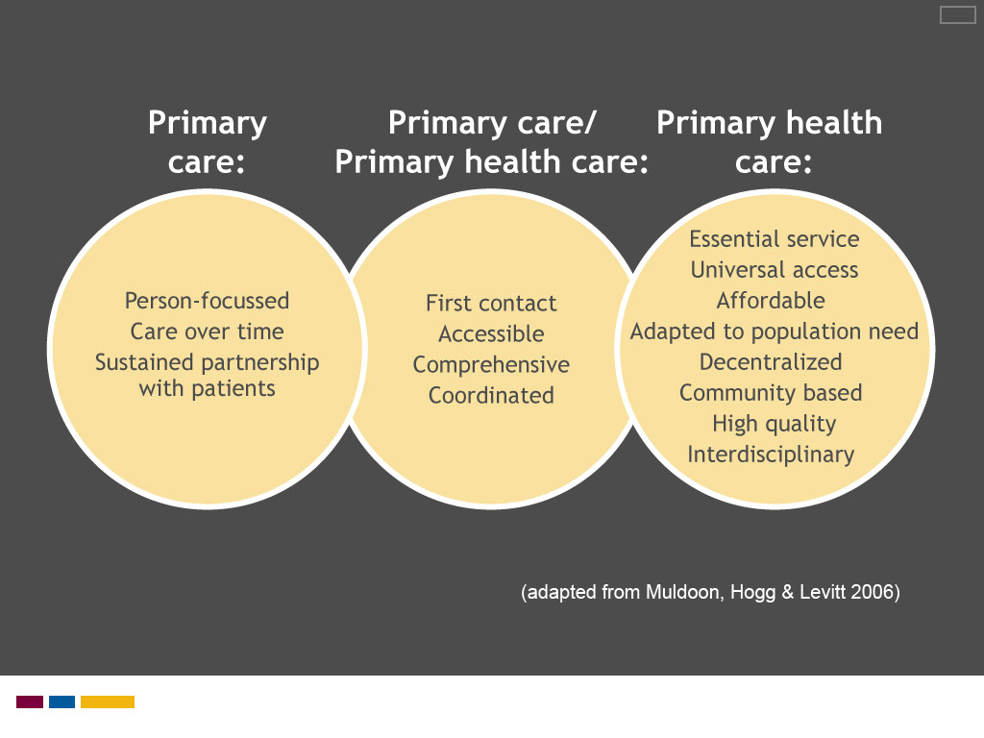
Slide notes
Muldoon, Hogg and Levitt provide a breakdown of distinct and overlapping features of primary care and primary health care,
which is summarized is provided on this screen.
Primary care operates at the individual level, whereas primary health care integrates population level health policies and principles.
(You can refer back to the article for a more comprehensive list of qualities defining primary health care.)
Areas of overlap include the concept of first level care and care that is accessible, comprehensive and coordinated.
Review the diagram summarizing the relationship between primary care and primary health care

and reflect on how their qualities are relevant to the practice of midwifery.
Text Captions
A diagram listing distinct and overlapping features of primary care and primary care

(adapted from Muldoon, Hogg & Levitt 2006)

Slide 16 - Defining primary health care
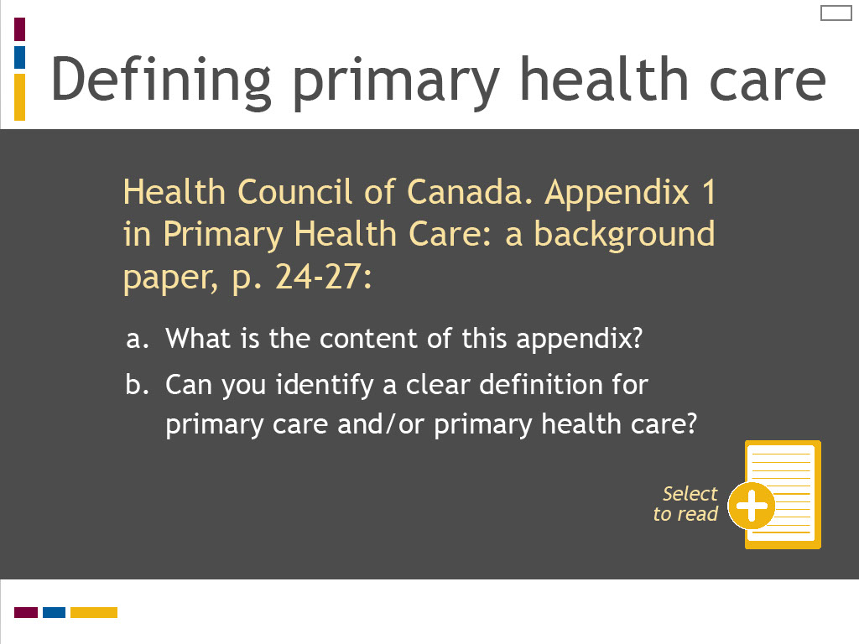
Slide notes
In our quest to uncover the meanings of primary care and primary health care, I would next like you to review “Primary health care: a background paper.”
This paper was published in 2005 by the Health Council of Canada, an independent, non-profit organization
established in 2003 as part of the First Ministers' Accord on Health Care Renewal.
Its role was to report on national health care reform and disseminate information on best practices and innovation in Canadian health care.
While the Council ceased operation in 2014, its website and publications remain archived on the web.
Select the reading icon to access the Health Council report.
Review “Definitions of Primary Health Care,” Appendix 1 on pages 24 to 27 and reflect on the questions listed on this screen.
To understand more about the meanings of primary care and primary health care, I would like you to review the article
“Primary care versus primary health care: what is the difference?” published in the Canadian Journal of Public Health in 2006.
In this article, the authors analyze a series of Canadian and international definitions to define and compare primary care and primary health care.
Select the reading icon to access this article. While reviewing the article, reflect on the questions listed on this screen.
I would like to highlight several strategies that may help you to learn and practice clinical reasoning.
The first strategy relates to the skills of observation and listening.
These are two essential tools in the clinical reasoning process, which can sometimes be overlooked in favour of technological or clinical procedures.
The Yale University School of Nursing has created an innovative program for nursing students
that links the skills of observation and listening to problem-solving and assessment.
In the “Looking Is Not Seeing and Listening Is Not Hearing” program,
students study art appreciation at the Yale Centre for British Art and sound at the Yale School of Music
to sharpen their observation and listening skills as preparation for clinical assessment.
This program is described in the Yale School of Nursing and Alumni Association publication Yale Nursing Matters.
To read more about this program and understand how you can use sound and art to sharpen your observation and listening skills,
link to this publication by selecting the additional reading icon.
Text Captions

Defining primary health care

Select to read
Health Council of Canada. Appendix 1 in Primary Health Care: a background paper, p. 24-27:

- What is the content of this appendix?
- Can you identify a clear definition for primary care and/or primary health care?

Slide 17 - No single definition
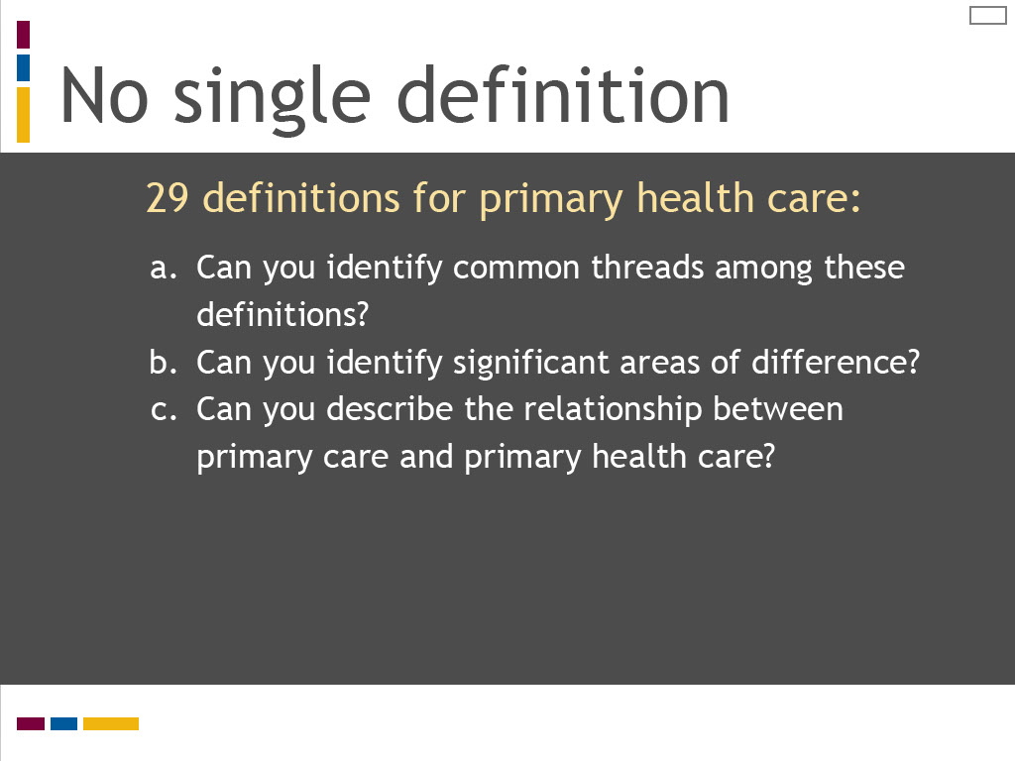
Slide notes
What is particularly striking about this appendix is the number of definitions that are listed.
The Council identifies 15 distinct definitions for primary health care in use in Canada at the federal, provincial and territorial levels.
It also lists 14 “other” prominent definitions used by professional and public policy organizations, both nationally and internationally.
Although these definitions may not be fully up to date given the report was published in 2005,
this four page appendix provides a dramatic statement of the diversity and complexity of primary health care.
We can conclude that rather than having a single definition, primary health care is a multi-faceted concept.
Take a moment to reflect further on this table of definitions using the questions listed on this screen.
In our quest to uncover the meanings of primary care and primary health care, I would next like you to review “Primary health care: a background paper.”
This paper was published in 2005 by the Health Council of Canada, an independent, non-profit organization
established in 2003 as part of the First Ministers' Accord on Health Care Renewal.
Its role was to report on national health care reform and disseminate information on best practices and innovation in Canadian health care.
While the Council ceased operation in 2014, its website and publications remain archived on the web.
Select the reading icon to access the Health Council report.
Review “Definitions of Primary Health Care,” Appendix 1 on pages 24 to 27 and reflect on the questions listed on this screen.
To understand more about the meanings of primary care and primary health care, I would like you to review the article
“Primary care versus primary health care: what is the difference?” published in the Canadian Journal of Public Health in 2006.
In this article, the authors analyze a series of Canadian and international definitions to define and compare primary care and primary health care.
Select the reading icon to access this article. While reviewing the article, reflect on the questions listed on this screen.
I would like to highlight several strategies that may help you to learn and practice clinical reasoning.
The first strategy relates to the skills of observation and listening.
These are two essential tools in the clinical reasoning process, which can sometimes be overlooked in favour of technological or clinical procedures.
The Yale University School of Nursing has created an innovative program for nursing students
that links the skills of observation and listening to problem-solving and assessment.
In the “Looking Is Not Seeing and Listening Is Not Hearing” program,
students study art appreciation at the Yale Centre for British Art and sound at the Yale School of Music
to sharpen their observation and listening skills as preparation for clinical assessment.
This program is described in the Yale School of Nursing and Alumni Association publication Yale Nursing Matters.
To read more about this program and understand how you can use sound and art to sharpen your observation and listening skills,
link to this publication by selecting the additional reading icon.
Text Captions

No single definition

29 definitions for primary health care:
- Can you identify common threads among these definitions?
- Can you identify significant areas of difference?
- Can you describe the relationship between primary care and primary health care?

Slide 18 - Common themes
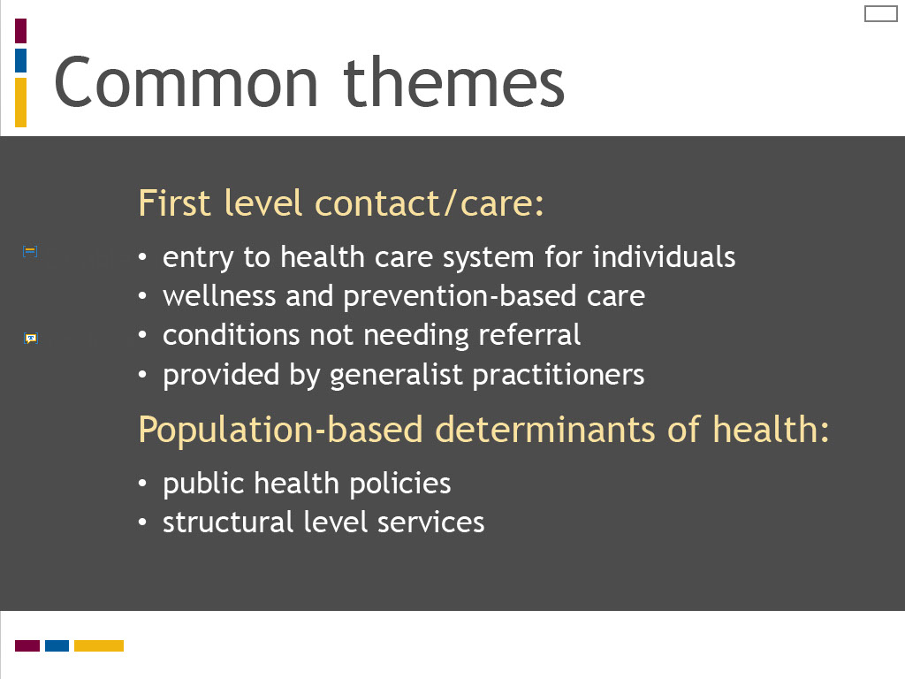
Slide notes
Although each of the definitions listed in the Health Council report provides a distinct interpretation of primary health care, one central idea is evident.
The word “first” is typically used to describe the level of care, a word that is synonymous with primary.
“First level” is used in two ways. It is used to refer to the point of contact between individuals and the health care system.
It is also used to refer to the lowest level of care in a hierarchy of disease and medical specialization.
In this way, primary health care is interpreted as entry level care for normal conditions
or those with low level complexity that precede referral to specialized care or services.
The second common theme among these definitions is the recognition that primary health care extends beyond individual health care services
to encompass structural level policies and services related to population-based determinants of health.
As you likely noticed, the nature and scope of these population-based factors varies widely across these definitions.
The key message from this reading is that primary health care is defined in many different ways, even within the context of a single country like Canada.
It is used to refer to individual health care services and it may also include population health factors.
The distinction between primary care and primary health care is not clearly stated in this reading,
however some of the definitions refer to primary care being a component of primary health care.
This is consistent with Muldoon, Hogg and Levitt’s analysis that primary care and primary health care are often used interchangeably.
The learning outcomes for this lesson are summarized on the screen. Take a moment to review these before proceeding.
The learning outcomes for this lesson are summarized on the screen.
Take a moment to review these and proceed when you are ready.

Text Captions

Common themes

First level contact/care:
- entry to health care system for individuals
- wellness and prevention-based care
- conditions not needing referral
- provided by generalist practitioners

Population-based determinants of health:
- public health policies
- structural level services

Slide 19 - Levels of care
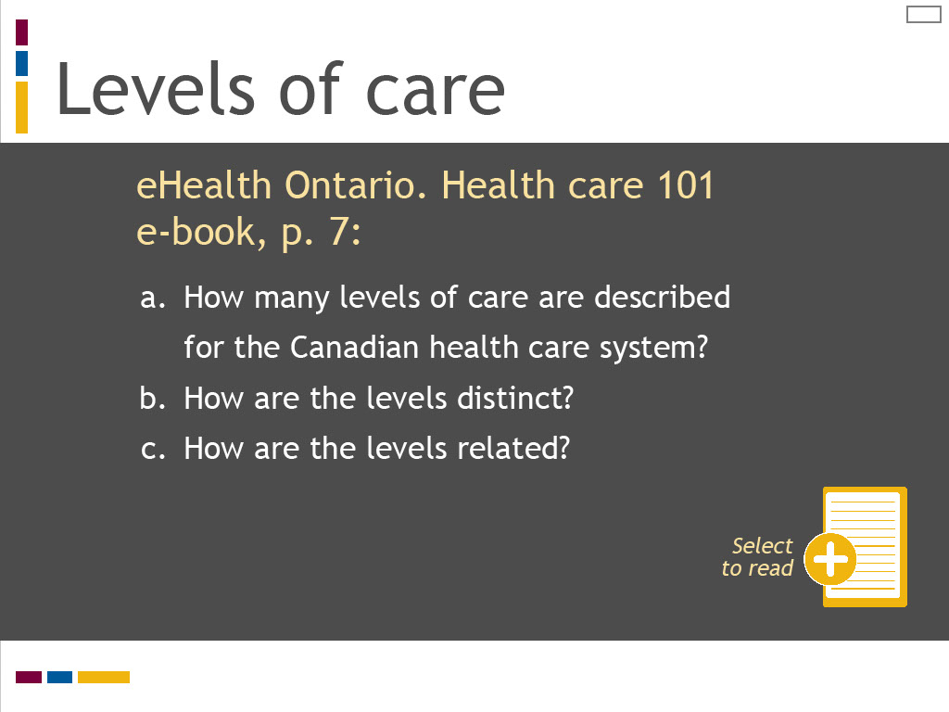
Slide notes
As you may already know, health care services are organized in a hierarchy of specialization in the Canadian health care system where primary care sits at the base or first level.
As care proceeds up this hierarchy, health services become increasingly specialized and patient or client health conditions more complex.
Access to health care services also becomes less direct, often requiring referral and lengthy wait times.
To understand more about how primary care is defined in relation to higher levels of service, review the “Health care 101 e-book.”
This is an informative and interactive primer on the Ontario health care system recently published by the Ontario government.
Select the reading icon to access this document.
Scroll down to page 7 and review the diagram describing levels of care. Reflect on the questions shown on this screen.
What is particularly striking about this appendix is the number of definitions that are listed.
The Council identifies 15 distinct definitions for primary health care in use in Canada at the federal, provincial and territorial levels.
It also lists 14 “other” prominent definitions used by professional and public policy organizations, both nationally and internationally.
Although these definitions may not be fully up to date given the report was published in 2005,
this four page appendix provides a dramatic statement of the diversity and complexity of primary health care.
We can conclude that rather than having a single definition, primary health care is a multi-faceted concept.
Take a moment to reflect further on this table of definitions using the questions listed on this screen.
In our quest to uncover the meanings of primary care and primary health care, I would next like you to review “Primary health care: a background paper.”
This paper was published in 2005 by the Health Council of Canada, an independent, non-profit organization
established in 2003 as part of the First Ministers' Accord on Health Care Renewal.
Its role was to report on national health care reform and disseminate information on best practices and innovation in Canadian health care.
While the Council ceased operation in 2014, its website and publications remain archived on the web.
Select the reading icon to access the Health Council report.
Review “Definitions of Primary Health Care,” Appendix 1 on pages 24 to 27 and reflect on the questions listed on this screen.
To understand more about the meanings of primary care and primary health care, I would like you to review the article
“Primary care versus primary health care: what is the difference?” published in the Canadian Journal of Public Health in 2006.
In this article, the authors analyze a series of Canadian and international definitions to define and compare primary care and primary health care.
Select the reading icon to access this article. While reviewing the article, reflect on the questions listed on this screen.
I would like to highlight several strategies that may help you to learn and practice clinical reasoning.
The first strategy relates to the skills of observation and listening.
These are two essential tools in the clinical reasoning process, which can sometimes be overlooked in favour of technological or clinical procedures.
The Yale University School of Nursing has created an innovative program for nursing students
that links the skills of observation and listening to problem-solving and assessment.
In the “Looking Is Not Seeing and Listening Is Not Hearing” program,
students study art appreciation at the Yale Centre for British Art and sound at the Yale School of Music
to sharpen their observation and listening skills as preparation for clinical assessment.
This program is described in the Yale School of Nursing and Alumni Association publication Yale Nursing Matters.
To read more about this program and understand how you can use sound and art to sharpen your observation and listening skills,
link to this publication by selecting the additional reading icon.
Text Captions

Levels of care

eHealth Ontario. Health care 101 e-book, p. 7:
- How many levels of care are described for the Canadian health care system?
- How are the levels distinct?
- How are the levels related?

Select to read

Slide 20 - Levels of care
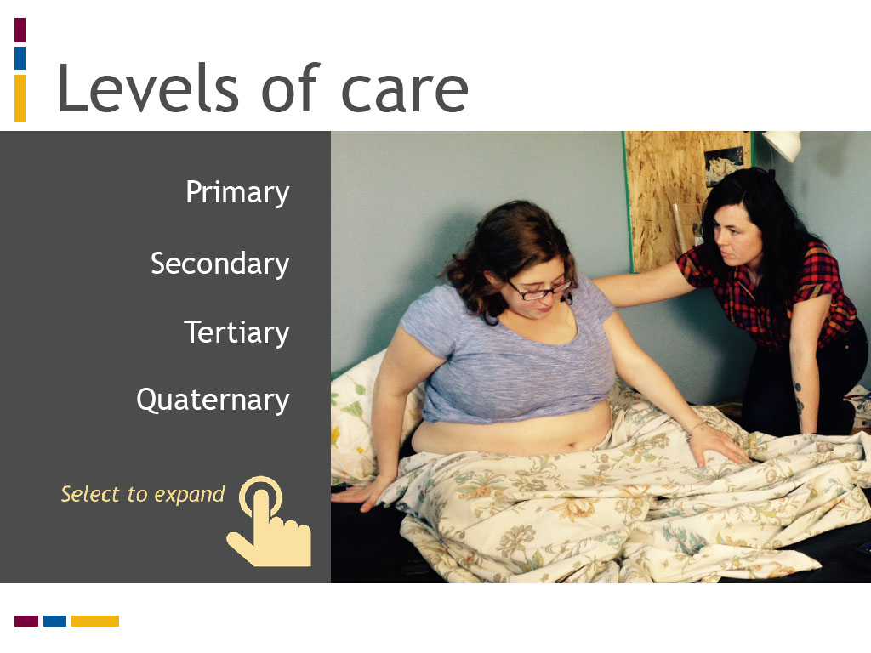
Slide notes
The four levels of care described in the Health care 101 e-book are listed on this screen.
Select each category to expand its meaning and review the type of services provided, the nature of access to the level of service, and the locations for care.

Analytic reasoning refers to a method of decision making that follows a linear sequence of detailed and specific steps.
This method is conceptualized in a variety of ways and using a variety of terms, such as hypothetico-deductive reasoning,
reasoning from first principles, and backward reasoning (where the clinician returns to the clinical data to refine their diagnosis).
Theories of analytic reasoning share the use of a systematic approach to investigate and eliminate potential differential diagnoses to come up with a likely, or working, diagnosis.
This style of decision making is typically associated with learners or novice practitioners.
It allows for careful analysis of a clinical situation, yet it is slow, cumbersome and time intensive.
(Think back to the reasoning from first principles scenario described by Dr. Austin that was so laborious that he suggested a transit pass may be in order.)
This style may also be used by practitioners of any skill level who face complex or unfamiliar situations that require a deliberate and methodical problem solving approach.
A sequence of steps for the analytic reasoning process are listed on this screen. Select each step to learn more about its meaning.
Text Captions

Levels of care

- Primary
  - direct access
  - first level entry to health care system
  - widest scope of services
  - promotes health and disease prevention
  - identifies diagnostic, curative, rehabilitative, supportive and palliative services
  - homes, offices, clinics, community health centres, nursing stations
- Secondary
  - services provided by specialists and other health professionals generally without first contact with patients/clients
  - patients/clients referred for secondary care treatment by primary care provider or other specialist
  - community hospitals and acute care facilities
- Tertiary
  - more specialized care than secondary level care
  - typically for in-hospital patients/clients
  - based on referral from primary or secondary care provider
  - academic teaching facilities or large community care facilities with access to specialists and specialized equipment
- Quaternary
  - highly specialized, advanced level care
  - may include experimental medicine, treatment of rare conditions and uncommon surgical procedures
  - not widely accessible
  - academic and teaching centres

Slide 21 - Where does midwifery fit?

Slide notes
While some definitions of primary care and primary health care acknowledge multi-disciplinary health care providers, midwives are not mentioned.
Yet the College of Midwives of Ontario clearly states that Ontario midwives provide primary care.
The College statement also suggests the Ontario midwifery model embodies primary care principles,
such as first point of entry to the health care system during pregnancy, first level care for “normal” childbearing,
and a scope of practice that is wellness rather than disease oriented.
How do we explain this disconnect? Where does midwifery fit in the Ontario health care system?
We will explore how midwifery is defined as a primary care profession in the following lesson of this module, “Defining Primary Midwifery Care.”

The College statement may seem clear and self-evident on first glance.
It tells us that midwives are registered health professionals who are regulated under Ontario health law.
Their work encompasses care for childbearing clients during pregnancy, labour and birth, and with their newborns during the first six weeks postpartum.
Midwives’ scope of practice focuses on normal vaginal deliveries. Their care is described as “primary” care.
The word primary is commonly understood to mean first. How does this concept translate into practice?
What is it about the work of midwives that makes it “primary” care? Can you explain what primary care means?
The three styles of decision making described by Dr. Austin are reasoning from first principles,
rule-based decision making, and pattern recognition.
In this lesson, we will examine two of these decision making methods more closely – reasoning from first principles and pattern recognition.
A rule-based approach refers to the use of structured tools to guide decision making,
such as evidence-based practice protocols or clinical practice guidelines.
This method is popular in health care to standardize clinical practice.
We will look more at how rule-based tools can support your learning of clinical decision making and care planning in Lesson 3 of this module,
“Learning to Make Clinical Decisions and Care Plans.”
In this lesson, we are interested in exploring methods that require clinical reasoning and critical analysis.
Theories of decision making classify methods for processing decisions and plans into two broad categories: analytic and non-analytic.
As will be explained, reasoning from first principles is an analytic method of decision making, whereas pattern recognition is a non-analytic method.
(Rule-based decision making could possibly be captured under the non-analytic category, as it is designed to enhance pattern recognition.)
To illustrate how analytic and non-analytic processing styles operate in clinical practice,
we will examine each method separately as a series of distinct steps, which are then applied to a simulated case of postpartum bleeding.
Deconstructing decision making and care planning in this way can help to demystify these processes for learners and their teachers.
Text Captions

Where does midwifery fit?

Slide 22 - Key messages
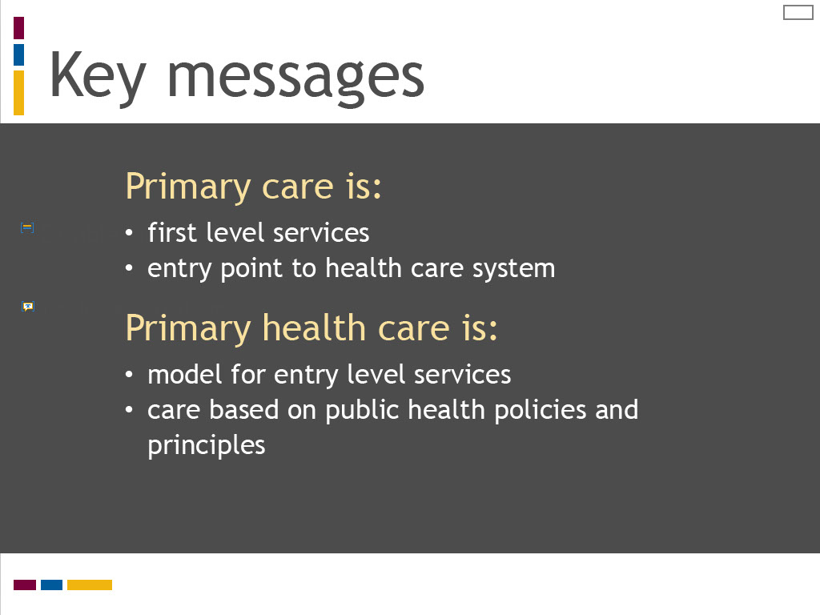
Slide notes
Here are the key messages for this lesson:

Primary care refers to first level services for individuals at the entry point to the health care system.

Primary health care refers to a model for first level services and care based on public health policies and principles.

Although each of the definitions listed in the Health Council report provides a distinct interpretation of primary health care, one central idea is evident.
The word “first” is typically used to describe the level of care, a word that is synonymous with primary.
“First level” is used in two ways. It is used to refer to the point of contact between individuals and the health care system.
It is also used to refer to the lowest level of care in a hierarchy of disease and medical specialization.
In this way, primary health care is interpreted as entry level care for normal conditions
or those with low level complexity that precede referral to specialized care or services.
The second common theme among these definitions is the recognition that primary health care extends beyond individual health care services
to encompass structural level policies and services related to population-based determinants of health.
As you likely noticed, the nature and scope of these population-based factors varies widely across these definitions.
The key message from this reading is that primary health care is defined in many different ways, even within the context of a single country like Canada.
It is used to refer to individual health care services and it may also include population health factors.
The distinction between primary care and primary health care is not clearly stated in this reading,
however some of the definitions refer to primary care being a component of primary health care.
This is consistent with Muldoon, Hogg and Levitt’s analysis that primary care and primary health care are often used interchangeably.
The learning outcomes for this lesson are summarized on the screen. Take a moment to review these before proceeding.
The learning outcomes for this lesson are summarized on the screen.
Take a moment to review these and proceed when you are ready.

Text Captions

Key messages

Primary care is:
- first level services
- entry point to health care system
Primary health care is:
- model for entry level services
- care based on public health policies and principles

Slide 23 - Key messages
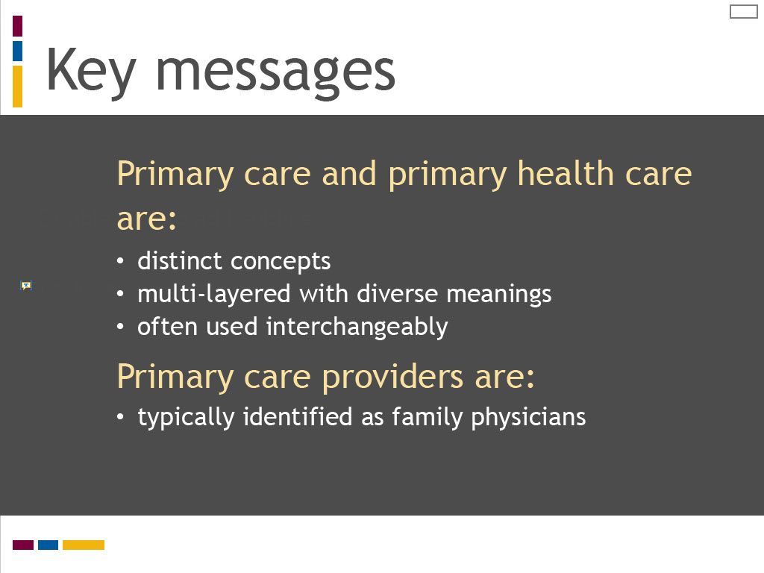
Slide notes
Primary care and primary health care are distinct concepts with multi-layered and diverse meanings, yet they are often used interchangeably.

Primary care providers are typically identified as family physicians in health policy, research literature, and practice.

We should also acknowledge the College of Midwives of Ontario defines midwives as primary care providers,

which we will explore further in Lesson 2 of this module.
Now take the opportunity to test your knowledge from this lesson.

Here are the key messages for this lesson:

Primary care refers to first level services for individuals at the entry point to the health care system.

Primary health care refers to a model for first level services and care based on public health policies and principles.

Although each of the definitions listed in the Health Council report provides a distinct interpretation of primary health care, one central idea is evident.
The word “first” is typically used to describe the level of care, a word that is synonymous with primary.
“First level” is used in two ways. It is used to refer to the point of contact between individuals and the health care system.
It is also used to refer to the lowest level of care in a hierarchy of disease and medical specialization.
In this way, primary health care is interpreted as entry level care for normal conditions
or those with low level complexity that precede referral to specialized care or services.
The second common theme among these definitions is the recognition that primary health care extends beyond individual health care services
to encompass structural level policies and services related to population-based determinants of health.
As you likely noticed, the nature and scope of these population-based factors varies widely across these definitions.
The key message from this reading is that primary health care is defined in many different ways, even within the context of a single country like Canada.
It is used to refer to individual health care services and it may also include population health factors.
The distinction between primary care and primary health care is not clearly stated in this reading,
however some of the definitions refer to primary care being a component of primary health care.
This is consistent with Muldoon, Hogg and Levitt’s analysis that primary care and primary health care are often used interchangeably.
The learning outcomes for this lesson are summarized on the screen. Take a moment to review these before proceeding.
The learning outcomes for this lesson are summarized on the screen.
Take a moment to review these and proceed when you are ready.

Text Captions

Double click to add subtitle

Key messages

Primary care and primary health care are:
- distinct concepts
- multi-layered with diverse meanings
- often used interchangeably
Primary care providers are:
- typically identified as family physicians

Slide 24 - Test your knowledge!
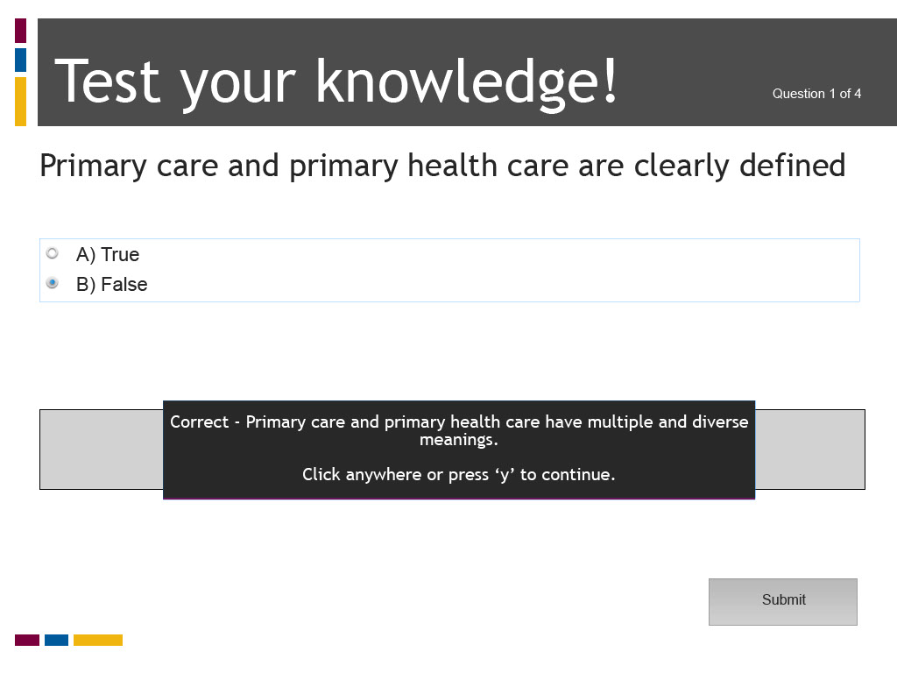
Slide notes
Text Captions

Test your knowledge!

Primary care and primary health care are clearly defined

A) True

B) False

Question 1 of 4

The correct answer is B) False. Primary care and primary health care have multiple and diverse meanings. There is a lack of consensus of what these concepts mean.

Slide 25 - Slide 25
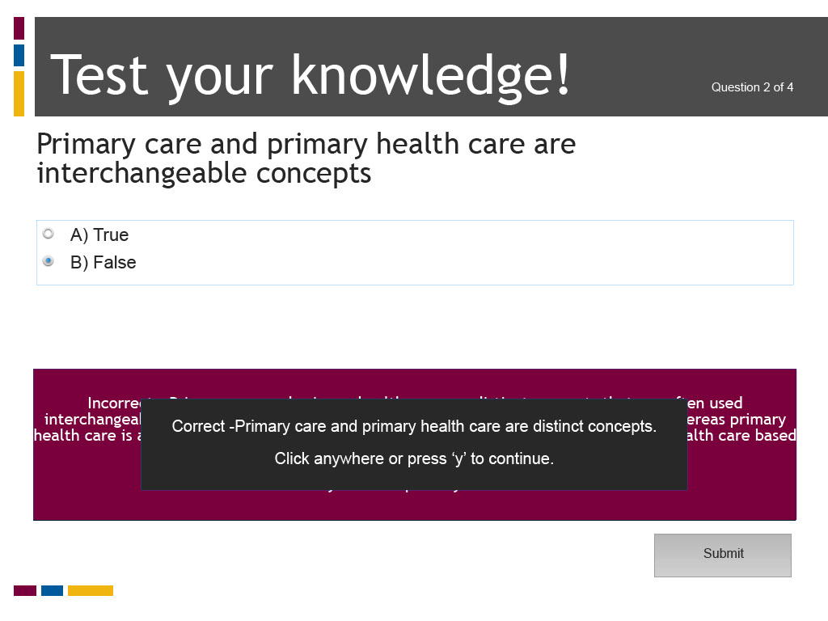
Slide notes
Text Captions

Test your knowledge!

Primary care and primary health care are interchangeable concepts

A) True

B) False

Question 2 of 4

The correct answer is B) False. Primary care and primary health care are distinct concepts that are often used interchangeably. Primary care refers to a level of health care delivery to individuals, whereas primary health care is a broader concept that encompasses service provision to individuals and health care based on public health policies and principles.

Slide 26 - Slide 26
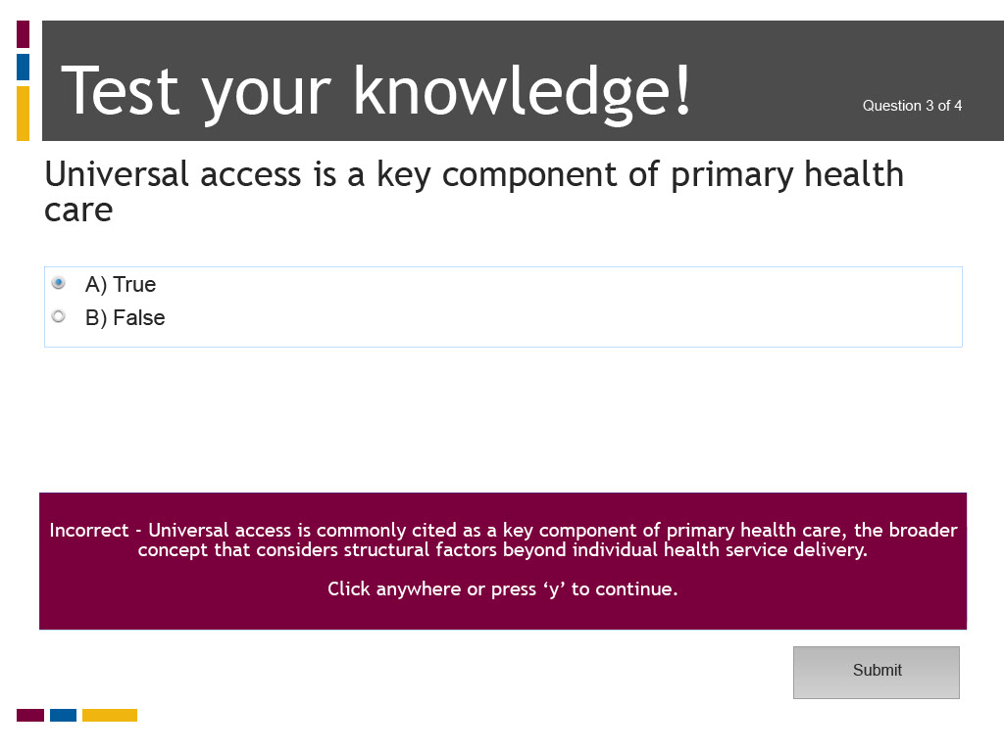
Slide notes
Text Captions

Test your knowledge!

Universal access is a key component of primary health care

A) True

B) False

Question 3 of 4

The correct answer is True. Universal access is commonly cited as a key component of primary health care, the broader concept that considers structural factors beyond individual health service delivery.

Slide 27 - Slide 27
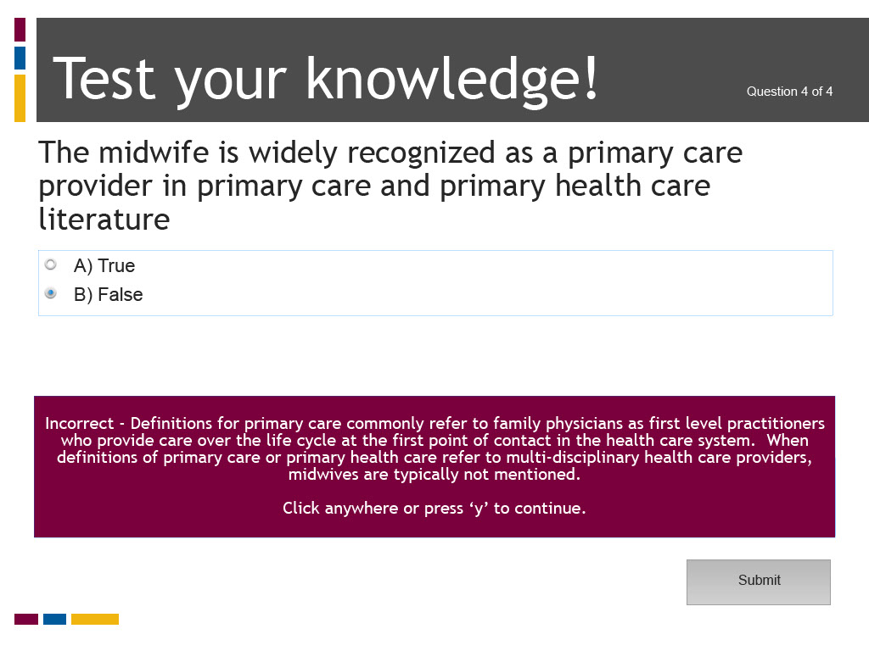
Slide notes
Text Captions

Test your knowledge!

The midwife is widely recognized as a primary care provider in primary care and primary health care literature

A) True

B) False

Question 4 of 4
The family physician is commonly defined as the quintessential primary care practitioner.

The correct answer is B) False. Definitions for primary care commonly refer to family physicians as first level practitioners who provide care over the life cycle at the first point of contact in the health care system. When definitions of primary care or primary health care refer to multi-disciplinary health care providers, midwives are typically not mentioned.

Slide 28 - Quiz Results

Slide notes
Text Captions

Quiz Results

Slide 29 - References
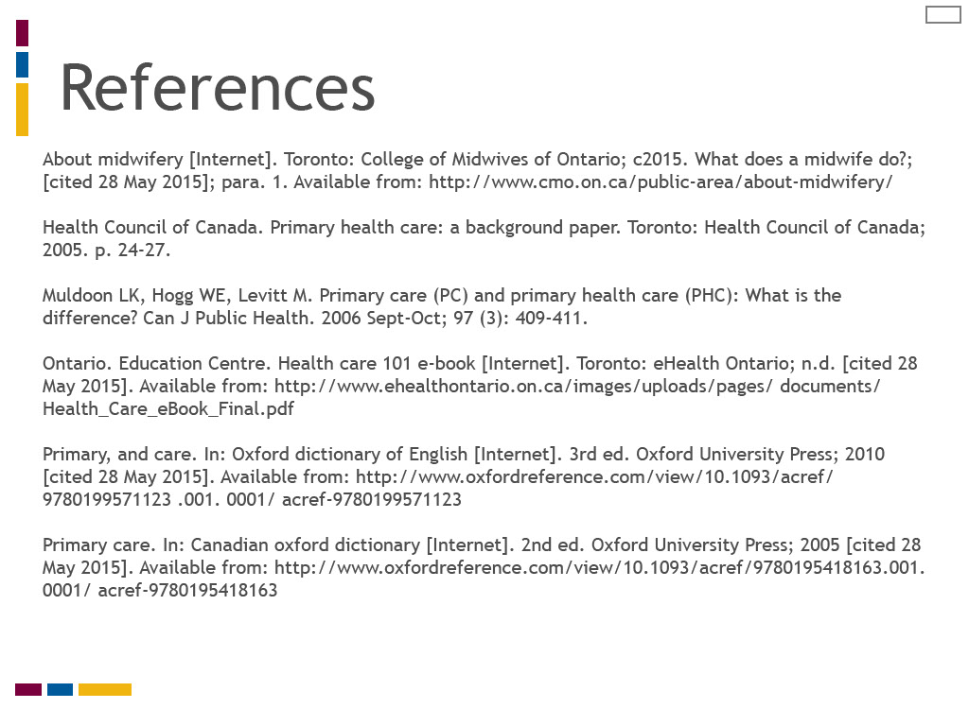
Slide notes
Text Captions

References

About midwifery [Internet]. Toronto: College of Midwives of Ontario; c2015. What does a midwife do?; [cited 28 May 2015]; para. 1.
Health Council of Canada. Primary health care: a background paper. Toronto: Health Council of Canada; 2005. p. 24-27.

Muldoon LK, Hogg WE, Levitt M. Primary care (PC) and primary health care (PHC): What is the difference? Can J Public Health. 2006 Sept-Oct; 97 (3): 409-411.

Ontario. Education Centre. Health care 101 e-book [Internet]. Toronto: eHealth Ontario; n.d. [cited 28 May 2015].
Primary, and care. In: Oxford dictionary of English [Internet]. 3rd ed. Oxford University Press; 2010 [cited 28 May 2015].
Primary care. In: Canadian oxford dictionary [Internet]. 2nd ed. Oxford University Press; 2005 [cited 28 May 2015].

Slide 30 - Credits

Slide notes
Text Captions

Credits

Authors: Elizabeth Allemang, RM, Associate Professor, Midwifery Education Program, Ryerson University

Faculty Collaborators: Liz Darling, RM, Associate Professor, Midwifery Education Program, Laurentian University, and Patty McNiven, RM, Associate Professor, Midwifery Education Program, McMaster University

Collaborating University: Midwifery Education Program, McMaster University

Project Manager: Jenna Robertson, RM

Instructional Design Support: Marybeth Burriss and Vince Cifani, Digital Educational Strategies, G. Raymond Chang School of Continuing Education, Ryerson University

Audio/Video Production: John Hajdu, Multimedia Author/Production Consultant, Digital Media Projects Office, Ryerson University, and Meera Balendran, Student and Alex Basso, Student, New Media, Image Arts, Ryerson University

Graphic Design: Laurie Barnett

Course Development: Lonespark Inc

e-Learning Support: Nancy Walton, Director and Carly Basian, Research Assistant, Office of e-learning, Ryerson University

Funding for this project was provided by the Ministry of Training Colleges and Universities (MTCU) 2014-2015 Shared Online Course Fund

Slide 31 - Certificate of Completion
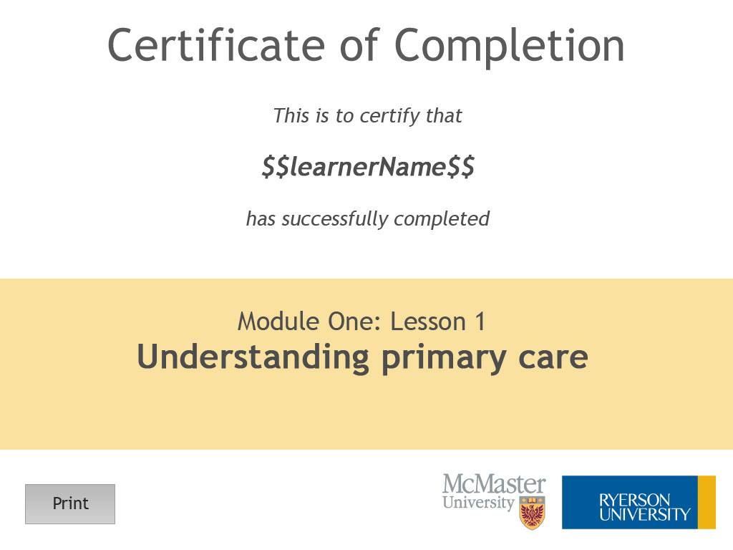
Slide notes
Text Captions

Module One: Lesson 1
Understanding primary care

