Slide 1 - Welcome
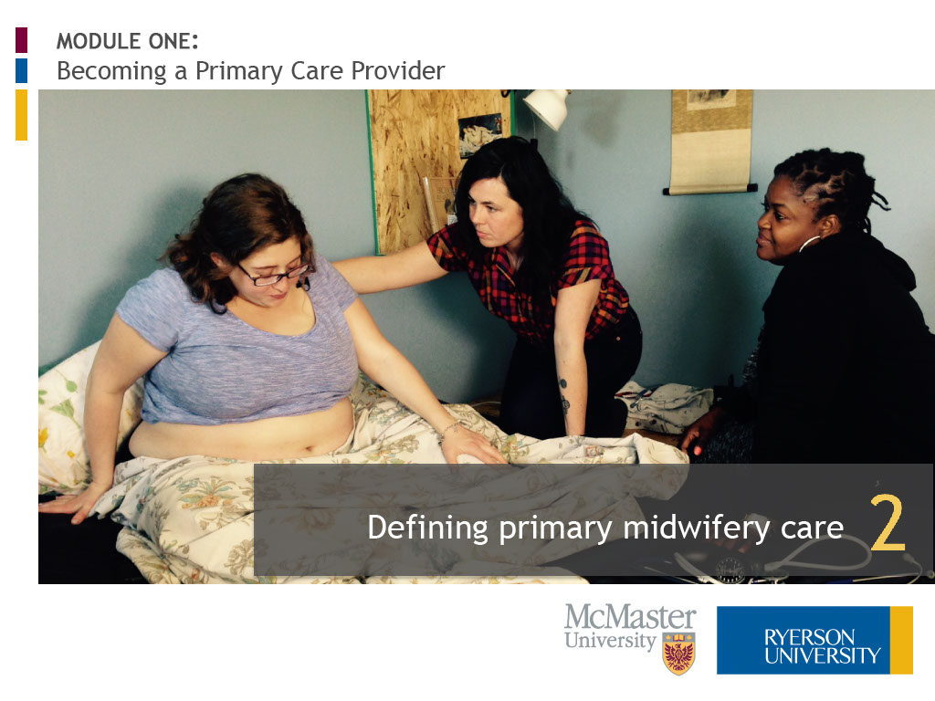
Slide notes
Hello. My name is Elizabeth Allemang and I am an Associate Professor in the Midwifery Education Program at Ryerson University.
Welcome to “Defining Primary Midwifery Care,” the second lesson of three in Module One, “Becoming a Primary Care Provider.” Let’s begin.
Text Captions

MODULE ONE:
Becoming a Primary Care Provider

Defining primary midwifery care

Slide 2 - Please enter your name

Slide notes
Text Captions

Please enter your name below:

Welcome

Slide 3 - Introduction
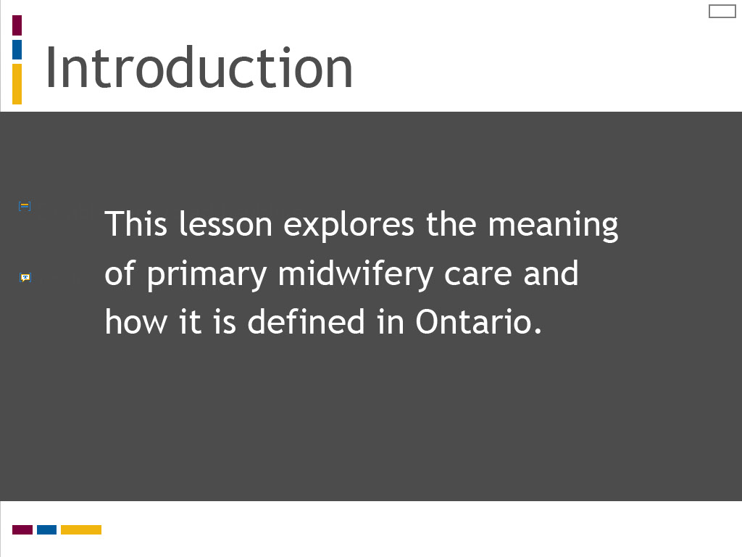
Slide notes
In this lesson, we explore the meaning of primary midwifery care and how this concept is defined in Ontario midwifery practice.

In this lesson, we explore the concepts of primary care and primary health care and consider how they apply to the practice of midwifery.
In this lesson we will explore theories of clinical decision making and care planning in health education and practice.
We will deconstruct two distinct methods for processing clinical decisions and care plans,
and apply these to the practice of midwifery.
Text Captions

Introduction

This lesson explores the meaning of primary midwifery care and how it is defined in Ontario.

Slide 4 - Learning Outcomes
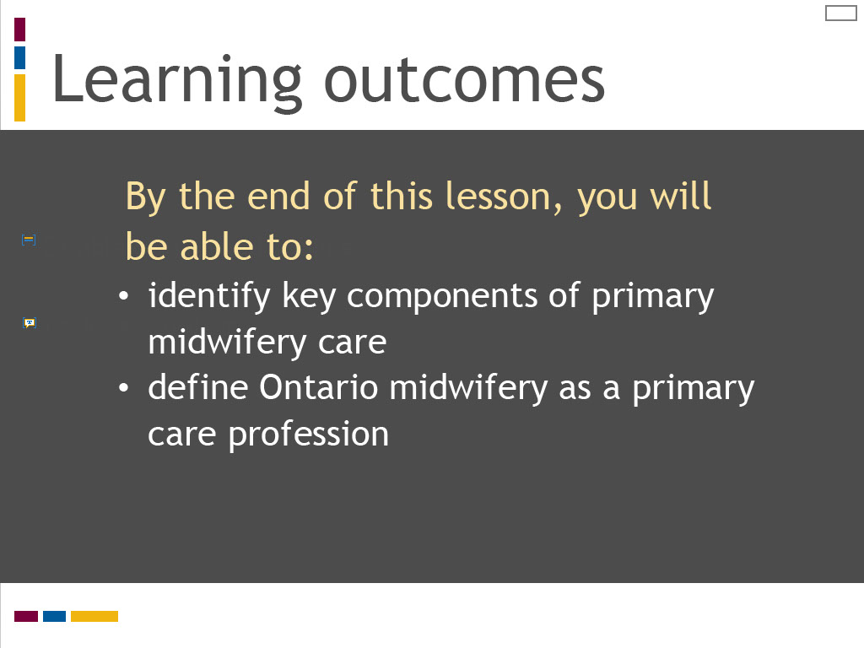
Slide notes
The learning outcomes for this lesson are summarized on the screen. Take a moment to review these before proceeding.

The learning outcomes for this lesson are summarized on the screen. Take a moment to review these before proceeding.
The learning outcomes for this lesson are summarized on the screen.
Take a moment to review these and proceed when you are ready.

Text Captions

Learning outcomes

By the end of this lesson, you will be able to:
- identify key components of primary midwifery care
- define Ontario midwifery as a primary care profession

Slide 5 - A midwife is...
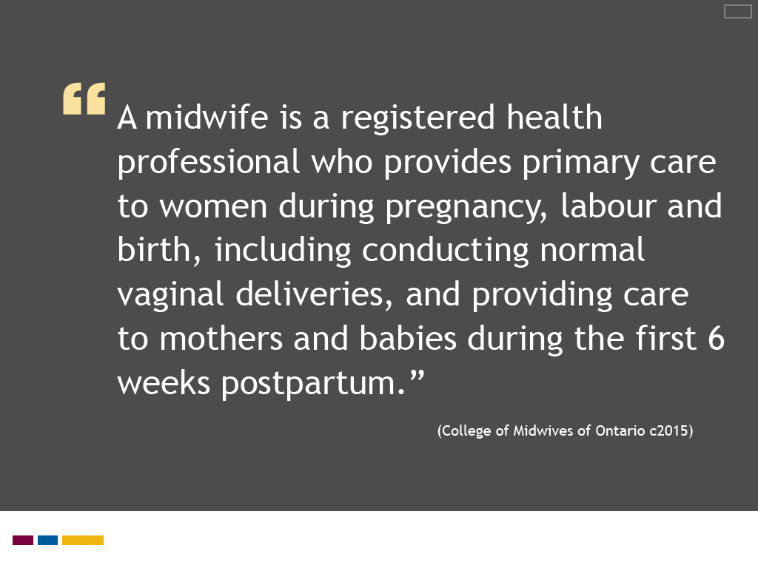
Slide notes
You were introduced to this quote in the first lesson of this module.
We reflected on how the College of Midwives of Ontario, the regulatory body for Ontario midwifery,
views midwives as primary care providers for childbearing clients and their newborns.
It is interesting, or perhaps puzzling, to note that the College describes Ontario midwives as primary care providers
when they are virtually absent from primary care literature and health policy.
(If you are not familiar with how primary care is defined, you may want to review the first lesson, “Understanding Primary Care,” before proceeding.)
Definitions of primary care traditionally recognize the family physician as the quintessential primary health care provider.
Although this perception is beginning to shift with growing recognition of the multi-disciplinary health care team, the role of the midwife is still not well defined.
In this lesson, we will look to sources that define the meaning of primary care in midwifery.
The College of Midwives of Ontario, the regulatory body for the Ontario midwifery profession,
provides this concise statement about what a midwife is on its website.
It is typical of the ways in which Ontario registered midwives are portrayed.
(You can find it by selecting “Public” on the College’s main webpage and then choosing the “About Midwifery” tab.)
By analyzing this statement, we get some understanding of the nature of midwives’ work and their role in the health care system.
Take a moment to review the statement. Can you identify four factors that describe what an Ontario registered midwife is?
You will next have the opportunity to respond to this question, which you can then compare to a correct answer.
Text Captions

A midwife is a registered health professional who provides primary care to women during pregnancy, labour and birth, including conducting normal vaginal deliveries, and providing care to mothers and babies during the first 6 weeks postpartum.”
(College of Midwives of Ontario c2015)

Slide 6 - Where does midwifery fit?

Slide notes
At the end of Lesson 1, I posed the question “Where does midwifery fit?” in the Ontario health care system.
Understanding midwifery’s position in the health care system is an important first step in defining primary midwifery care.
To begin this discussion, I would like you to review two contrasting representations of midwifery’s position in Ontario health care,
which highlight the need for a shared understanding of the role of midwifery.
While some definitions of primary care and primary health care acknowledge multi-disciplinary health care providers, midwives are not mentioned.
Yet the College of Midwives of Ontario clearly states that Ontario midwives provide primary care.
The College statement also suggests the Ontario midwifery model embodies primary care principles,
such as first point of entry to the health care system during pregnancy, first level care for “normal” childbearing,
and a scope of practice that is wellness rather than disease oriented.
How do we explain this disconnect? Where does midwifery fit in the Ontario health care system?
We will explore how midwifery is defined as a primary care profession in the following lesson of this module, “Defining Primary Midwifery Care.”

The College statement may seem clear and self-evident on first glance.
It tells us that midwives are registered health professionals who are regulated under Ontario health law.
Their work encompasses care for childbearing clients during pregnancy, labour and birth, and with their newborns during the first six weeks postpartum.
Midwives’ scope of practice focuses on normal vaginal deliveries. Their care is described as “primary” care.
The word primary is commonly understood to mean first. How does this concept translate into practice?
What is it about the work of midwives that makes it “primary” care? Can you explain what primary care means?
The three styles of decision making described by Dr. Austin are reasoning from first principles,
rule-based decision making, and pattern recognition.
In this lesson, we will examine two of these decision making methods more closely – reasoning from first principles and pattern recognition.
A rule-based approach refers to the use of structured tools to guide decision making,
such as evidence-based practice protocols or clinical practice guidelines.
This method is popular in health care to standardize clinical practice.
We will look more at how rule-based tools can support your learning of clinical decision making and care planning in Lesson 3 of this module,
“Learning to Make Clinical Decisions and Care Plans.”
In this lesson, we are interested in exploring methods that require clinical reasoning and critical analysis.
Theories of decision making classify methods for processing decisions and plans into two broad categories: analytic and non-analytic.
As will be explained, reasoning from first principles is an analytic method of decision making, whereas pattern recognition is a non-analytic method.
(Rule-based decision making could possibly be captured under the non-analytic category, as it is designed to enhance pattern recognition.)
To illustrate how analytic and non-analytic processing styles operate in clinical practice,
we will examine each method separately as a series of distinct steps, which are then applied to a simulated case of postpartum bleeding.
Deconstructing decision making and care planning in this way can help to demystify these processes for learners and their teachers.
Text Captions

Where does midwifery fit?

Slide 7 - Ontario health professionals
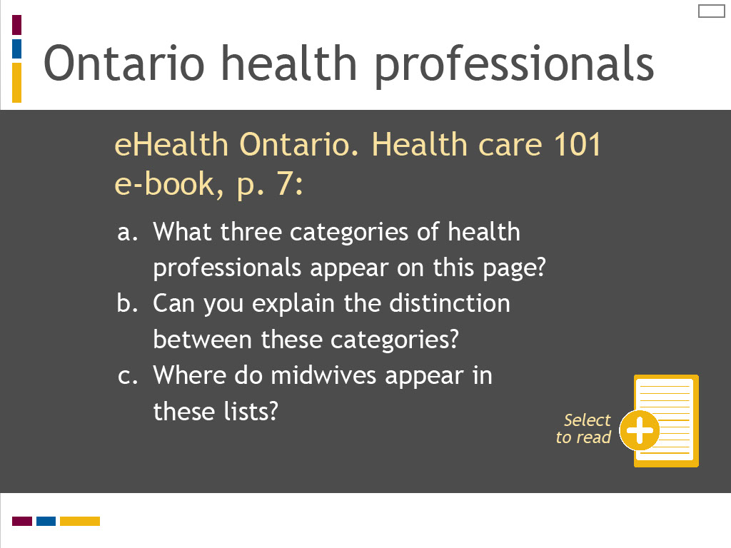
Slide notes
The first source I would like you to review is the “Health care 101 e-book” that you were introduced to in Lesson 1.
The Health care 101 e-book is an informative and interactive primer on the Ontario health care system recently published by the Ontario government.
Select the reading icon to access this resource. Scroll down to page 7 to review the list of health care professionals.
What three categories of health professionals appear on this page? Select the drop down menu for each of these three categories.
Can you explain the distinction between these categories? Where do midwives appear in these lists?
To understand more about the meanings of primary care and primary health care, I would like you to review the article
“Primary care versus primary health care: what is the difference?” published in the Canadian Journal of Public Health in 2006.
In this article, the authors analyze a series of Canadian and international definitions to define and compare primary care and primary health care.
Select the reading icon to access this article. While reviewing the article, reflect on the questions listed on this screen.
I would like to highlight several strategies that may help you to learn and practice clinical reasoning.
The first strategy relates to the skills of observation and listening.
These are two essential tools in the clinical reasoning process, which can sometimes be overlooked in favour of technological or clinical procedures.
The Yale University School of Nursing has created an innovative program for nursing students
that links the skills of observation and listening to problem-solving and assessment.
In the “Looking Is Not Seeing and Listening Is Not Hearing” program,
students study art appreciation at the Yale Centre for British Art and sound at the Yale School of Music
to sharpen their observation and listening skills as preparation for clinical assessment.
This program is described in the Yale School of Nursing and Alumni Association publication Yale Nursing Matters.
To read more about this program and understand how you can use sound and art to sharpen your observation and listening skills,
link to this publication by selecting the additional reading icon.
Text Captions

Ontario health professionals

eHealth Ontario. Health care 101 e-book, p. 7:

- What three categories of health professionals appear on this page?
- Can you explain the distinction between these categories?
- Where do midwives appear in these lists?

Select to read

Slide 8 - The case of the missing midwives…
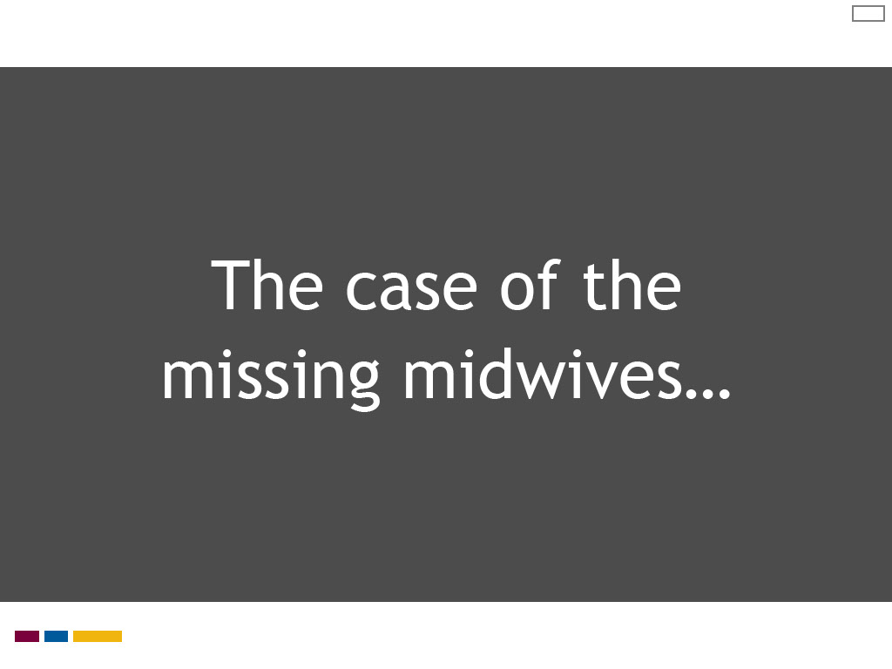
Slide notes
As you likely noticed, midwives are missing from all three lists of health care professionals.
The distinction between the three categories is also left unclear. When I first looked at this resource, I thought I had misread it.
I scrolled through the book carefully and found the College of Midwives of Ontario included in a list of professional regulatory bodies near the end of the document.
I returned to page 7 to make sure I had not missed where midwives appeared.
The Health care 101 e-book is a great resource, however the absence of midwifery provides a stark illustration of why primary midwifery care needs definition.
How can this oversight be explained? Why do you think midwives are not included in this government primer on the Ontario health care system?

At the end of Lesson 1, I posed the question “Where does midwifery fit?” in the Ontario health care system.
Understanding midwifery’s position in the health care system is an important first step in defining primary midwifery care.
To begin this discussion, I would like you to review two contrasting representations of midwifery’s position in Ontario health care,
which highlight the need for a shared understanding of the role of midwifery.
While some definitions of primary care and primary health care acknowledge multi-disciplinary health care providers, midwives are not mentioned.
Yet the College of Midwives of Ontario clearly states that Ontario midwives provide primary care.
The College statement also suggests the Ontario midwifery model embodies primary care principles,
such as first point of entry to the health care system during pregnancy, first level care for “normal” childbearing,
and a scope of practice that is wellness rather than disease oriented.
How do we explain this disconnect? Where does midwifery fit in the Ontario health care system?
We will explore how midwifery is defined as a primary care profession in the following lesson of this module, “Defining Primary Midwifery Care.”

The College statement may seem clear and self-evident on first glance.
It tells us that midwives are registered health professionals who are regulated under Ontario health law.
Their work encompasses care for childbearing clients during pregnancy, labour and birth, and with their newborns during the first six weeks postpartum.
Midwives’ scope of practice focuses on normal vaginal deliveries. Their care is described as “primary” care.
The word primary is commonly understood to mean first. How does this concept translate into practice?
What is it about the work of midwives that makes it “primary” care? Can you explain what primary care means?
The three styles of decision making described by Dr. Austin are reasoning from first principles,
rule-based decision making, and pattern recognition.
In this lesson, we will examine two of these decision making methods more closely – reasoning from first principles and pattern recognition.
A rule-based approach refers to the use of structured tools to guide decision making,
such as evidence-based practice protocols or clinical practice guidelines.
This method is popular in health care to standardize clinical practice.
We will look more at how rule-based tools can support your learning of clinical decision making and care planning in Lesson 3 of this module,
“Learning to Make Clinical Decisions and Care Plans.”
In this lesson, we are interested in exploring methods that require clinical reasoning and critical analysis.
Theories of decision making classify methods for processing decisions and plans into two broad categories: analytic and non-analytic.
As will be explained, reasoning from first principles is an analytic method of decision making, whereas pattern recognition is a non-analytic method.
(Rule-based decision making could possibly be captured under the non-analytic category, as it is designed to enhance pattern recognition.)
To illustrate how analytic and non-analytic processing styles operate in clinical practice,
we will examine each method separately as a series of distinct steps, which are then applied to a simulated case of postpartum bleeding.
Deconstructing decision making and care planning in this way can help to demystify these processes for learners and their teachers.
Text Captions

The case of the missing midwives…

Slide 9 - Why is midwifery missing?
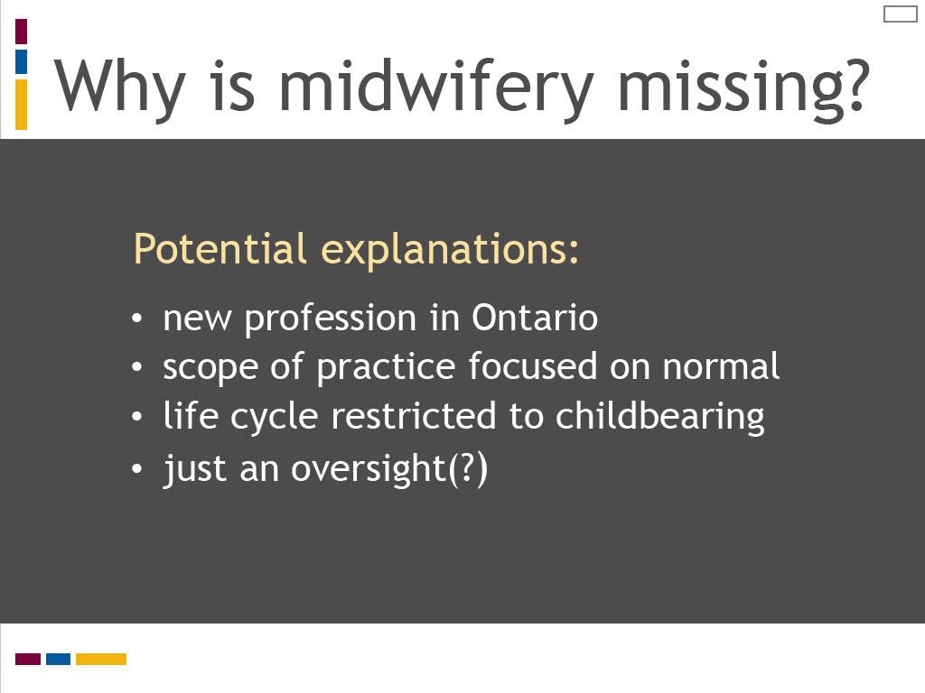
Slide notes
Perhaps midwifery is overlooked because it is still a relatively new profession in Canada,
having first been regulated and publicly funded in Ontario just over 20 years ago.
Could it be that the midwifery scope of practice for normal childbearing is too narrowly focused on one aspect of the life cycle
when compared to the comprehensive life cycle care of family medicine?
Perhaps it is simply an oversight that midwives are left out.
We can only speculate, however this does seem to be an opportunity for our professional organizations to advocate for the inclusion of midwifery.
In their comparative analysis of primary care and primary health care,
Muldoon, Hogg and Levitt come to several conclusions about the meaning and relationship of these concepts that are summarized on this screen.
They argue primary care and primary health care are distinct concepts that are often used interchangeably.
They highlight the debate and lack of consensus in Canada regarding the meaning and use of these terms.

To understand more about the meanings of primary care and primary health care, I would like you to review the article
“Primary care versus primary health care: what is the difference?” published in the Canadian Journal of Public Health in 2006.
In this article, the authors analyze a series of Canadian and international definitions to define and compare primary care and primary health care.
Select the reading icon to access this article. While reviewing the article, reflect on the questions listed on this screen.
I would like to highlight several strategies that may help you to learn and practice clinical reasoning.
The first strategy relates to the skills of observation and listening.
These are two essential tools in the clinical reasoning process, which can sometimes be overlooked in favour of technological or clinical procedures.
The Yale University School of Nursing has created an innovative program for nursing students
that links the skills of observation and listening to problem-solving and assessment.
In the “Looking Is Not Seeing and Listening Is Not Hearing” program,
students study art appreciation at the Yale Centre for British Art and sound at the Yale School of Music
to sharpen their observation and listening skills as preparation for clinical assessment.
This program is described in the Yale School of Nursing and Alumni Association publication Yale Nursing Matters.
To read more about this program and understand how you can use sound and art to sharpen your observation and listening skills,
link to this publication by selecting the additional reading icon.
Text Captions

Why is midwifery missing?
Potential explanations:
- new profession in Ontario
- scope of practice focused on normal
- life cycle restricted to childbearing
- just an oversight(?)

Slide 10 - Human resource standards
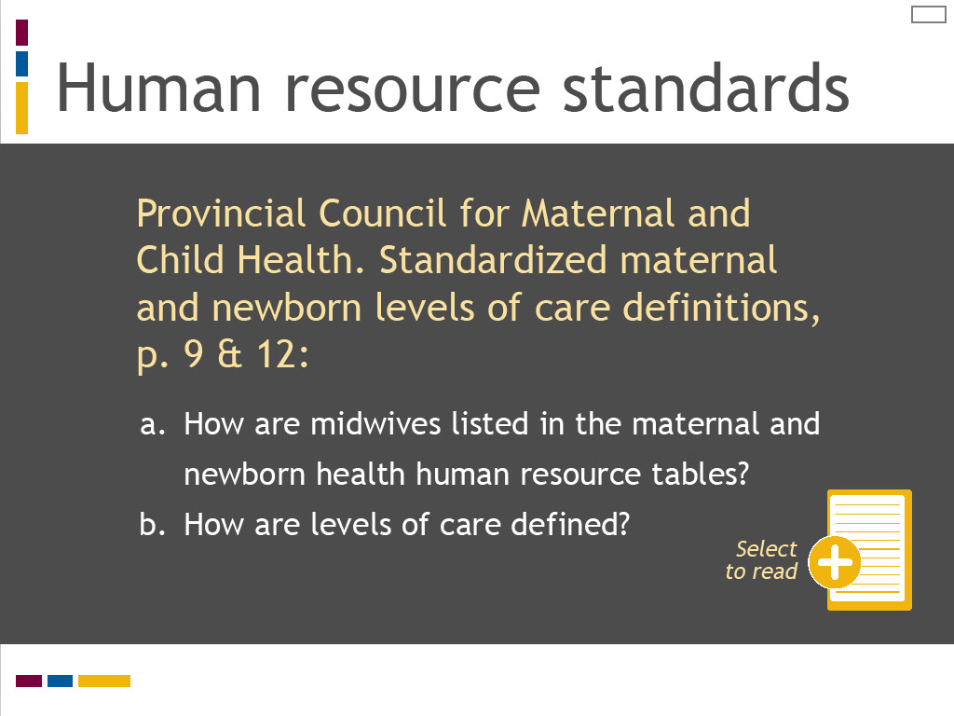
Slide notes
I would next like you to review a document published in 2011 by the Ontario Provincial Council for Maternal and Child Health and updated in 2013,
“Standardized maternal and newborn levels of care definitions.”
This health policy document defines levels of cares, available health services, and human resource requirements for maternal and newborn care in the Ontario health care system.
Select the reading icon to access this document.
Review the table of human resource requirements for maternal and newborn care that appear on pages 9 and 12 and reflect on the questions listed on this screen.
In our quest to uncover the meanings of primary care and primary health care, I would next like you to review “Primary health care: a background paper.”
This paper was published in 2005 by the Health Council of Canada, an independent, non-profit organization
established in 2003 as part of the First Ministers' Accord on Health Care Renewal.
Its role was to report on national health care reform and disseminate information on best practices and innovation in Canadian health care.
While the Council ceased operation in 2014, its website and publications remain archived on the web.
Select the reading icon to access the Health Council report.
Review “Definitions of Primary Health Care,” Appendix 1 on pages 24 to 27 and reflect on the questions listed on this screen.
To understand more about the meanings of primary care and primary health care, I would like you to review the article
“Primary care versus primary health care: what is the difference?” published in the Canadian Journal of Public Health in 2006.
In this article, the authors analyze a series of Canadian and international definitions to define and compare primary care and primary health care.
Select the reading icon to access this article. While reviewing the article, reflect on the questions listed on this screen.
I would like to highlight several strategies that may help you to learn and practice clinical reasoning.
The first strategy relates to the skills of observation and listening.
These are two essential tools in the clinical reasoning process, which can sometimes be overlooked in favour of technological or clinical procedures.
The Yale University School of Nursing has created an innovative program for nursing students
that links the skills of observation and listening to problem-solving and assessment.
In the “Looking Is Not Seeing and Listening Is Not Hearing” program,
students study art appreciation at the Yale Centre for British Art and sound at the Yale School of Music
to sharpen their observation and listening skills as preparation for clinical assessment.
This program is described in the Yale School of Nursing and Alumni Association publication Yale Nursing Matters.
To read more about this program and understand how you can use sound and art to sharpen your observation and listening skills,
link to this publication by selecting the additional reading icon.
Text Captions

Provincial Council for Maternal and Child Health. Standardized maternal and newborn levels of care definitions, p. 9 & 12:
- How are midwives listed in the maternal and newborn health human resource tables?
- How are levels of care defined?
Human resource standards

Select to read

Slide 11 - Medical resource standards for maternal care
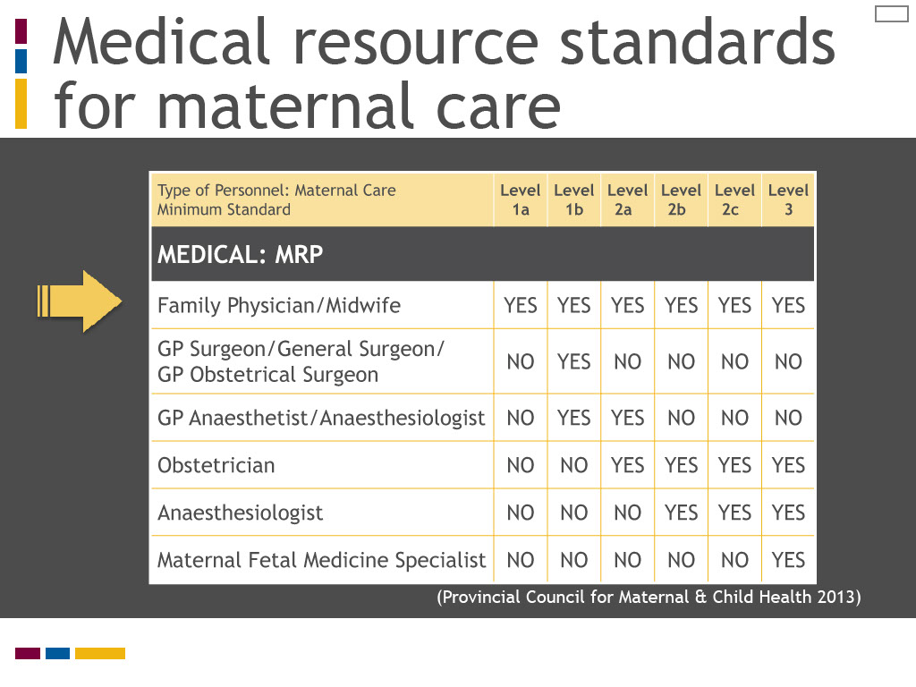
Slide notes
The minimum human resource standards for medical personnel in maternal care as defined by the Provincial Council for Maternal and Child Health are listed on this screen.
Here the Council identifies both the midwife and the family physician as the minimum human resource standard for Level 1a maternal care.
(If you are unfamiliar with how Level 1a is defined, review the level criteria in the Provincial Council document.
These include standards for risk categories, facility supports, and practitioner skill.)
As this table shows, midwives are also identified as maternity care providers in facilities with more advanced levels of care

where specialist physicians are also included in the minimum human resource standards.
Text Captions

Medical resource standards for maternal care
PCMCH table of medical resource standards for maternal care

(Provincial Council for Maternal & Child Health 2013)

Slide 12 - Medical resource standards for newborn care
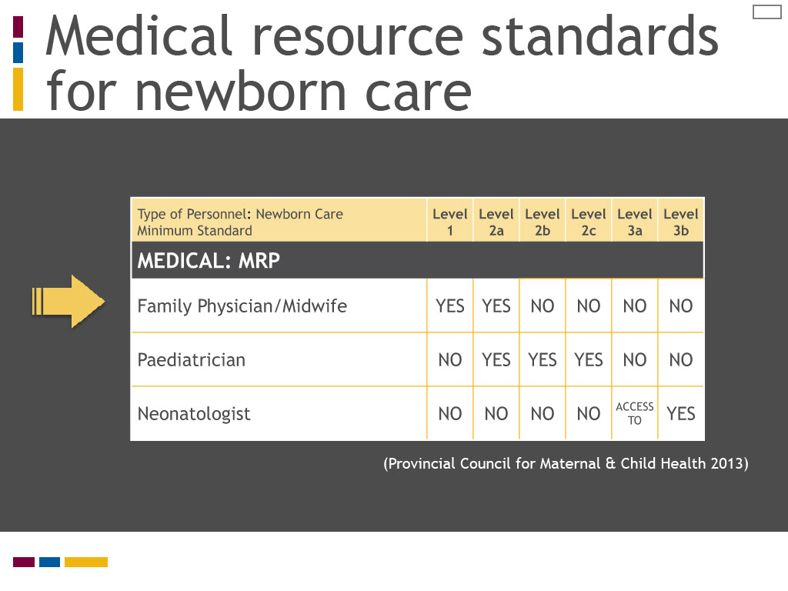
Slide notes
The minimum human resource standards for medical personnel in newborn care are listed on this screen.
The Provincial Council identifies the midwife and the family physician as the minimum human resource standard for newborn care for Levels 1 and 2a.
(Again, review the level criteria if you are not familiar with the standards for Levels 1 and 2a for newborn care.)

The minimum human resource standards for medical personnel in maternal care as defined by the Provincial Council for Maternal and Child Health are listed on this screen.
Here the Council identifies both the midwife and the family physician as the minimum human resource standard for Level 1a maternal care.
(If you are unfamiliar with how Level 1a is defined, review the level criteria in the Provincial Council document.
These include standards for risk categories, facility supports, and practitioner skill.)
As this table shows, midwives are also identified as maternity care providers in facilities with more advanced levels of care

where specialist physicians are also included in the minimum human resource standards.
Text Captions

Medical resource standards for newborn care
PCMCH table of medical resource standards for maternal care

(Provincial Council for Maternal & Child Health 2013)

Slide 13 - Low risk providers: Hand in hand with family physicians
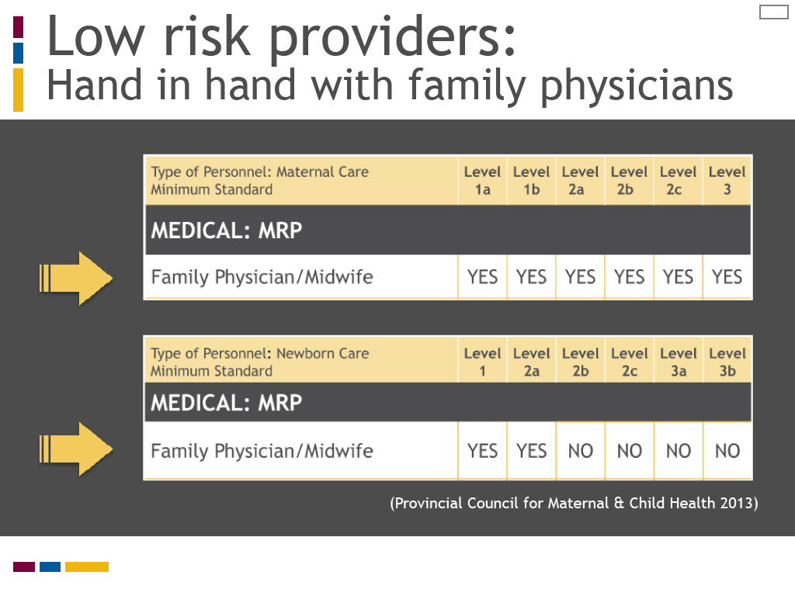
Slide notes
Clearly the Provincial Council for Maternal and Child Health provides an alternate vision for where midwives fit in the Ontario health care system.
The Council sees midwives as integral primary care providers for low risk maternal and newborn care, on par with family physicians.
How can this alternate vision of midwifery be explained? It may be that the authoring organization for the standard

is specifically focused on maternal and child health, and midwives are included on its advisory committees.
To understand more fully how midwives are defined as primary care providers in Ontario,

we will now turn to midwifery organizations, both within and outside Ontario.
The minimum human resource standards for medical personnel in newborn care are listed on this screen.
The Provincial Council identifies the midwife and the family physician as the minimum human resource standard for newborn care for Levels 1 and 2a.
(Again, review the level criteria if you are not familiar with the standards for Levels 1 and 2a for newborn care.)

The minimum human resource standards for medical personnel in maternal care as defined by the Provincial Council for Maternal and Child Health are listed on this screen.
Here the Council identifies both the midwife and the family physician as the minimum human resource standard for Level 1a maternal care.
(If you are unfamiliar with how Level 1a is defined, review the level criteria in the Provincial Council document.
These include standards for risk categories, facility supports, and practitioner skill.)
As this table shows, midwives are also identified as maternity care providers in facilities with more advanced levels of care

where specialist physicians are also included in the minimum human resource standards.
Text Captions

Low risk providers:
Hand in hand with family physicians
PCMCH tables for maternal and newborn care indicating the common level for midwives and family physicians

(Provincial Council for Maternal & Child Health 2013)

Slide 14 - Defining primary midwifery care
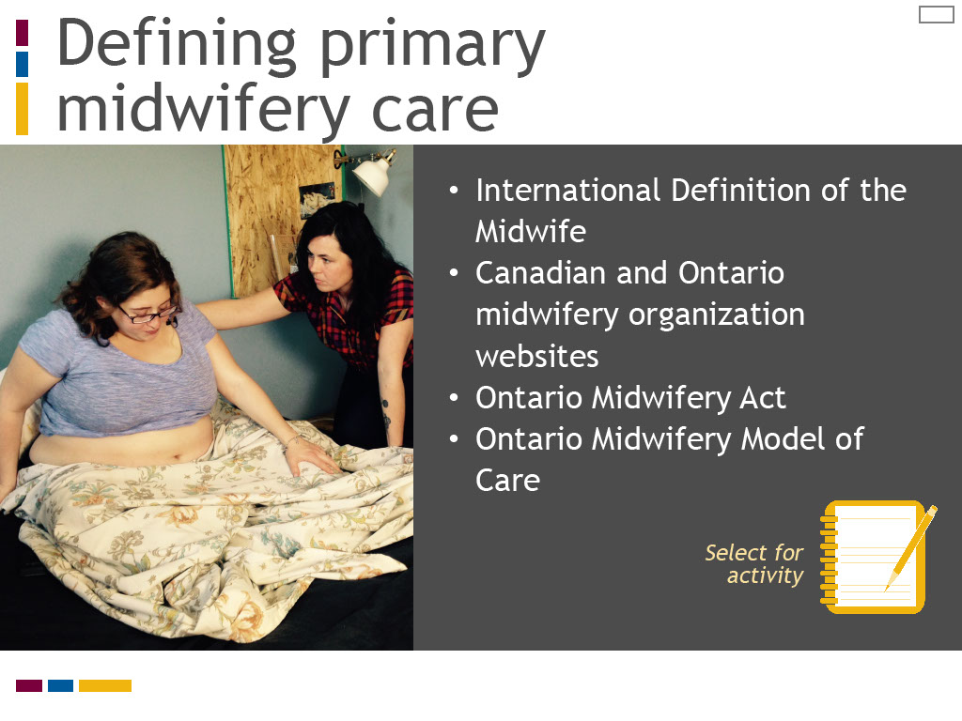
Slide notes
An activity is provided for you to explore how the international, national and provincial midwifery organizations and documents listed on this screen define midwifery as a primary care profession.
Select the activity icon to access the instructions, web links and tools to do a scavenger hunt for defining primary midwifery care.
You will link to six documents or websites and match how they describe midwifery to a chart listing features of primary care and primary health care.
When you have completed the activity, you are asked to review your chart and summarize how midwifery is defined as a primary care profession.
We will then review the significant contribution of each resource.

Text Captions

Defining primary midwifery care
- International Definition of the Midwife
- Canadian and Ontario midwifery organization websites
- Ontario Midwifery Act
- Ontario Midwifery Model of Care

Select for activity

Slide 15 - International definition
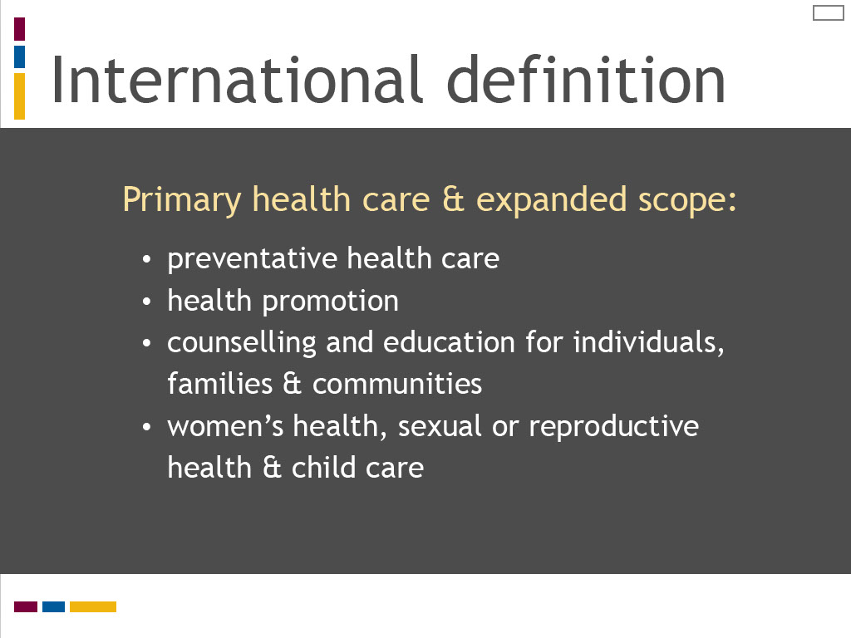
Slide notes
The International Definition of the Midwife was created in the early 1970s to establish a consistent vision for midwifery,
despite international variation in models of regulation, practice and education.
It is regularly reviewed and updated by the International Confederation of Midwives.
The 2011 definition highlights midwives’ professional responsibility and competence as educated, recognized professionals.
It defines the midwifery scope of practice as focused on normal childbearing with a client-centred model of care in community and hospital settings.
What is particularly striking about the International Definition is that it incorporates key features of primary health care,
including preventive health care, health promotion, and health counselling and education.
It envisions the midwife’s role in these areas as extending beyond the individual to encompass the family and the community.
The other significant feature of the International Definition is that it recognizes the midwifery scope of practice may extend to women’s health, sexual or reproductive health, and child care.
What is particularly striking about this appendix is the number of definitions that are listed.
The Council identifies 15 distinct definitions for primary health care in use in Canada at the federal, provincial and territorial levels.
It also lists 14 “other” prominent definitions used by professional and public policy organizations, both nationally and internationally.
Although these definitions may not be fully up to date given the report was published in 2005,
this four page appendix provides a dramatic statement of the diversity and complexity of primary health care.
We can conclude that rather than having a single definition, primary health care is a multi-faceted concept.
Take a moment to reflect further on this table of definitions using the questions listed on this screen.
In our quest to uncover the meanings of primary care and primary health care, I would next like you to review “Primary health care: a background paper.”
This paper was published in 2005 by the Health Council of Canada, an independent, non-profit organization
established in 2003 as part of the First Ministers' Accord on Health Care Renewal.
Its role was to report on national health care reform and disseminate information on best practices and innovation in Canadian health care.
While the Council ceased operation in 2014, its website and publications remain archived on the web.
Select the reading icon to access the Health Council report.
Review “Definitions of Primary Health Care,” Appendix 1 on pages 24 to 27 and reflect on the questions listed on this screen.
To understand more about the meanings of primary care and primary health care, I would like you to review the article
“Primary care versus primary health care: what is the difference?” published in the Canadian Journal of Public Health in 2006.
In this article, the authors analyze a series of Canadian and international definitions to define and compare primary care and primary health care.
Select the reading icon to access this article. While reviewing the article, reflect on the questions listed on this screen.
I would like to highlight several strategies that may help you to learn and practice clinical reasoning.
The first strategy relates to the skills of observation and listening.
These are two essential tools in the clinical reasoning process, which can sometimes be overlooked in favour of technological or clinical procedures.
The Yale University School of Nursing has created an innovative program for nursing students
that links the skills of observation and listening to problem-solving and assessment.
In the “Looking Is Not Seeing and Listening Is Not Hearing” program,
students study art appreciation at the Yale Centre for British Art and sound at the Yale School of Music
to sharpen their observation and listening skills as preparation for clinical assessment.
This program is described in the Yale School of Nursing and Alumni Association publication Yale Nursing Matters.
To read more about this program and understand how you can use sound and art to sharpen your observation and listening skills,
link to this publication by selecting the additional reading icon.
Text Captions

International definition

Primary health care & expanded scope:
- preventative health care
- health promotion
- counselling and education for individuals, families & communities
- women’s health, sexual or reproductive health & child care

Slide 16 - Canadian Association of Midwives
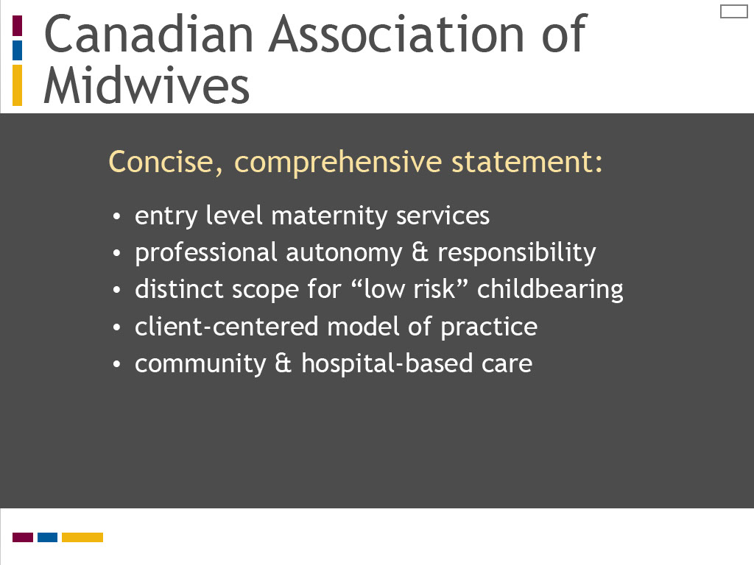
Slide notes
The Canadian Association of Midwives, or CAM, is a national umbrella organization representing midwives and midwifery associations from across the country.
It plays a prominent role in public education and advocacy for midwifery at the national and international levels.
Although midwifery is not yet universally regulated or funded throughout all of Canada,
it has become regulated in most provinces and territories over the last 20 years
and it is consistently defined by its professional and regulatory organizations as a primary care profession.
CAM’s simple website statement “What is a Canadian Registered Midwife?”
defines midwifery in ways that are consistent with the principles of primary care and primary health care reviewed in Lesson 1.
It describes midwives as providing “first point of entry” to the health care system, a key concept underlying many definitions of primary care and primary health care.
The entry point for midwives, however, is narrowed from the life cycle care of family medicine to maternity services.
The statement that midwives are “fully responsible for clinical decisions and the management of care within their scope of practice”
suggests midwives have professional autonomy and accountability within a distinct scope of practice for low risk maternity care.
It also tells us that midwives, like family physicians, are also responsible to identify and coordinate consultation and referral for care outside their scope of practice,
which is consistent with primary care principles of coordinating and integrating specialized services.
The description of the midwifery model of care reflects public health principles underlying definitions of primary health care,
such as “promoting normal” childbearing, facilitating “informed choice” decision making with clients, and providing “continuity of care” and “support.”
Lastly, this statement notes that midwives provide community-based care and in hospital settings, which is consistent with the primary health care principle of care close to home.
It is important to note that the Canadian Association of Midwives is currently developing a national statement on the model for midwifery
that will promote the understanding of midwifery as a primary care profession.
The development of a national statement reflects the progressive development of midwifery across the country as a relatively new profession.
It also strengthens a unified and standardized vision for midwifery as a primary care profession in a country where health is regulated at a provincial or territorial, rather than a national, level.

The International Definition of the Midwife was created in the early 1970s to establish a consistent vision for midwifery,
despite international variation in models of regulation, practice and education.
It is regularly reviewed and updated by the International Confederation of Midwives.
The 2011 definition highlights midwives’ professional responsibility and competence as educated, recognized professionals.
It defines the midwifery scope of practice as focused on normal childbearing with a client-centred model of care in community and hospital settings.
What is particularly striking about the International Definition is that it incorporates key features of primary health care,
including preventive health care, health promotion, and health counselling and education.
It envisions the midwife’s role in these areas as extending beyond the individual to encompass the family and the community.
The other significant feature of the International Definition is that it recognizes the midwifery scope of practice may extend to women’s health, sexual or reproductive health, and child care.
What is particularly striking about this appendix is the number of definitions that are listed.
The Council identifies 15 distinct definitions for primary health care in use in Canada at the federal, provincial and territorial levels.
It also lists 14 “other” prominent definitions used by professional and public policy organizations, both nationally and internationally.
Although these definitions may not be fully up to date given the report was published in 2005,
this four page appendix provides a dramatic statement of the diversity and complexity of primary health care.
We can conclude that rather than having a single definition, primary health care is a multi-faceted concept.
Take a moment to reflect further on this table of definitions using the questions listed on this screen.
In our quest to uncover the meanings of primary care and primary health care, I would next like you to review “Primary health care: a background paper.”
This paper was published in 2005 by the Health Council of Canada, an independent, non-profit organization
established in 2003 as part of the First Ministers' Accord on Health Care Renewal.
Its role was to report on national health care reform and disseminate information on best practices and innovation in Canadian health care.
While the Council ceased operation in 2014, its website and publications remain archived on the web.
Select the reading icon to access the Health Council report.
Review “Definitions of Primary Health Care,” Appendix 1 on pages 24 to 27 and reflect on the questions listed on this screen.
To understand more about the meanings of primary care and primary health care, I would like you to review the article
“Primary care versus primary health care: what is the difference?” published in the Canadian Journal of Public Health in 2006.
In this article, the authors analyze a series of Canadian and international definitions to define and compare primary care and primary health care.
Select the reading icon to access this article. While reviewing the article, reflect on the questions listed on this screen.
I would like to highlight several strategies that may help you to learn and practice clinical reasoning.
The first strategy relates to the skills of observation and listening.
These are two essential tools in the clinical reasoning process, which can sometimes be overlooked in favour of technological or clinical procedures.
The Yale University School of Nursing has created an innovative program for nursing students
that links the skills of observation and listening to problem-solving and assessment.
In the “Looking Is Not Seeing and Listening Is Not Hearing” program,
students study art appreciation at the Yale Centre for British Art and sound at the Yale School of Music
to sharpen their observation and listening skills as preparation for clinical assessment.
This program is described in the Yale School of Nursing and Alumni Association publication Yale Nursing Matters.
To read more about this program and understand how you can use sound and art to sharpen your observation and listening skills,
link to this publication by selecting the additional reading icon.
Text Captions

Canadian Association of Midwives

Concise, comprehensive statement:
- entry level maternity services
- professional autonomy & responsibility
- distinct scope for “low risk” childbearing
- client-centered model of practice
- community & hospital-based care

Slide 17 - Canadian Association of Midwives
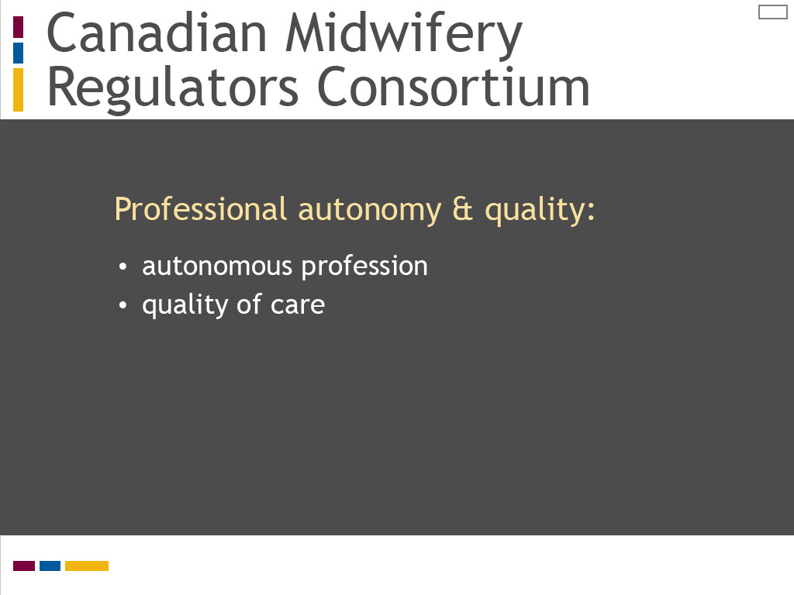
Slide notes
The Canadian Association of Midwives web page describing who midwives are directs readers to the website of the Canadian Midwifery Regulators Consortium, or CMRC, for more information.
The CMRC is a national body representing midwifery regulatory organizations from across the country.
It provides an overview of Canadian midwifery that highlights midwives’ professional autonomy and the quality of their care,
reinforcing the concept of midwifery as a primary care profession.
The CMRC has also developed a list of “Canadian Competencies for Midwives” and a “Canadian Model of Midwifery Practice” statement,
which provide more detail about how midwives are defined as “autonomous professionals.”
(These documents can be found on the CMRC website, if you are interested in reviewing them further.)

The Canadian Association of Midwives, or CAM, is a national umbrella organization representing midwives and midwifery associations from across the country.
It plays a prominent role in public education and advocacy for midwifery at the national and international levels.
Although midwifery is not yet universally regulated or funded throughout all of Canada,
it has become regulated in most provinces and territories over the last 20 years
and it is consistently defined by its professional and regulatory organizations as a primary care profession.
CAM’s simple website statement “What is a Canadian Registered Midwife?”
defines midwifery in ways that are consistent with the principles of primary care and primary health care reviewed in Lesson 1.
It describes midwives as providing “first point of entry” to the health care system, a key concept underlying many definitions of primary care and primary health care.
The entry point for midwives, however, is narrowed from the life cycle care of family medicine to maternity services.
The statement that midwives are “fully responsible for clinical decisions and the management of care within their scope of practice”
suggests midwives have professional autonomy and accountability within a distinct scope of practice for low risk maternity care.
It also tells us that midwives, like family physicians, are also responsible to identify and coordinate consultation and referral for care outside their scope of practice,
which is consistent with primary care principles of coordinating and integrating specialized services.
The description of the midwifery model of care reflects public health principles underlying definitions of primary health care,
such as “promoting normal” childbearing, facilitating “informed choice” decision making with clients, and providing “continuity of care” and “support.”
Lastly, this statement notes that midwives provide community-based care and in hospital settings, which is consistent with the primary health care principle of care close to home.
It is important to note that the Canadian Association of Midwives is currently developing a national statement on the model for midwifery
that will promote the understanding of midwifery as a primary care profession.
The development of a national statement reflects the progressive development of midwifery across the country as a relatively new profession.
It also strengthens a unified and standardized vision for midwifery as a primary care profession in a country where health is regulated at a provincial or territorial, rather than a national, level.

The International Definition of the Midwife was created in the early 1970s to establish a consistent vision for midwifery,
despite international variation in models of regulation, practice and education.
It is regularly reviewed and updated by the International Confederation of Midwives.
The 2011 definition highlights midwives’ professional responsibility and competence as educated, recognized professionals.
It defines the midwifery scope of practice as focused on normal childbearing with a client-centred model of care in community and hospital settings.
What is particularly striking about the International Definition is that it incorporates key features of primary health care,
including preventive health care, health promotion, and health counselling and education.
It envisions the midwife’s role in these areas as extending beyond the individual to encompass the family and the community.
The other significant feature of the International Definition is that it recognizes the midwifery scope of practice may extend to women’s health, sexual or reproductive health, and child care.
What is particularly striking about this appendix is the number of definitions that are listed.
The Council identifies 15 distinct definitions for primary health care in use in Canada at the federal, provincial and territorial levels.
It also lists 14 “other” prominent definitions used by professional and public policy organizations, both nationally and internationally.
Although these definitions may not be fully up to date given the report was published in 2005,
this four page appendix provides a dramatic statement of the diversity and complexity of primary health care.
We can conclude that rather than having a single definition, primary health care is a multi-faceted concept.
Take a moment to reflect further on this table of definitions using the questions listed on this screen.
In our quest to uncover the meanings of primary care and primary health care, I would next like you to review “Primary health care: a background paper.”
This paper was published in 2005 by the Health Council of Canada, an independent, non-profit organization
established in 2003 as part of the First Ministers' Accord on Health Care Renewal.
Its role was to report on national health care reform and disseminate information on best practices and innovation in Canadian health care.
While the Council ceased operation in 2014, its website and publications remain archived on the web.
Select the reading icon to access the Health Council report.
Review “Definitions of Primary Health Care,” Appendix 1 on pages 24 to 27 and reflect on the questions listed on this screen.
To understand more about the meanings of primary care and primary health care, I would like you to review the article
“Primary care versus primary health care: what is the difference?” published in the Canadian Journal of Public Health in 2006.
In this article, the authors analyze a series of Canadian and international definitions to define and compare primary care and primary health care.
Select the reading icon to access this article. While reviewing the article, reflect on the questions listed on this screen.
I would like to highlight several strategies that may help you to learn and practice clinical reasoning.
The first strategy relates to the skills of observation and listening.
These are two essential tools in the clinical reasoning process, which can sometimes be overlooked in favour of technological or clinical procedures.
The Yale University School of Nursing has created an innovative program for nursing students
that links the skills of observation and listening to problem-solving and assessment.
In the “Looking Is Not Seeing and Listening Is Not Hearing” program,
students study art appreciation at the Yale Centre for British Art and sound at the Yale School of Music
to sharpen their observation and listening skills as preparation for clinical assessment.
This program is described in the Yale School of Nursing and Alumni Association publication Yale Nursing Matters.
To read more about this program and understand how you can use sound and art to sharpen your observation and listening skills,
link to this publication by selecting the additional reading icon.
Text Captions

Canadian Midwifery Regulators Consortium

Professional autonomy & quality:
- autonomous profession
- quality of care

Slide 18 - Ontario Midwifery Act
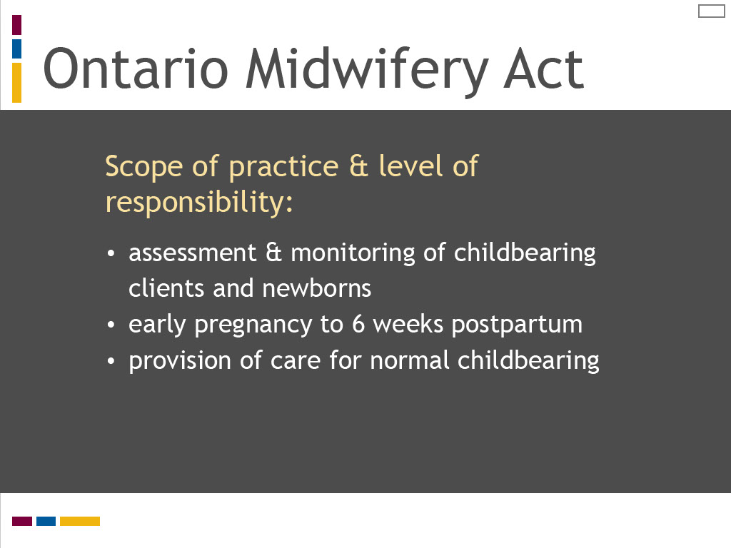
Slide notes
The Ontario Midwifery Act sets the parameters for the midwifery scope of practice together with the overarching legislation for Ontario health professionals, the Regulated Health Professions Act.
This legislation defines the regulatory responsibilities for the College of Midwives of Ontario in its role of protecting the public,
as well as the details for what health care procedures midwives can perform.
By law, midwifery in Ontario is defined as a self-regulating profession, which means it is an autonomous profession with the legislative power to govern itself within the parameters of the law.
The Midwifery Act defines the midwifery scope of practice as encompassing the assessment and monitoring of childbearing women in pregnancy, labour, birth and the postpartum period, together with their newborns, in “normal” situations.
The Midwifery Act also specifies which health care procedures, or “authorized acts,” midwives may perform as defined in law.
The Ontario Midwifery Act assumes midwives are fully responsible and accountable for their scope of practice and authorized acts.

The International Definition of the Midwife was created in the early 1970s to establish a consistent vision for midwifery,
despite international variation in models of regulation, practice and education.
It is regularly reviewed and updated by the International Confederation of Midwives.
The 2011 definition highlights midwives’ professional responsibility and competence as educated, recognized professionals.
It defines the midwifery scope of practice as focused on normal childbearing with a client-centred model of care in community and hospital settings.
What is particularly striking about the International Definition is that it incorporates key features of primary health care,
including preventive health care, health promotion, and health counselling and education.
It envisions the midwife’s role in these areas as extending beyond the individual to encompass the family and the community.
The other significant feature of the International Definition is that it recognizes the midwifery scope of practice may extend to women’s health, sexual or reproductive health, and child care.
What is particularly striking about this appendix is the number of definitions that are listed.
The Council identifies 15 distinct definitions for primary health care in use in Canada at the federal, provincial and territorial levels.
It also lists 14 “other” prominent definitions used by professional and public policy organizations, both nationally and internationally.
Although these definitions may not be fully up to date given the report was published in 2005,
this four page appendix provides a dramatic statement of the diversity and complexity of primary health care.
We can conclude that rather than having a single definition, primary health care is a multi-faceted concept.
Take a moment to reflect further on this table of definitions using the questions listed on this screen.
In our quest to uncover the meanings of primary care and primary health care, I would next like you to review “Primary health care: a background paper.”
This paper was published in 2005 by the Health Council of Canada, an independent, non-profit organization
established in 2003 as part of the First Ministers' Accord on Health Care Renewal.
Its role was to report on national health care reform and disseminate information on best practices and innovation in Canadian health care.
While the Council ceased operation in 2014, its website and publications remain archived on the web.
Select the reading icon to access the Health Council report.
Review “Definitions of Primary Health Care,” Appendix 1 on pages 24 to 27 and reflect on the questions listed on this screen.
To understand more about the meanings of primary care and primary health care, I would like you to review the article
“Primary care versus primary health care: what is the difference?” published in the Canadian Journal of Public Health in 2006.
In this article, the authors analyze a series of Canadian and international definitions to define and compare primary care and primary health care.
Select the reading icon to access this article. While reviewing the article, reflect on the questions listed on this screen.
I would like to highlight several strategies that may help you to learn and practice clinical reasoning.
The first strategy relates to the skills of observation and listening.
These are two essential tools in the clinical reasoning process, which can sometimes be overlooked in favour of technological or clinical procedures.
The Yale University School of Nursing has created an innovative program for nursing students
that links the skills of observation and listening to problem-solving and assessment.
In the “Looking Is Not Seeing and Listening Is Not Hearing” program,
students study art appreciation at the Yale Centre for British Art and sound at the Yale School of Music
to sharpen their observation and listening skills as preparation for clinical assessment.
This program is described in the Yale School of Nursing and Alumni Association publication Yale Nursing Matters.
To read more about this program and understand how you can use sound and art to sharpen your observation and listening skills,
link to this publication by selecting the additional reading icon.
Text Captions

Ontario Midwifery Act

Scope of practice & level of responsibility:
- assessment & monitoring of childbearing clients and newborns
- early pregnancy to 6 weeks postpartum
- provision of care for normal childbearing

Slide 19 - Ontario midwifery model
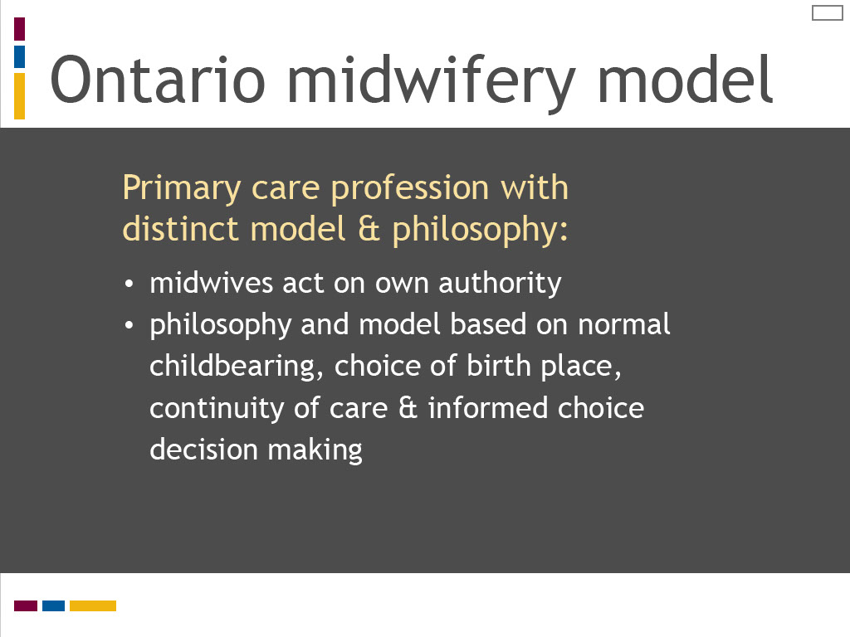
Slide notes
The pre-eminent sources for defining midwifery as a primary care profession in Ontario come from the College of Midwives of Ontario.
The CMO website lists legislation, regulations, and practice standards and guidelines that establish a regulatory framework for Ontario midwifery as a primary care profession.
(If you are not familiar with the website of the College of Midwives of Ontario, you may want to take a moment to pause this presentation
and open your web browser to explore the CMO website to become familiar with its format and content.)
The explicit purpose of the CMO standard “The Ontario Midwifery Model of Care” is to define the model of care provided by Ontario midwives.
It opens by defining who a midwife is using the 2011 International Definition of a Midwife,
and acknowledging support for this definition from the Canadian Association of Midwives and the Canadian Midwifery Regulators Consortium.
It defines the midwifery scope of practice by referring to the Ontario Midwifery Act of 1991.
This standard clearly identifies midwives as primary care providers who “act on their own authority” in its overview of the Ontario midwifery model of care.
. It also details a midwifery philosophy of care, which reflects key principles of primary care and primary health care
such as support for normal childbearing, choice of birth place, continuity of care provider, and informed choice decision making by the client.
The Ontario Midwifery Act sets the parameters for the midwifery scope of practice together with the overarching legislation for Ontario health professionals, the Regulated Health Professions Act.
This legislation defines the regulatory responsibilities for the College of Midwives of Ontario in its role of protecting the public,
as well as the details for what health care procedures midwives can perform.
By law, midwifery in Ontario is defined as a self-regulating profession, which means it is an autonomous profession with the legislative power to govern itself within the parameters of the law.
The Midwifery Act defines the midwifery scope of practice as encompassing the assessment and monitoring of childbearing women in pregnancy, labour, birth and the postpartum period, together with their newborns, in “normal” situations.
The Midwifery Act also specifies which health care procedures, or “authorized acts,” midwives may perform as defined in law.
The Ontario Midwifery Act assumes midwives are fully responsible and accountable for their scope of practice and authorized acts.

The International Definition of the Midwife was created in the early 1970s to establish a consistent vision for midwifery,
despite international variation in models of regulation, practice and education.
It is regularly reviewed and updated by the International Confederation of Midwives.
The 2011 definition highlights midwives’ professional responsibility and competence as educated, recognized professionals.
It defines the midwifery scope of practice as focused on normal childbearing with a client-centred model of care in community and hospital settings.
What is particularly striking about the International Definition is that it incorporates key features of primary health care,
including preventive health care, health promotion, and health counselling and education.
It envisions the midwife’s role in these areas as extending beyond the individual to encompass the family and the community.
The other significant feature of the International Definition is that it recognizes the midwifery scope of practice may extend to women’s health, sexual or reproductive health, and child care.
What is particularly striking about this appendix is the number of definitions that are listed.
The Council identifies 15 distinct definitions for primary health care in use in Canada at the federal, provincial and territorial levels.
It also lists 14 “other” prominent definitions used by professional and public policy organizations, both nationally and internationally.
Although these definitions may not be fully up to date given the report was published in 2005,
this four page appendix provides a dramatic statement of the diversity and complexity of primary health care.
We can conclude that rather than having a single definition, primary health care is a multi-faceted concept.
Take a moment to reflect further on this table of definitions using the questions listed on this screen.
In our quest to uncover the meanings of primary care and primary health care, I would next like you to review “Primary health care: a background paper.”
This paper was published in 2005 by the Health Council of Canada, an independent, non-profit organization
established in 2003 as part of the First Ministers' Accord on Health Care Renewal.
Its role was to report on national health care reform and disseminate information on best practices and innovation in Canadian health care.
While the Council ceased operation in 2014, its website and publications remain archived on the web.
Select the reading icon to access the Health Council report.
Review “Definitions of Primary Health Care,” Appendix 1 on pages 24 to 27 and reflect on the questions listed on this screen.
To understand more about the meanings of primary care and primary health care, I would like you to review the article
“Primary care versus primary health care: what is the difference?” published in the Canadian Journal of Public Health in 2006.
In this article, the authors analyze a series of Canadian and international definitions to define and compare primary care and primary health care.
Select the reading icon to access this article. While reviewing the article, reflect on the questions listed on this screen.
I would like to highlight several strategies that may help you to learn and practice clinical reasoning.
The first strategy relates to the skills of observation and listening.
These are two essential tools in the clinical reasoning process, which can sometimes be overlooked in favour of technological or clinical procedures.
The Yale University School of Nursing has created an innovative program for nursing students
that links the skills of observation and listening to problem-solving and assessment.
In the “Looking Is Not Seeing and Listening Is Not Hearing” program,
students study art appreciation at the Yale Centre for British Art and sound at the Yale School of Music
to sharpen their observation and listening skills as preparation for clinical assessment.
This program is described in the Yale School of Nursing and Alumni Association publication Yale Nursing Matters.
To read more about this program and understand how you can use sound and art to sharpen your observation and listening skills,
link to this publication by selecting the additional reading icon.
Text Captions

Ontario midwifery model

Primary care profession with distinct model & philosophy:
- midwives act on own authority
- philosophy and model based on normal childbearing, choice of birth place, continuity of care & informed choice decision making

Slide 20 - Association of Ontario Midwives
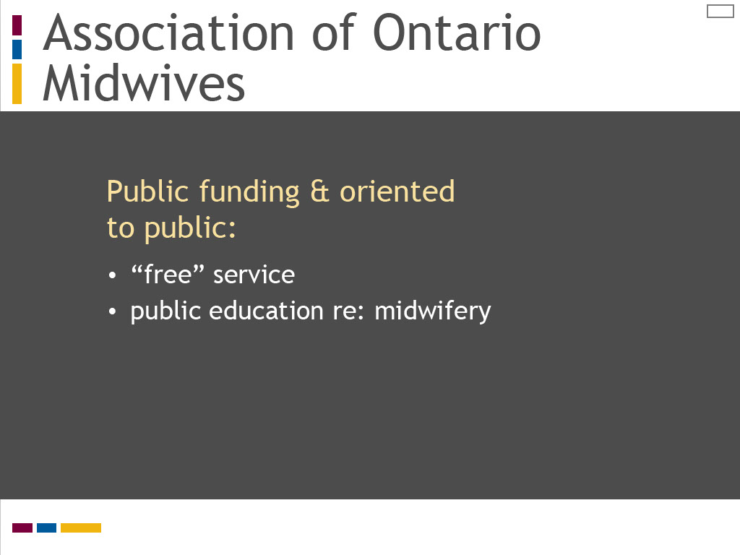
Slide notes
The Association of Ontario Midwives, the professional organization for Ontario midwifery, has two websites, one designed for the public and the other for midwife members.
These websites also describe the meaning of midwifery as a primary care profession in Ontario.
The web page describing what a midwife is on the AOM’s public website notes midwifery services are “free,” meaning they are publicly funded by the Ontario government.
It also provides information for prospective clients about the nature of midwifery as a primary care profession.
This web page includes an interactive quiz about Ontario midwifery and a link to client testimonials, both of which highlight midwives’ role and responsibilities as primary care providers.
The pre-eminent sources for defining midwifery as a primary care profession in Ontario come from the College of Midwives of Ontario.
The CMO website lists legislation, regulations, and practice standards and guidelines that establish a regulatory framework for Ontario midwifery as a primary care profession.
(If you are not familiar with the website of the College of Midwives of Ontario, you may want to take a moment to pause this presentation
and open your web browser to explore the CMO website to become familiar with its format and content.)
The explicit purpose of the CMO standard “The Ontario Midwifery Model of Care” is to define the model of care provided by Ontario midwives.
It opens by defining who a midwife is using the 2011 International Definition of a Midwife,
and acknowledging support for this definition from the Canadian Association of Midwives and the Canadian Midwifery Regulators Consortium.
It defines the midwifery scope of practice by referring to the Ontario Midwifery Act of 1991.
This standard clearly identifies midwives as primary care providers who “act on their own authority” in its overview of the Ontario midwifery model of care.
. It also details a midwifery philosophy of care, which reflects key principles of primary care and primary health care
such as support for normal childbearing, choice of birth place, continuity of care provider, and informed choice decision making by the client.
The Ontario Midwifery Act sets the parameters for the midwifery scope of practice together with the overarching legislation for Ontario health professionals, the Regulated Health Professions Act.
This legislation defines the regulatory responsibilities for the College of Midwives of Ontario in its role of protecting the public,
as well as the details for what health care procedures midwives can perform.
By law, midwifery in Ontario is defined as a self-regulating profession, which means it is an autonomous profession with the legislative power to govern itself within the parameters of the law.
The Midwifery Act defines the midwifery scope of practice as encompassing the assessment and monitoring of childbearing women in pregnancy, labour, birth and the postpartum period, together with their newborns, in “normal” situations.
The Midwifery Act also specifies which health care procedures, or “authorized acts,” midwives may perform as defined in law.
The Ontario Midwifery Act assumes midwives are fully responsible and accountable for their scope of practice and authorized acts.

The International Definition of the Midwife was created in the early 1970s to establish a consistent vision for midwifery,
despite international variation in models of regulation, practice and education.
It is regularly reviewed and updated by the International Confederation of Midwives.
The 2011 definition highlights midwives’ professional responsibility and competence as educated, recognized professionals.
It defines the midwifery scope of practice as focused on normal childbearing with a client-centred model of care in community and hospital settings.
What is particularly striking about the International Definition is that it incorporates key features of primary health care,
including preventive health care, health promotion, and health counselling and education.
It envisions the midwife’s role in these areas as extending beyond the individual to encompass the family and the community.
The other significant feature of the International Definition is that it recognizes the midwifery scope of practice may extend to women’s health, sexual or reproductive health, and child care.
What is particularly striking about this appendix is the number of definitions that are listed.
The Council identifies 15 distinct definitions for primary health care in use in Canada at the federal, provincial and territorial levels.
It also lists 14 “other” prominent definitions used by professional and public policy organizations, both nationally and internationally.
Although these definitions may not be fully up to date given the report was published in 2005,
this four page appendix provides a dramatic statement of the diversity and complexity of primary health care.
We can conclude that rather than having a single definition, primary health care is a multi-faceted concept.
Take a moment to reflect further on this table of definitions using the questions listed on this screen.
In our quest to uncover the meanings of primary care and primary health care, I would next like you to review “Primary health care: a background paper.”
This paper was published in 2005 by the Health Council of Canada, an independent, non-profit organization
established in 2003 as part of the First Ministers' Accord on Health Care Renewal.
Its role was to report on national health care reform and disseminate information on best practices and innovation in Canadian health care.
While the Council ceased operation in 2014, its website and publications remain archived on the web.
Select the reading icon to access the Health Council report.
Review “Definitions of Primary Health Care,” Appendix 1 on pages 24 to 27 and reflect on the questions listed on this screen.
To understand more about the meanings of primary care and primary health care, I would like you to review the article
“Primary care versus primary health care: what is the difference?” published in the Canadian Journal of Public Health in 2006.
In this article, the authors analyze a series of Canadian and international definitions to define and compare primary care and primary health care.
Select the reading icon to access this article. While reviewing the article, reflect on the questions listed on this screen.
I would like to highlight several strategies that may help you to learn and practice clinical reasoning.
The first strategy relates to the skills of observation and listening.
These are two essential tools in the clinical reasoning process, which can sometimes be overlooked in favour of technological or clinical procedures.
The Yale University School of Nursing has created an innovative program for nursing students
that links the skills of observation and listening to problem-solving and assessment.
In the “Looking Is Not Seeing and Listening Is Not Hearing” program,
students study art appreciation at the Yale Centre for British Art and sound at the Yale School of Music
to sharpen their observation and listening skills as preparation for clinical assessment.
This program is described in the Yale School of Nursing and Alumni Association publication Yale Nursing Matters.
To read more about this program and understand how you can use sound and art to sharpen your observation and listening skills,
link to this publication by selecting the additional reading icon.
Text Captions

Association of Ontario Midwives

Public funding & oriented to public:
- “free” service
- public education re: midwifery

Slide 21 - Primary care in midwifery
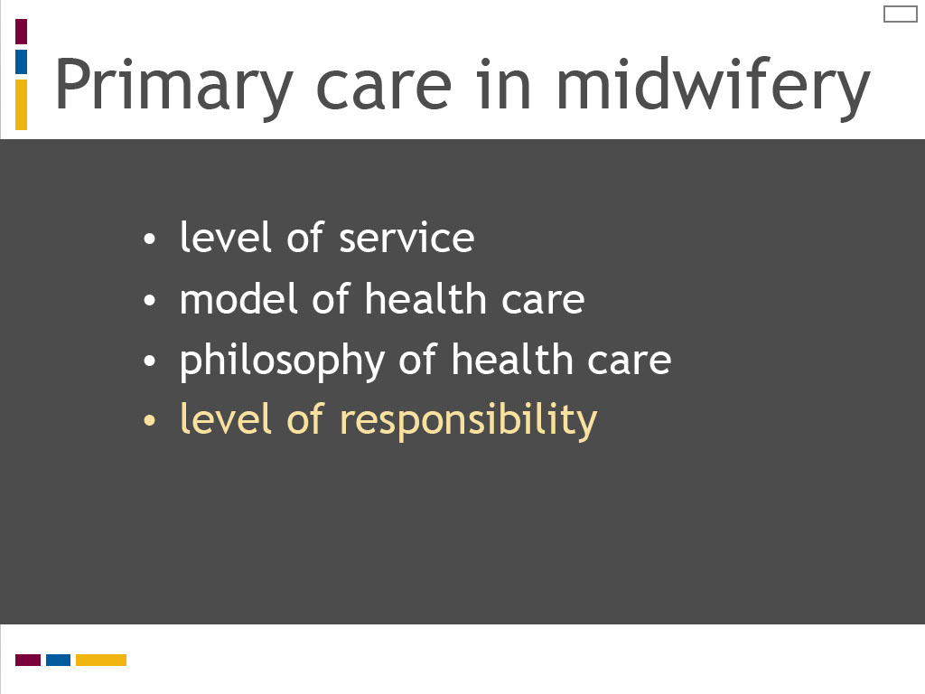
Slide notes
Our review of primary midwifery care adds another significant element for defining primary care.
The concepts of professional accountability, responsibility and autonomy cross the midwifery sources examined in this lesson.
"Level of responsibility” can therefore be added as a defining feature of primary care,
in addition to the level, model and philosophy of health services for individuals, communities and societies.
We will explore the clinical practice of primary midwifery care and strategies to learn this role and responsibility in the third and final lesson of this module, “Primary Care in Action.”
The Association of Ontario Midwives, the professional organization for Ontario midwifery, has two websites, one designed for the public and the other for midwife members.
These websites also describe the meaning of midwifery as a primary care profession in Ontario.
The web page describing what a midwife is on the AOM’s public website notes midwifery services are “free,” meaning they are publicly funded by the Ontario government.
It also provides information for prospective clients about the nature of midwifery as a primary care profession.
This web page includes an interactive quiz about Ontario midwifery and a link to client testimonials, both of which highlight midwives’ role and responsibilities as primary care providers.
The pre-eminent sources for defining midwifery as a primary care profession in Ontario come from the College of Midwives of Ontario.
The CMO website lists legislation, regulations, and practice standards and guidelines that establish a regulatory framework for Ontario midwifery as a primary care profession.
(If you are not familiar with the website of the College of Midwives of Ontario, you may want to take a moment to pause this presentation
and open your web browser to explore the CMO website to become familiar with its format and content.)
The explicit purpose of the CMO standard “The Ontario Midwifery Model of Care” is to define the model of care provided by Ontario midwives.
It opens by defining who a midwife is using the 2011 International Definition of a Midwife,
and acknowledging support for this definition from the Canadian Association of Midwives and the Canadian Midwifery Regulators Consortium.
It defines the midwifery scope of practice by referring to the Ontario Midwifery Act of 1991.
This standard clearly identifies midwives as primary care providers who “act on their own authority” in its overview of the Ontario midwifery model of care.
. It also details a midwifery philosophy of care, which reflects key principles of primary care and primary health care
such as support for normal childbearing, choice of birth place, continuity of care provider, and informed choice decision making by the client.
The Ontario Midwifery Act sets the parameters for the midwifery scope of practice together with the overarching legislation for Ontario health professionals, the Regulated Health Professions Act.
This legislation defines the regulatory responsibilities for the College of Midwives of Ontario in its role of protecting the public,
as well as the details for what health care procedures midwives can perform.
By law, midwifery in Ontario is defined as a self-regulating profession, which means it is an autonomous profession with the legislative power to govern itself within the parameters of the law.
The Midwifery Act defines the midwifery scope of practice as encompassing the assessment and monitoring of childbearing women in pregnancy, labour, birth and the postpartum period, together with their newborns, in “normal” situations.
The Midwifery Act also specifies which health care procedures, or “authorized acts,” midwives may perform as defined in law.
The Ontario Midwifery Act assumes midwives are fully responsible and accountable for their scope of practice and authorized acts.

The International Definition of the Midwife was created in the early 1970s to establish a consistent vision for midwifery,
despite international variation in models of regulation, practice and education.
It is regularly reviewed and updated by the International Confederation of Midwives.
The 2011 definition highlights midwives’ professional responsibility and competence as educated, recognized professionals.
It defines the midwifery scope of practice as focused on normal childbearing with a client-centred model of care in community and hospital settings.
What is particularly striking about the International Definition is that it incorporates key features of primary health care,
including preventive health care, health promotion, and health counselling and education.
It envisions the midwife’s role in these areas as extending beyond the individual to encompass the family and the community.
The other significant feature of the International Definition is that it recognizes the midwifery scope of practice may extend to women’s health, sexual or reproductive health, and child care.
What is particularly striking about this appendix is the number of definitions that are listed.
The Council identifies 15 distinct definitions for primary health care in use in Canada at the federal, provincial and territorial levels.
It also lists 14 “other” prominent definitions used by professional and public policy organizations, both nationally and internationally.
Although these definitions may not be fully up to date given the report was published in 2005,
this four page appendix provides a dramatic statement of the diversity and complexity of primary health care.
We can conclude that rather than having a single definition, primary health care is a multi-faceted concept.
Take a moment to reflect further on this table of definitions using the questions listed on this screen.
In our quest to uncover the meanings of primary care and primary health care, I would next like you to review “Primary health care: a background paper.”
This paper was published in 2005 by the Health Council of Canada, an independent, non-profit organization
established in 2003 as part of the First Ministers' Accord on Health Care Renewal.
Its role was to report on national health care reform and disseminate information on best practices and innovation in Canadian health care.
While the Council ceased operation in 2014, its website and publications remain archived on the web.
Select the reading icon to access the Health Council report.
Review “Definitions of Primary Health Care,” Appendix 1 on pages 24 to 27 and reflect on the questions listed on this screen.
To understand more about the meanings of primary care and primary health care, I would like you to review the article
“Primary care versus primary health care: what is the difference?” published in the Canadian Journal of Public Health in 2006.
In this article, the authors analyze a series of Canadian and international definitions to define and compare primary care and primary health care.
Select the reading icon to access this article. While reviewing the article, reflect on the questions listed on this screen.
I would like to highlight several strategies that may help you to learn and practice clinical reasoning.
The first strategy relates to the skills of observation and listening.
These are two essential tools in the clinical reasoning process, which can sometimes be overlooked in favour of technological or clinical procedures.
The Yale University School of Nursing has created an innovative program for nursing students
that links the skills of observation and listening to problem-solving and assessment.
In the “Looking Is Not Seeing and Listening Is Not Hearing” program,
students study art appreciation at the Yale Centre for British Art and sound at the Yale School of Music
to sharpen their observation and listening skills as preparation for clinical assessment.
This program is described in the Yale School of Nursing and Alumni Association publication Yale Nursing Matters.
To read more about this program and understand how you can use sound and art to sharpen your observation and listening skills,
link to this publication by selecting the additional reading icon.
Text Captions

Primary care in midwifery
- level of service
- model of health care
- philosophy of health care
- level of responsibility

Slide 22 - Defining Ontario midwifery
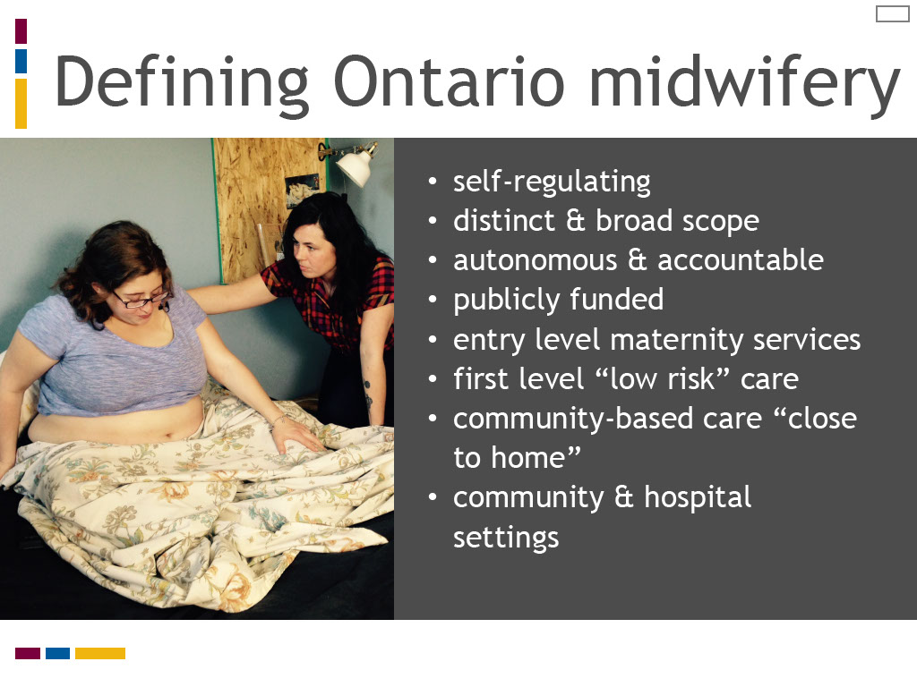
Slide notes
This screen and the following one list key features that define Ontario midwifery are as a primary care profession.
Take a moment to review these features and reflect on how each one translates into clinical practice.
You will also find the activity icon on the next screen where you can access a completed chart for the scavenger hunt activity, which you can then compare to yours.

An activity is provided for you to explore how the international, national and provincial midwifery organizations and documents listed on this screen define midwifery as a primary care profession.
Select the activity icon to access the instructions, web links and tools to do a scavenger hunt for defining primary midwifery care.
You will link to six documents or websites and match how they describe midwifery to a chart listing features of primary care and primary health care.
When you have completed the activity, you are asked to review your chart and summarize how midwifery is defined as a primary care profession.
We will then review the significant contribution of each resource.

Text Captions

Defining Ontario midwifery
- self-regulating
- distinct & broad scope
- autonomous & accountable
- publicly funded
- entry level maternity services
- first level “low risk” care
- community-based care “close to home”
- community & hospital settings

Slide 23 - Defining Ontario midwifery
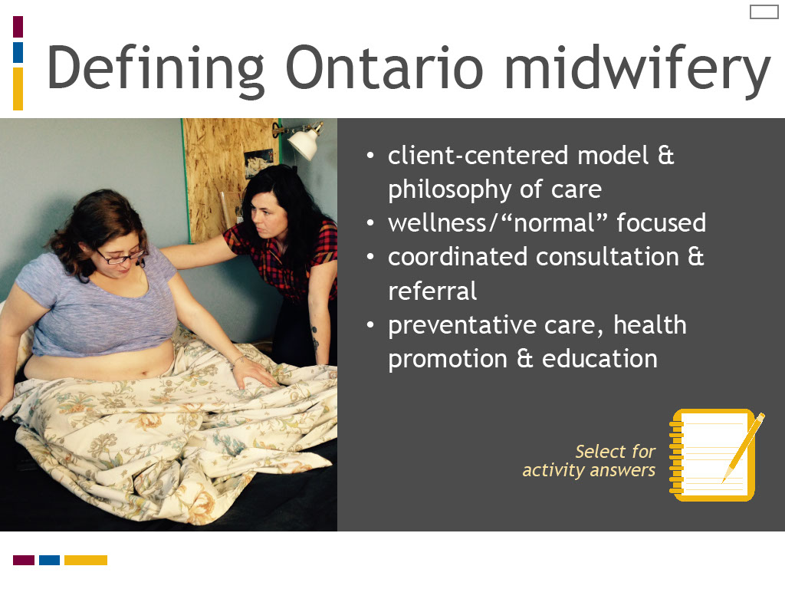
Slide notes
An activity is provided for you to explore how the international, national and provincial midwifery organizations and documents listed on this screen define midwifery as a primary care profession.
Select the activity icon to access the instructions, web links and tools to do a scavenger hunt for defining primary midwifery care.
You will link to six documents or websites and match how they describe midwifery to a chart listing features of primary care and primary health care.
When you have completed the activity, you are asked to review your chart and summarize how midwifery is defined as a primary care profession.
We will then review the significant contribution of each resource.

Text Captions

Defining Ontario midwifery
- client-centered model & philosophy of care
- wellness/“normal” focused
- coordinated consultation & referral
- preventative care, health promotion & education

Select for activity answers

Slide 24 - Meanings of primary care
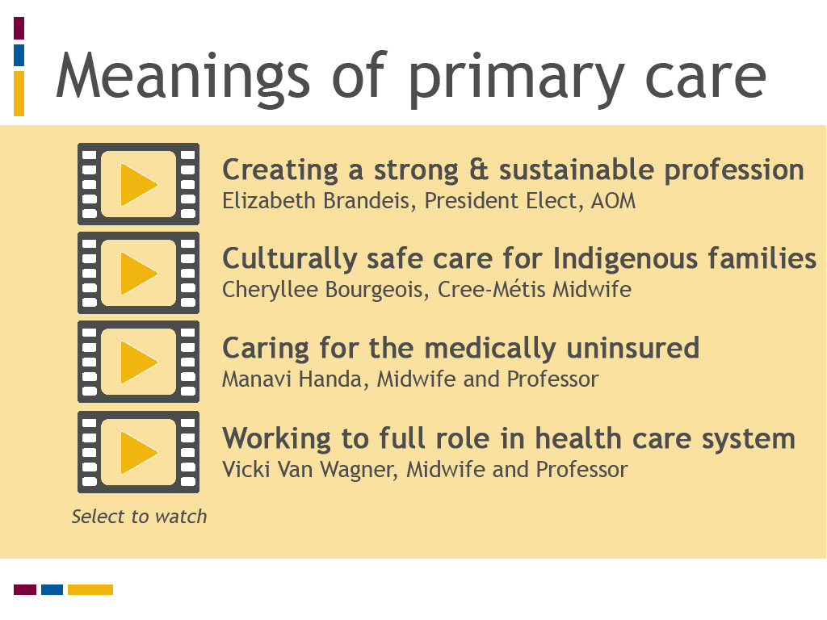
Slide notes
View or listen to these videos to learn what Ontario midwives, who are also teachers in the Midwifery Education Program,
want to share with you about what primary midwifery care means in their work as midwives, for their clients, and for the profession.
As you review these videos, consider the following questions:
What is your understanding of what primary care means to the midwives in these videos?
What do you think having a midwife who is a primary care provider means to midwifery clients?
How does midwifery’s primary care status impact the profession?
And what does being a primary care provider mean to you?
Text Captions

Meanings of primary care

Select to watch

Creating a strong & sustainable profession
Elizabeth Brandeis, President Elect, AOM

Culturally safe care for Indigenous families
Cheryllee Bourgeois, Cree-Métis Midwife

Caring for the medically uninsured
Manavi Handa, Midwife and Professor

Working to full role in health care system
Vicki Van Wagner, Midwife and Professor

Slide 25 - Key messages
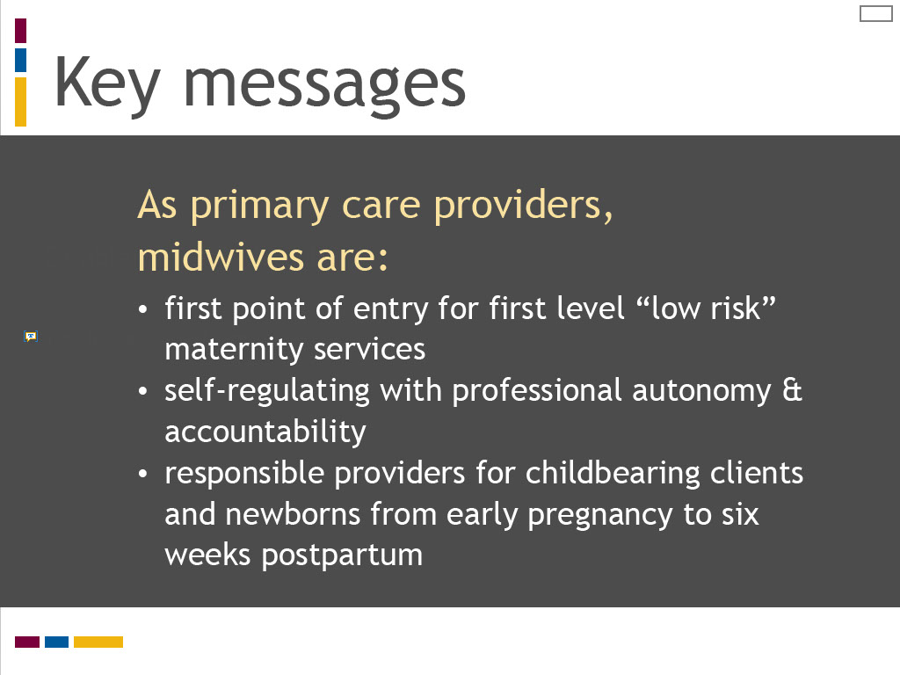
Slide notes
Here are the key messages for this lesson, “Defining Primary Midwifery Care.”
As primary care providers, Ontario midwives provide a first point of entry to the health care system for “low risk” maternity care services.
Midwives are self-regulating professionals with professional autonomy and accountability for their actions.
They are the most responsible care providers for childbearing clients and their newborns, from early pregnancy to six weeks postpartum.

Primary care and primary health care are distinct concepts with multi-layered and diverse meanings, yet they are often used interchangeably.

Primary care providers are typically identified as family physicians in health policy, research literature, and practice.

We should also acknowledge the College of Midwives of Ontario defines midwives as primary care providers,

which we will explore further in Lesson 2 of this module.
Now take the opportunity to test your knowledge from this lesson.

Here are the key messages for this lesson:

Primary care refers to first level services for individuals at the entry point to the health care system.

Primary health care refers to a model for first level services and care based on public health policies and principles.

Although each of the definitions listed in the Health Council report provides a distinct interpretation of primary health care, one central idea is evident.
The word “first” is typically used to describe the level of care, a word that is synonymous with primary.
“First level” is used in two ways. It is used to refer to the point of contact between individuals and the health care system.
It is also used to refer to the lowest level of care in a hierarchy of disease and medical specialization.
In this way, primary health care is interpreted as entry level care for normal conditions
or those with low level complexity that precede referral to specialized care or services.
The second common theme among these definitions is the recognition that primary health care extends beyond individual health care services
to encompass structural level policies and services related to population-based determinants of health.
As you likely noticed, the nature and scope of these population-based factors varies widely across these definitions.
The key message from this reading is that primary health care is defined in many different ways, even within the context of a single country like Canada.
It is used to refer to individual health care services and it may also include population health factors.
The distinction between primary care and primary health care is not clearly stated in this reading,
however some of the definitions refer to primary care being a component of primary health care.
This is consistent with Muldoon, Hogg and Levitt’s analysis that primary care and primary health care are often used interchangeably.
The learning outcomes for this lesson are summarized on the screen. Take a moment to review these before proceeding.
The learning outcomes for this lesson are summarized on the screen.
Take a moment to review these and proceed when you are ready.

Text Captions

Double click to add subtitle

Key messages

As primary care providers, midwives are:
- first point of entry for first level “low risk” maternity services
- self-regulating with professional autonomy & accountability
- responsible providers for childbearing clients and newborns from early pregnancy to six weeks postpartum

Slide 26 - Key messages
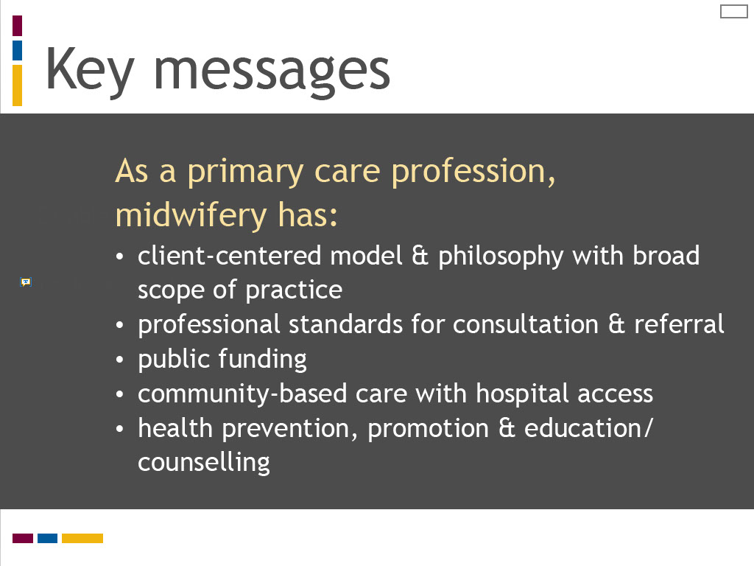
Slide notes
The Ontario midwifery profession has a distinct client-centred model and philosophy of care with a broad scope of practice defined by the Ontario Midwifery Act.
Midwives access and coordinate consultation and referral as indicated by their professional standards, clinical judgement, and client choice.
Ontario midwifery is publicly funded. Midwifery care is based in the community with access to hospital care,

and it encompasses preventative health care, health promotion, and education and counselling.
Now take the opportunity to test your knowledge from this lesson.

Here are the key messages for this lesson, “Defining Primary Midwifery Care.”
As primary care providers, Ontario midwives provide a first point of entry to the health care system for “low risk” maternity care services.
Midwives are self-regulating professionals with professional autonomy and accountability for their actions.
They are the most responsible care providers for childbearing clients and their newborns, from early pregnancy to six weeks postpartum.

Primary care and primary health care are distinct concepts with multi-layered and diverse meanings, yet they are often used interchangeably.

Primary care providers are typically identified as family physicians in health policy, research literature, and practice.

We should also acknowledge the College of Midwives of Ontario defines midwives as primary care providers,

which we will explore further in Lesson 2 of this module.
Now take the opportunity to test your knowledge from this lesson.

Here are the key messages for this lesson:

Primary care refers to first level services for individuals at the entry point to the health care system.

Primary health care refers to a model for first level services and care based on public health policies and principles.

Although each of the definitions listed in the Health Council report provides a distinct interpretation of primary health care, one central idea is evident.
The word “first” is typically used to describe the level of care, a word that is synonymous with primary.
“First level” is used in two ways. It is used to refer to the point of contact between individuals and the health care system.
It is also used to refer to the lowest level of care in a hierarchy of disease and medical specialization.
In this way, primary health care is interpreted as entry level care for normal conditions
or those with low level complexity that precede referral to specialized care or services.
The second common theme among these definitions is the recognition that primary health care extends beyond individual health care services
to encompass structural level policies and services related to population-based determinants of health.
As you likely noticed, the nature and scope of these population-based factors varies widely across these definitions.
The key message from this reading is that primary health care is defined in many different ways, even within the context of a single country like Canada.
It is used to refer to individual health care services and it may also include population health factors.
The distinction between primary care and primary health care is not clearly stated in this reading,
however some of the definitions refer to primary care being a component of primary health care.
This is consistent with Muldoon, Hogg and Levitt’s analysis that primary care and primary health care are often used interchangeably.
The learning outcomes for this lesson are summarized on the screen. Take a moment to review these before proceeding.
The learning outcomes for this lesson are summarized on the screen.
Take a moment to review these and proceed when you are ready.

Text Captions

Double click to add subtitle

Key messages

As a primary care profession, midwifery has:

- client-centered model & philosophy with broad scope of practice
- professional standards for consultation & referral
- public funding
- community-based care with hospital access
- health prevention, promotion & education/ counselling

Slide 27 - Test your knowledge!
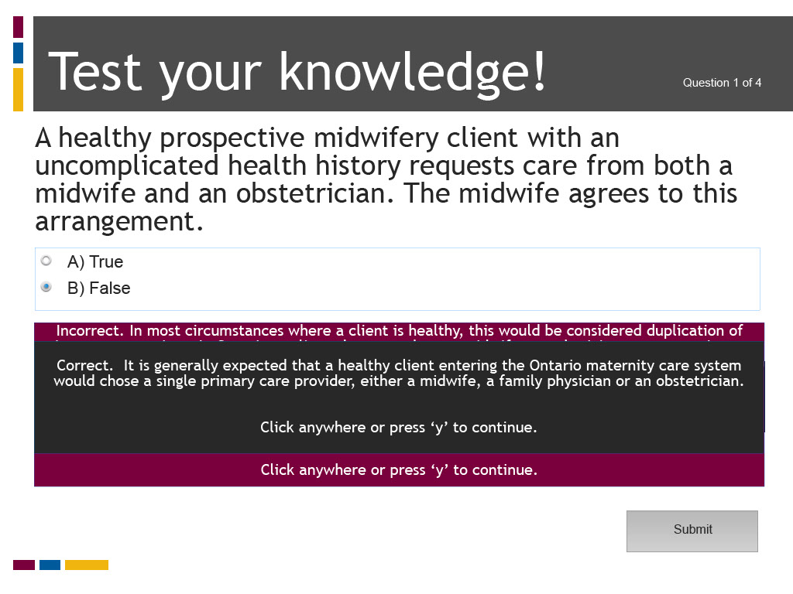
Slide notes
Text Captions

Test your knowledge!

A healthy prospective midwifery client with an uncomplicated health history requests care from both a midwife and an obstetrician. The midwife agrees to this arrangement.

A) True

B) False

Question 1 of 4

The correct answer is B) False. In most circumstances where a client is healthy, this would be considered duplication of primary care services. In Ontario, a client chooses to have a midwife or a physician as a maternity care provider. There are exceptions where a midwife is approved by the College of Midwives of Ontario for an “alternate practice arrangement” to share care with another regulated health professional, for example in a rural community where there are limited health human resources. A client may also be cared for by both a midwife and physician following referral where the midwife is in a supportive care role and the physician is the primary care provider or, on occasion, when the midwife shares primary care with the physician.

Slide 28 - Test your knowledge!
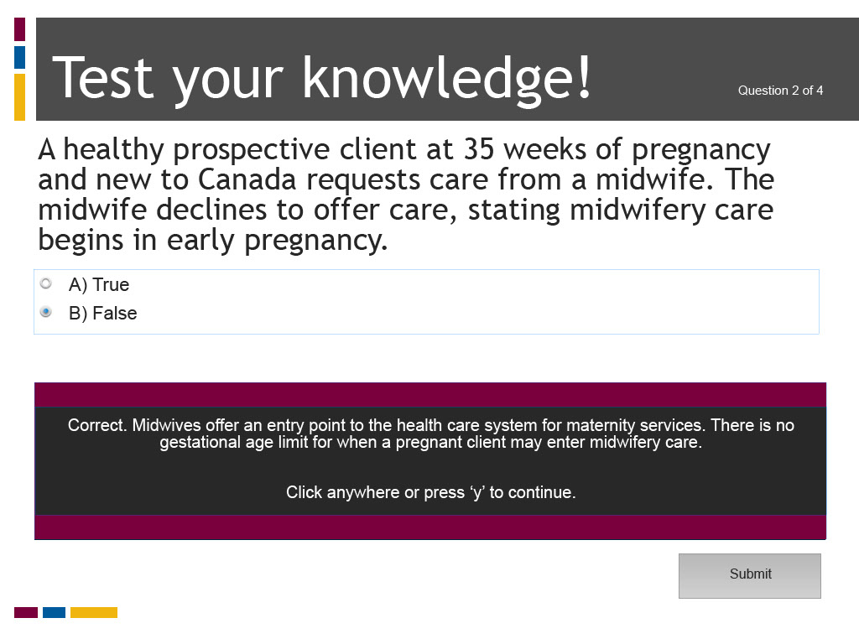
Slide notes
Text Captions

Test your knowledge!

A healthy prospective client at 35 weeks of pregnancy and new to Canada requests care from a midwife. The midwife declines to offer care, stating midwifery care begins in early pregnancy.

A) True

B) False

Question 2 of 4

The correct answer is False. Midwives offer an entry point to the health care system for maternity services. Their scope of practice allows them to care for childbearing persons beginning in early pregnancy, but there is no gestational age limit for when a pregnant client may enter midwifery care.

Slide 29 - Test your knowledge!
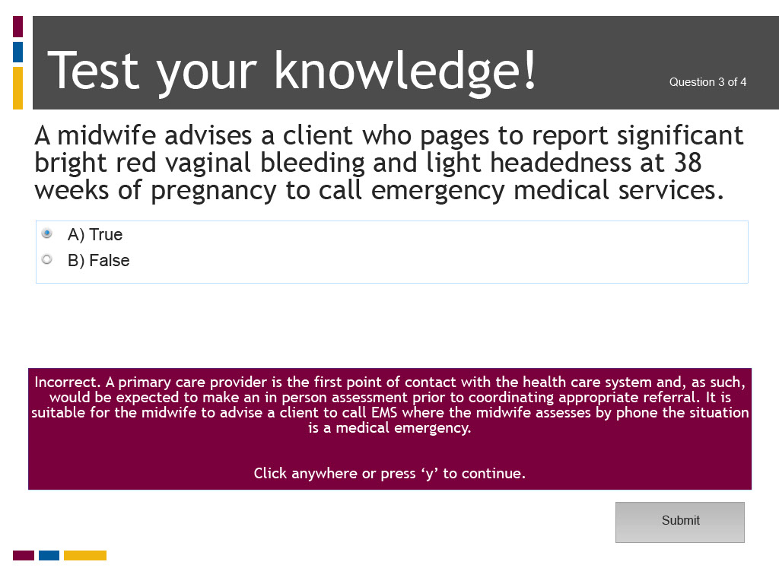
Slide notes
Text Captions

Test your knowledge!

A midwife advises a client who pages to report significant bright red vaginal bleeding and light headedness at 38 weeks of pregnancy to call emergency medical services.

A) True

B) False

Question 3 of 4

The correct answer is True. A primary care provider is the first point of contact with the health care system and, as such, would be expected to make an in person assessment prior to coordinating appropriate referral. It is suitable for the midwife to advise a client to call EMS where the midwife assesses by phone the situation is a medical emergency.

Slide 30 - Test your knowledge!
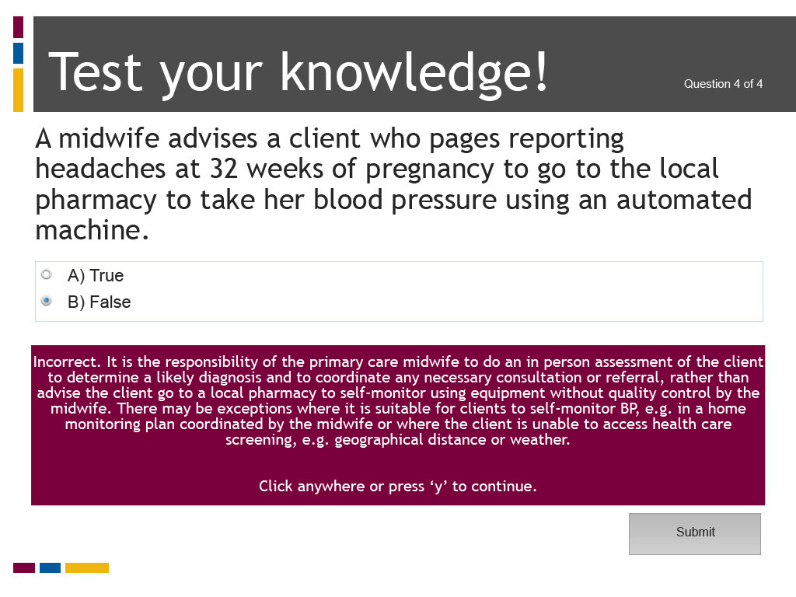
Slide notes
Text Captions

Test your knowledge!

A midwife advises a client who pages reporting headaches at 32 weeks of pregnancy to go to the local pharmacy to take her blood pressure using an automated machine.

A) True

B) False

Question 4 of 4

The correct answer is False. The midwife’s scope of practice encompasses assessment and monitoring of pregnant clients and their newborns and providing care for normal childbearing. Where a client pages with signs or symptoms that may signal a complex condition, the midwife is responsible to do an in person assessment to determine a likely diagnosis and to coordinate consultation and referral according to professional standards of practice if the findings fall outside normal.

It is the responsibility of the primary care midwife to do an in person assessment of the client to determine a likely diagnosis and to coordinate any necessary consultation or referral, rather than advise the client go to a local pharmacy to self-monitor using equipment without quality control by the midwife. There may be exceptions where it is suitable for clients to self-monitor BP, e.g. in a home monitoring plan coordinated by the midwife or where the client is unable to access health care screening, e.g. geographical distance or weather.

Slide 31 - Quiz Results

Slide notes
Text Captions

Quiz Results

Slide 32 - References
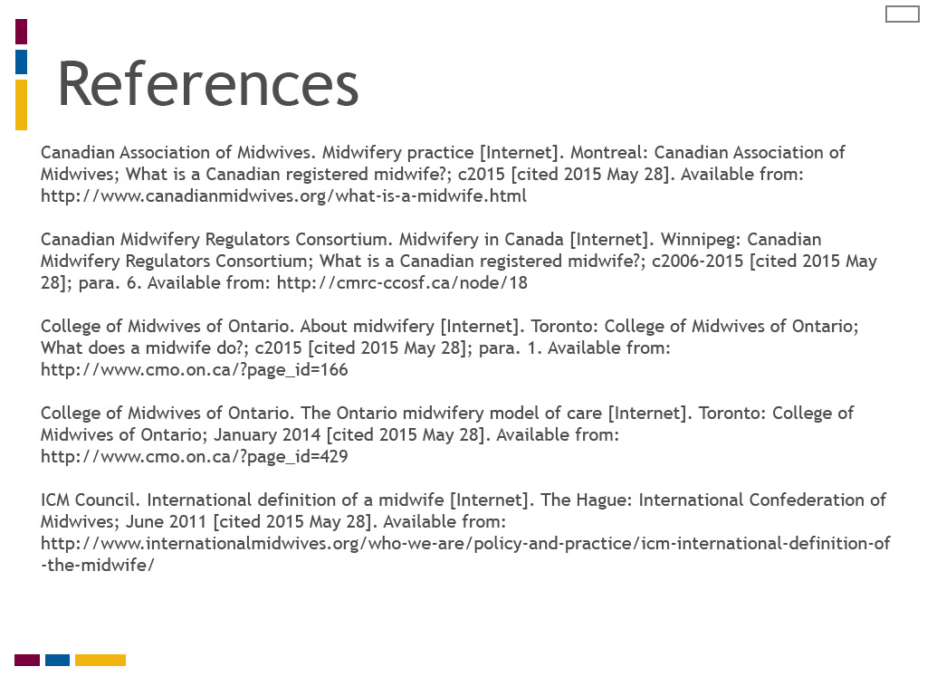
Slide notes
Text Captions

References

Canadian Association of Midwives. Midwifery practice [Internet]. Montreal: Canadian Association of Midwives; What is a Canadian registered midwife?; c2015 [cited 2015 May 28].
Canadian Midwifery Regulators Consortium. Midwifery in Canada [Internet]. Winnipeg: Canadian Midwifery Regulators Consortium; What is a Canadian registered midwife?; c2006-2015 [cited 2015 May 28]; para. 6.
College of Midwives of Ontario. About midwifery [Internet]. Toronto: College of Midwives of Ontario; What does a midwife do?; c2015 [cited 2015 May 28]; para. 1.
College of Midwives of Ontario. The Ontario midwifery model of care [Internet]. Toronto: College of Midwives of Ontario; January 2014 [cited 2015 May 28].
ICM Council. International definition of a midwife [Internet]. The Hague: International Confederation of Midwives; June 2011 [cited 2015 May 28].

Slide 33 - References
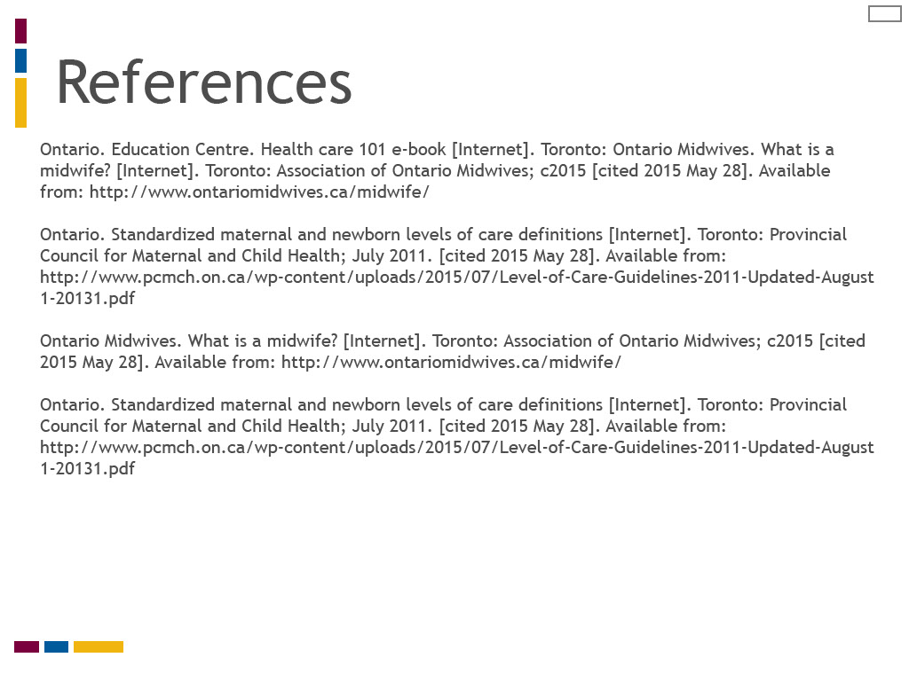
Slide notes
Text Captions

References

Ontario. Education Centre. Health care 101 e-book [Internet]. Toronto: Ontario Midwives. What is a midwife? [Internet]. Toronto: Association of Ontario Midwives; c2015 [cited 2015 May 28].
Ontario. Standardized maternal and newborn levels of care definitions [Internet]. Toronto: Provincial Council for Maternal and Child Health; July 2011. [cited 2015 May 28].
Ontario Midwives. What is a midwife? [Internet]. Toronto: Association of Ontario Midwives; c2015 [cited 2015 May 28].
Ontario. Standardized maternal and newborn levels of care definitions [Internet]. Toronto: Provincial Council for Maternal and Child Health; July 2011. [cited 2015 May 28].

Slide 34 - Credits

Slide notes
Text Captions

Credits

Authors: Elizabeth Allemang, RM, Associate Professor, Midwifery Education Program, Ryerson University

Faculty Collaborators: Liz Darling, RM, Associate Professor, Midwifery Education Program, Laurentian University, and Patty McNiven, RM, Associate Professor, Midwifery Education Program, McMaster University

Collaborating University: Midwifery Education Program, McMaster University

Project Manager: Jenna Robertson, RM

Instructional Design Support: Marybeth Burriss and Vince Cifani, Digital Educational Strategies, G. Raymond Chang School of Continuing Education, Ryerson University

Audio/Video Production: John Hajdu, Multimedia Author/Production Consultant, Digital Media Projects Office, Ryerson University, and Meera Balendran, Student and Alex Basso, Student, New Media, Image Arts, Ryerson University

Graphic Design: Laurie Barnett

Course Development: Lonespark Inc

e-Learning Support: Nancy Walton, Director and Carly Basian, Research Assistant, Office of e-learning, Ryerson University

Video Participants: Elizabeth Brandeis, RM and President Elect, Association of Ontario Midwives, Cheryllee Bourgeois, Cree-Métis RM, Manavi Handa, RM and Assistant Professor, and Vicki Van Wagner, RM and Associate Professor, Midwifery Education Program, Ryerson University

Funding for this project was provided by the Ministry of Training Colleges and Universities (MTCU) 2014-2015 Shared Online Course Fund

Slide 35 - Certificate of Completion
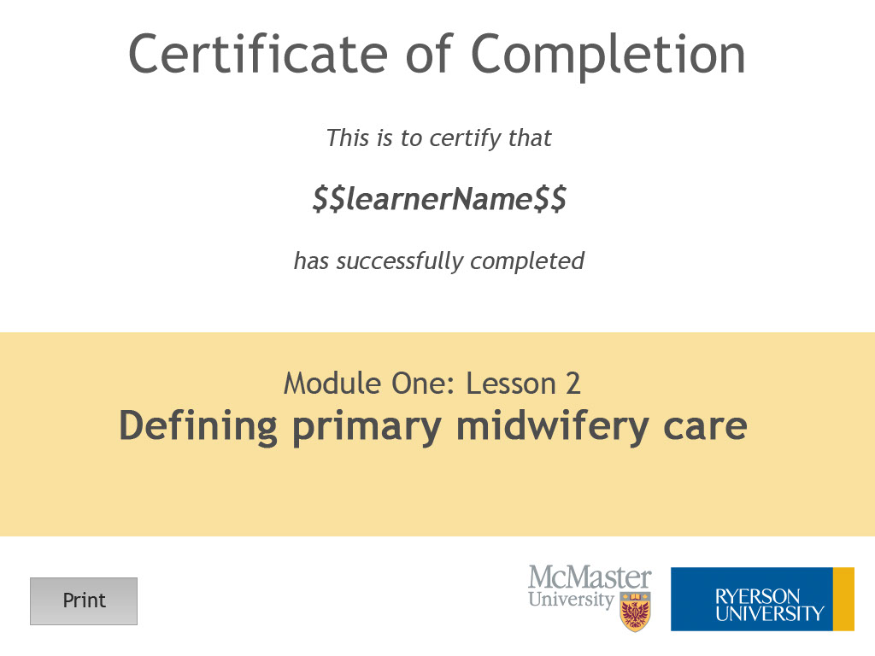
Slide notes
Text Captions

Module One: Lesson 2
Defining primary midwifery care

