The following procedures must be followed each time a lab member visits the lab.

1. BEFORE VISITING LAB

1.1 Book Visit on Google Calendar
Register your visit on Google Calendar for Ryerson KHE Lab (PHYSICS-KHE-240) or iBEST Lab (PHYSICS-LKSKI-DOUPLIK). Note: if you currently do not have Calendar access, email Graham Ferrier (gferrier@ryerson.ca) to request access.

PHYSICS-KHE-240
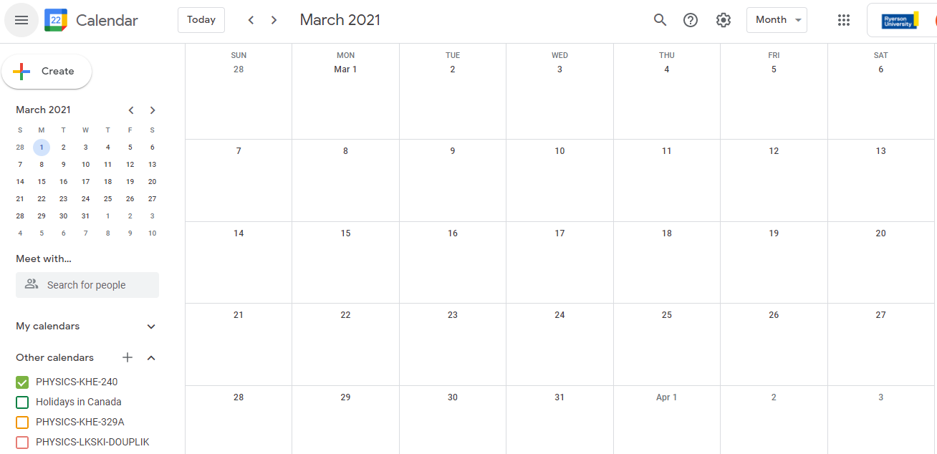

PHYSICS-LKSKI-DOUPLIK
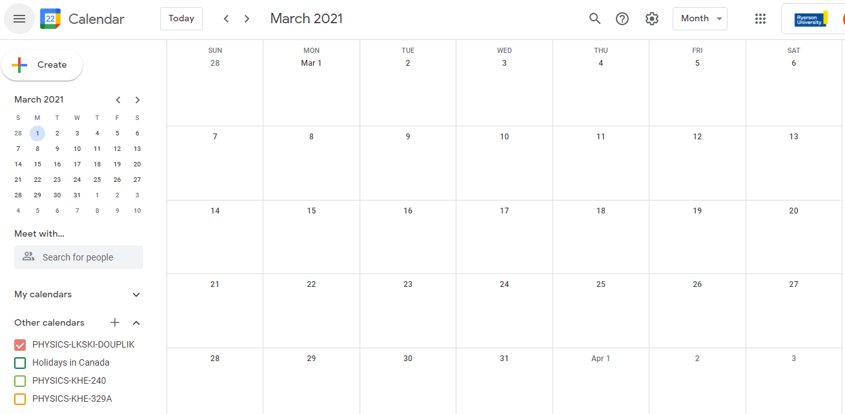
How to book visit on Calendar
- Ensure you select a time slot where there is a 30minute window before and after another member’s booked time
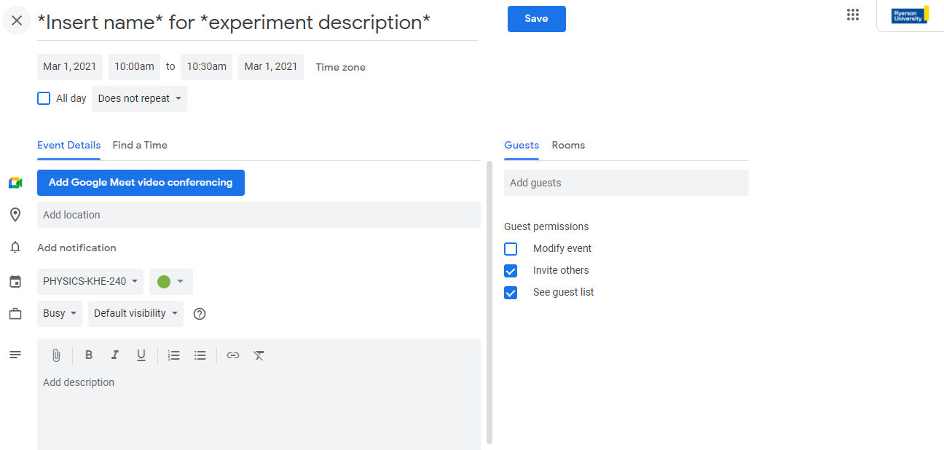

1.2: Complete Health Screening Form for Ryerson employees
If you are considered a Ryerson employee (i.e. research assistant), complete the health screening form before visiting campus each time.

Faculty/Staff Health Screening Form:
https://www.ryerson.ca/covid-19/return-to-campus/health-hygiene/health-screening/

Students (undergraduate, graduate) must review Student Health Screening: https://www.ryerson.ca/covid-19/reporting-covid-19-cases/information-for-students/student-health-screening/

2. DURING LAB VISIT
- Wear a mask in the lab at all times
- Keep 2m distance from others
- Wipe down touched workspaces when finished working

