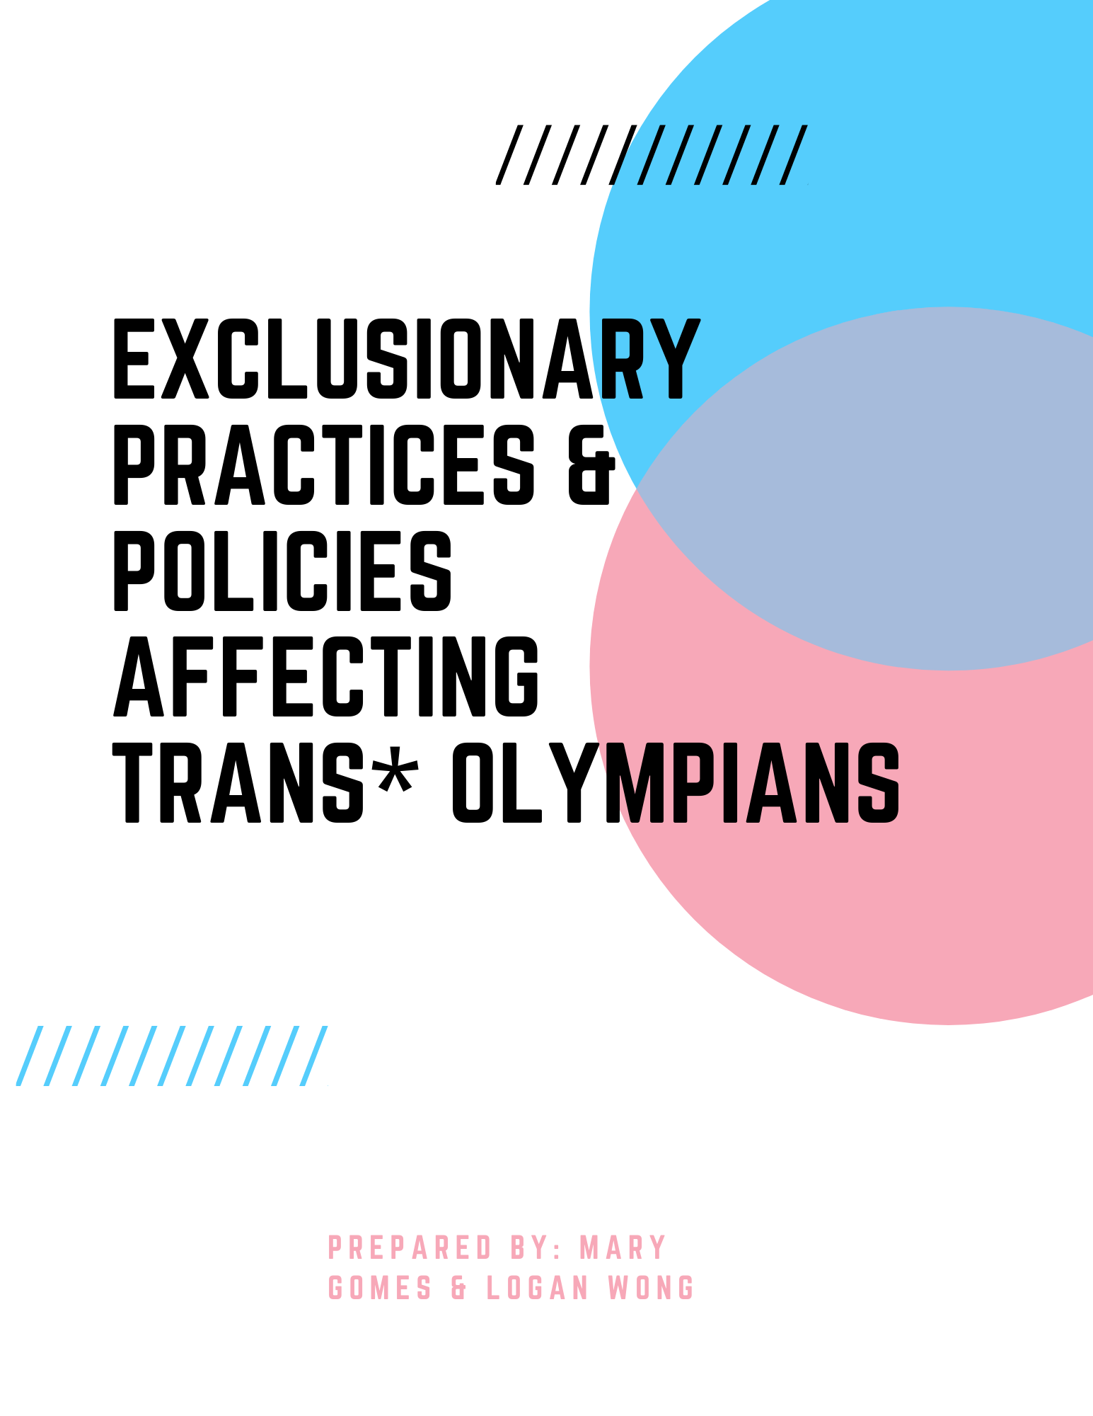

Table of Contents
  - Introduction
  - Defining the Problem ~ Exclusionary Practices & Policies Affecting Trans* Athletes
    - How do we define the problem?
    - How do trans* athletes & researchers define it?
  - How do trans* athletes describe the effects of exclusionary practices & policies?
    - Evolution of transgender policies & practices
    - Timeline (2004, 2016 & now)
    - History of gender within sports prior to 2004
    - Medicalization of gender in sports
  - Hurdles ~ What are they, Why are they exclusive, Who do they affect? & What are the gaps? VS what are the inclusive policies & practices
    - Laws, policies & practices in Canada & around the world
    - STATS TIME: The difficulty with stats
  - Conclusion

Introduction
The recognition of transgender people (The authors use “trans* - with an asterisk & simply “trans” as
an umbrella term to refer to a variety of identities that are constantly evolving) in and out of sport is changing rapidly, and popular news media now regularly mentions the lives and experiences of transgender individuals. This analysis recognizes the increasing visibility of transgender people in sports. We aim to contribute to the limited research about how transgender athletes are affected by exclusionary policies and practices within competive sport, especially at the Olympics. Our research will include the societal, environmental and medical aspects of exclusionary policies and practices within competitive sport affecting trans* olympians. Conventional heteronormative beliefs about the nature of gender, gender roles, and gender identity are fundamentally challenged by the experiences of many transgender individuals in many contexts but especially in an essentialist, binary, heteronormative environment such as competive sport.

Defining the Problem
Historically, the exclusion of trans* athletes based on stererotypical ideals of gender, gender roles, and gender identity has created policies and practices within sport which further immobilize the success of transgender athletes. Explicit or implicit exclusion of trans* people by not recognizing their true identities leads to fear, ignorance and discrimination from sports teachers, coaches, facility staff, other participants and the public, which may result in simply discouraging the participation in sports. “The rigid division of sport into male or female, based upon bio-genetic sex differences, would seem to have been driven by an ideological and political heterosexual imperative that privileges masculinity” (Hargie, O. D., Mitchell, D. H., & Somerville, I. J.2017). This rigidity and privileging of masculine bodies has contributed to the hostile environments and attitudes towards and perceptions of trans* athletes within the world of sport resulting in the creation of exclusionary policies and practices affecting trans* folx. Throughout this report we will explore the restrictive medical policies and practices that affect trans* athlete’s eligibility to compete in the Olympic Games.

Evolution of Transgender IOC Policies & Practices
The historical exclusion of trans* athletes stems from the perpetual systems of oppression that are upheld through policies and practices made by the epitome of all competitive sport organizations - the International Olympic Committee (IOC). Policies and practices created by the IOC are benchmarks of all of competitive sport. As most athletes view the Olympic as the epitome of sport, this analysis will evaluate the exclusionary policies and practices affecting transgender athletes at the Olympics. The timeline below shows how the International Olympic Committee’s (IOC) policies and practices have evolved from the 2004 summer Olympics to the upcoming Olympic games in 2020.

Figure 1

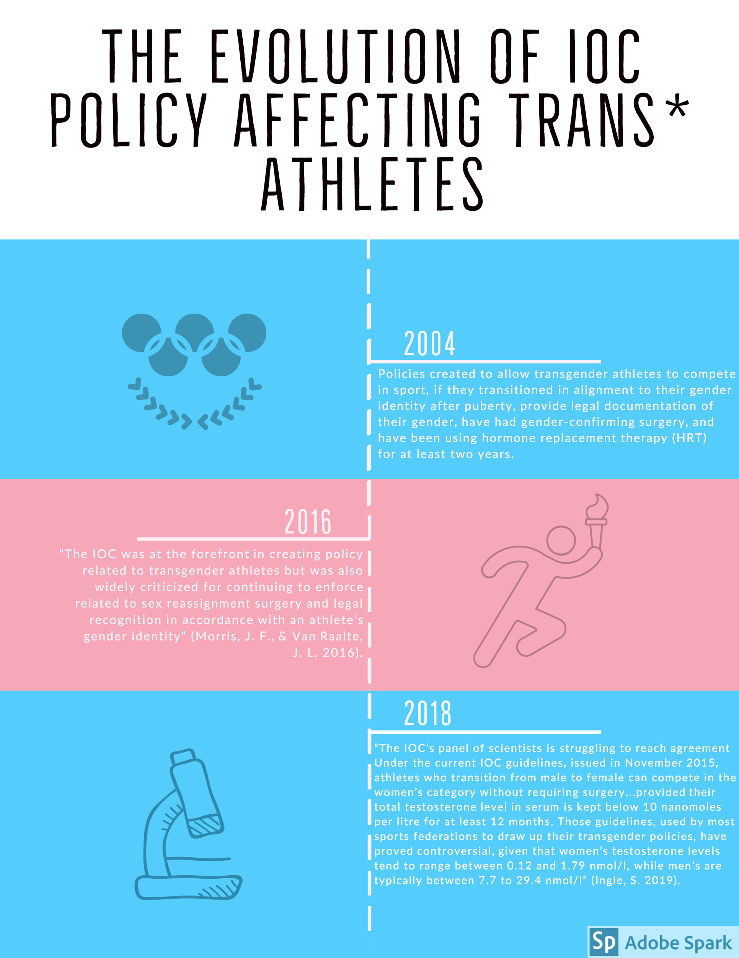

The History of Gender Within Sports
The sport culture and environment is essentialist, binary, and heteronormative. “The maintenance of sex-segregated sports in the twentieth century has been based on two assumptions: that human beings come in two sexual forms, male and female, and that one of those forms has significant biological advantages in terms of sporting performance. From the 1930’s sports organizations have increasingly turned to biomedical experts to provide ‘objective’ scientific tests to maintain segregation in sports, an activity nearly always justified by an appeal to the notion of fair competition.”(Anderson, E., et al 2017 p.131). As a result, these underlying assumptions provide little room for the inclusion of trans athletes. It has only been within the last decade that any consideration has been given to trans athletes.

In addition to the historical heteronormative assumptions prevalent in sport, trans athletes have had to face the ethnocentrism of sport and gender, particularly how sport culture has increasingly become politicized.``Sports events celebrating the body and physical culture have long been driven by political and ideological motives, from the ancient civilizations of Greece and Rome to the societies of early modern Europe, in more modern Western societies as well as less developed and non-Western ones'' (Tomlinson, A. & Young C. 2006). Sport culture is embedded in and maintains heterosexuality and heteronormativity which plays a central role in “maintaining the gender hierarchy that subordinates women to men''; (Schilt, K., & Westbrook, L. 2009) which is understandably harmful to trans*athletes.

Within the general population, finding athletes who have an elite level talent and the desire to pursue them is rare. Finding trans* athletes is even more rare. “Nevertheless, a number of trans* athletes emerged starting in 1970” (Anderson, E., et al 2017 p. 156) which is more a testament to their perseverance and determination as opposed to shifts in the underlying structure of sport. However their appearance has paved the way for the beginning of change. “Designing sport policies that address both issues of inclusion and equity is a complex challenge.” (Anderson, E., et al 2017 p. 156) For us, advocating for the designing and implementation of inclusive policies and practices in sport is a political act of resistance. Challenging heterosexuality and/or heteronormativity is also a political act and advocacy for trans* inclusion in sport needs to persist as exclusion is still alive and well.

In recent years there has been more recognition of the harassment faced by LGBTQIA+ and other minority athletes at all levels. This discrimanation has prompted an encouraging rise of corporate and social responsibility in sport to support the changing public perception of trans* and other minority athletes. An example of an anti-bullying and/or anti-discrimanation initiative championed by the National Hockey League (NHL) is the “Hockey is for Everyone” campaign which strives to “support any teammate, coach or fan who brings heart, energy and passion to the rink. We believe all hockey programs - from professionals to youth organizations - should provide a safe, positive and inclusive environment for players and families regardless of race, color, religion, national origin, gender identity or expression, disability, sexual orientation and socio-economic status.” (NHL 2020). National programs like this will encourage young trans* athletes to become future Olympians and may have an impact on how inclusive policies and practices are created elsewhere.

Medicalization of Gender in Sports
“The first systematic at-event sex testing was introduced at the 1966 European Athletics Championship held in Budapest, and then taken up widely at other international sports events.” (Anderson, E., et al 2017 p.135)....eventually including the International Olympic Committee (IOC) which continues to insist in believe
ing the concept that “we are all born either male or female and could not change over our lifetime. (Anderson, E., et al 2017 p.136) Scientific tests were and continue to be used to determine the sex of athletes to confirm any potenial significant biological advantages in terms of sporting performance. These tests …”demonstrate the shifting balance of power and authority in sport sciences, as well as clear conflicts between biological, social and cultural ways of understanding bodily difference.” (Anderson, E., et al 2017 p.131). There was an interesting shift during a period of greater recognition of trans* athletes that we believe still exists today, where the treatment of ‘male to female’ or feminine-identifying trans* athletes were surveilled more heavily than female to male or masculine-identifying trans* athletes. This shift in attention acknowledges trans athletes but maintains the persistence of the privileging masculine bodies and of the patriarchal ideologies within competitive sport.

Hurdles ~ What are they, Why are they exclusive, Who do they affect? & What are the gaps?
Trans* athletes face a multitude of hurdles from the exclusionary policies and practices within competitive sport that impacts participation at all levels leading up to and including the Olympics. Some of the factors for lack of participation in sport… “may be related to homophobia and or transphobia in sports, sparse trans* role models in professional and other organized sporting leagues, and the absence of affirmative trans-inclusion policies” (Anderson, E., et al 2017 p. 43). We need to understand why these policies and practices are exclusive, who is affected, and the identify the gaps such as “explicit trans*- inclusion policies that instead work toward including only gender-conforming trans* athletes, while excluding others (eg., stipulating mandatory genital reassignment surgery and/or hormone replacement therapy, or no allowance of non-binary or gender non-conforming persons)” (Anderson, E., et al 2017 p. 43).

Laws, Policies & Practices in Canada & Around the World
There are many trans* athletes around the world breaking barriers for other gender diverse athletes. (Anderson, E., et al 2017 p.45). There are some specific trans* athlete experiences that Anderson et al. highlight that demonstrate how transgender athletes are affected by exclusionary policies and practices within competitive sport from a global perspective. Some of the athletes Anderson et al. highlights have for various valid reasons started transitioning after their professional sport careers were over. Others have been forcefully outed over the course of their careers.

Jaiyah Saelua was the first trans* person to play in a FIFA World Cup qualifier. Jaiyah is originally from a small nation of five islands in the South Pacific. Today she is the only internationally recognized fa’afafine, a femine gender identity held by people born male in Polynesia. The role of fa’afafine is an embraced third gender that encourages sport participation. As fa’afafine is essentially another term for trans*, trans* policies and practices also affect fa’afafine folks. Fallon Fox is a talented high performance mixed-martial arts (MMA) fighter who, since coming out, has had a contrasting experience to Jaiyah. Since Fallon Fox came out in 2013, her career has been jeopardized by transphobia and painful interactions leading to fewer matches and sporting opportunities.

As we have already mentioned, sport culture, performance, and competition privileges masculine bodies at all levels of sport. This begs the question of whether Jaiyah and Fallon’s experiences in sport differ because of the types of sports they competed in or for some other reason? Considering soccer is traditionally played by both male and female identifying athletes, we can assume that along with other factors, Jaiyah may have had a more positive sporting experience because feminine bodies have been associated with her chosen sport for many years. It is also notable that, in comparison to soccer, mixed-martial arts (MMA) is hyper-focused on strength and fighting abilities, which culturally has been considered masculine and, perhaps, contributes to the contested belief of any potential significant biological advantages in terms of sporting performance.

Despite the IOC establishing policies to protect and support trans* athletes in the Olympics, the issue of excluding trans* athletes from sports still occurs on a country-by-country basis. There are 206 nations that are allowed to participate in the Olympics. Some of the 206 nations are not at a place socially or politically safe to dialogue about trans* issues in their countries. If countries do not have trans* specific policies established (in and/or out of athletics) , trans* athletes will have an inherently more difficult and/or impossible time to access the Olympics through their specific country’s National Olympic Committee (NOC), or any other national level of sports. We are not at the finish line yet; we need more countries, if not all countries on board to open discussions about protecting their trans* citizens and future athletes.

STATS TIME: The difficulty with stats
There is very limited research on how transgender athletes are affected by exclusionary policies and practices within competive sport at the Olympics. Finding accurate and specific statistics has been a challenge. Aside from general statistics about trans* athletes and physical activity we have had to make some estimates of statistics about trans* Olympians.

Chapter 7 of Anderson, E., et al 2017 is based on a research project studying the practice of sport and physical exercise (SPE) in Spain. “Global participation of trans* people in sport and physical exercise (SPE) shows that almost three out of four trans* persons (74.9%) participate in some form of sport and physical exercise (SPE).” Anderson, E., et al 2017 p.82) Continuing with our global findings, “according to Trans Pulse Project 58% of trans* people in Victoria Australia reported avoiding some sports due to their gender identity 44% of trans* people avoid going to the gym for fear of being outed, harassed, or being read as trans*” (Anderson, E., et al 2017, p. 43).

The stats suggest that there could be as many as 70 trans athletes at the Olympics. The stats also suggest that 30 percent of all athletes use performance enhancing drugs (PEDs) which is a focus of much attention at the Olympics. One might conclude that 21 of the trans athletes use PEDs. However, this doesn't take into consideration that trans athletes might be worried about being outed if they failed a steroid test. Since most trans athletes are on some form of hormone replacement therapy, this fear of being outed probably reduces the numbers for trans athletes illegally using (PEDs) and may even reduce the actual number of trans athletes participating in the Olympic competition. This further demonstrates how the restrictive medical policies and practices can have a negative impact on trans* athlete’s participation in sport. “Unfortunately, the lack of policies and information about transgender inclusion means that many educators and coaches are not equipped to react appropriately when transgender athletes participate on sports...” (Cathryn Lucas-Carr et al. 2012). The complexities of balancing gender identity, PED enforcement and sport participation in addition to facing transphobia at the Olympic level needs to evolve for the sake of trans athlete equity.
Inclusive policies & practices - What are they, Why are they inclusive?
As our research is centred around the exclusionary policies and practices within competitive sport affecting trans* Olympians, we have yet to discuss trans-inclusive policies and practices. Figure 2 shows general trans-inclusive practices that can be used in many sport contexts and levels of sport. The following quote seems to summarize the essence of trans*-inclusivity in sport perfectly. To create safer, more inclusive spaces for trans* athletes we must be “revolutionary revisioning of sport that does not place so much emphasis on categorization but instead requires specific sport skills that are not gendered and where categories beyond women’s and men’s are contested.” (Anderson, E., et al 2017 p. 76).

This quote is one of the best recommendations for trans-inclusive policies or practice we have come across in our research. Yet it seems to be the most challenging to implement. Implementing this recommendation suggests an overhaul of the structure of sport competition at elite levels. Figure 2 depicts general trans-inclusive practices that are applicable in many sport contexts. It is our hope that the recommendations shown above become best practices across sport contexts and levels of competition to inform the potential and much needed overhaul of the structure of sport competition. “The International Olympic Committee (IOC)’s consensus statement...on harassment and abuse in sport called for the creation of a culture of dignity, respect, and safety...recognizing that sport organizations are gatekeepers of safety and should demonstrate strong leadership in identifying and eradicating these {harmful} practices.” (Anderson, E., et al 2017 p. 68) These are noble words, but now policies are needed that match these words, especially for trans athletes.
*Figure 2 General Recommendations - Coaches, Teams, organizations etc

Conclusion
The belief in the gender binary persists in sports and sport organizations around the world including the IOC. Hurdles are explicit, such as exclusionary policies and practices, and implicit, such as homo/transphobia, sparse role models and lack of affirmative policies. The general hostility of sport policy makers to these who transgress the gender binary is vividly illustrated by the history of sex-verification testing in sport.” (Anderson, E., et al 2017 p. 195) “Therefore, while the The International Olympic Committee (IOC)’s guidelines may signal new levels of inclusion for trans* athletes in some ways, they still work to reinforce restrictive assumptions about sex, hormones, and athletic performance.”(Anderson, E., et al 2017 p. 198)

The recognition of transgender people in and out of sport is changing rapidly. Policies and practices are beginning to evolve and corporate and social initiatives are being implemented and more and more, inclusiveness is being valued. Striking the right balance and crafting thoughtful policies on such new and complex concepts requires fundamental shifts in age old perceptions and beliefs. More research and discussion is so very needed to move forward in this field. The surface has only been scratched and deeper thought will be needed befor the correct changes can be made.

An alternate spelling of the noun "folks," to be inclusive of LGBTQ2IA+ people of colour.

