Vaping - The Social Crisis in the Guise of a Health Risk
Harmiksha Patel & Riya Brahmbhatt
April 8, 2020

Understanding the Challenge
While vaping products and e-cigarettes were developed to help current adult smokers quit smoking, the inappropriate marketing and youth-oriented social enticement has led to an unanticipated but rapid rise in vaping among youth and young adults.

What is Vaping?
An electronic device such as an e-cigarette allows users to inhale heated “vape juice” or “e-juice” a substance that is formulated of vegetable glycerin, propylene glycol, water, food-grade flavoring, and nicotine (Health Canada, 2020). The ingredients vegetable glycerin and propylene glycol disperse the flavoring and dilute the liquid (Health Canada, 2020). Vaping heats up products instead of burning them, thereby allowing for the effect of the products without releasing the toxic chemicals cigarettes release (Health Canada, 2020).
Vaping and e-cigarettes are represented as ways to help with de-addiction, but without provision of adequate information on the contents, disadvantages and potential harms of using e-cigarettes or vaping.

Where the Issue Lies
The usage trend of such products among younger, nicotine addiction-free populations is troubling due to the potential consequences of introducing a highly infatuating practice that is both under-researched and harmful to health. In 2011, vaping among adolescents in the United States was minimal to nonexistent (Miech, Johnston, O’Malley, Bachman & Patrick, 2019). Over the course of six years, the practice became the most prevalent out of any similar tobacco products (Miech et al., 2019). Moreover, regulatory and policy gaps in countries such as Canada and the United States have allowed the industry to create enticing, kid friendly flavors that appeal to youth. This evolution of vaping into a mainstream trend among young adults not only highlights the issue of introducing minimally researched products into our markets, but also the consequences of lucrative marketing that targets vulnerable populations like adolescents. In their self-acclaimed path to end cigarette-based nicotine dependency, the vaping industry created their own personalized and highly profitable dependency and addiction.

Why is Vaping an Issue?
In terms of adolescent and young adult health, vaping is a serious threat to lung health. In August to September of 2019, a rise in e-cigarette and vaping associated lung injuries (EVALI) was recorded across Canada (CDC, 2020). It is true that nicotine-free vaping products exist and are being used by youth however, these products still carry a significant risk due to the toxicity of inhaling aerosols and are not as well-known as nicotine based options (Thompson, 2018). Furthermore, researchers at Dartmouth College’s Norris Cotton Cancer Center found that e-cigarettes only slightly increase successful smoking cessation among adult smokers, while significantly increasing the number of youth vapers who become cigarette smokers (Soneji, Sung, Primack, Pierce, & Sargent, 2018). In fact, the study found that young adults who engage in vaping are three times as likely to transition to cigarettes than young adults who do not vape (Soneji et al, 2018). In 2015, while only 2,070 cigarette smoking adults actually used e-cigarettes to quit smoking, a shocking 168, 000 young adults began smoking after using vaping products just once (Soneji et al., 2018).

Therefore, while the explicit intention of vaping developers was that they wanted to help current smokers quit smoking, they have also implicitly created a dangerous pathway for young adults to begin smoking and increase their health risks. As a result, we must question whether vaping products and e-cigarettes’ use should really be promoted for smokers for cessation at the cost of nearly 81 times more non-smoking individuals generating an interest in smoking (Soneji et al., 2018). Based on its marginal success rate among adult smokers, vaping is not the solution or a strategy for harm reduction for current smokers. We feel that this industry knowingly uses their harm reduction product to augment their business.

The Cycle
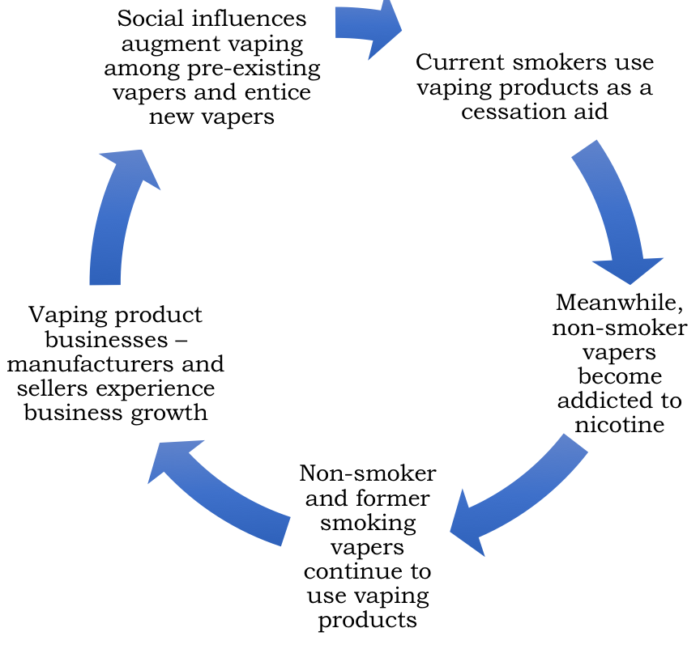

Root Causes of the Problem
JUUL, the leader in vaping product sales, claims that, “Those who do not currently use nicotine products should not start.” is part of their mission (JUUL Labs, 2019). However, through the statistics shared earlier in this report, it is evident that in fact, there are more youth and young adults using vaping and e-cigarette products who have not used nicotine products than those who have. Youth, young adults and their families, consequently, experience the negative health effects of vaping and e-cigarette use. While there are multiple roots to this issue that has been planted in society, the key cause is the lack of a collaborative approach to target this issue.

For one, there is unregulated sale of vaping and e-cigarette products on Alibaba, Amazon, eBay and Kijiji. Despite the fact that the Tobacco and Vaping Products Act aims to reduce vaping among youth and young adults, the act does not regulate sale on third party websites (Government of Canada, 2020). This makes it all the more easier for youth and young adults to practice social exchanging of these products.

The social media influence is immensely large. Although the government of Canada and Ministry of Health Canada has initiated an awareness campaign, the number of times their hashtags have been used in comparison to pro-vaping and pro e-cigarette hashtags is significantly smaller. A recent study by Frontiers in 2020 shows that even after manufacturer and seller marketing has been shut down by government regulations, the ratio of pro-vaping to anti-vaping social media presence is 10,000 to 1 posts.

Youth-oriented marketing is largely existent and at the same time, attracts youth and young adults towards using vaping products and e-cigarettes (Krishnamoorthi, 2019). The virtual and tactile appearance of these products is also attractive for a younger age group. For instance, images of candy flavours, and fruit flavours are posted. Flavours such as mango, bubble-gum, mint candy, and fruit medley are alone perceived as harmless and when used for nicotine-free and nicotine vaping products or e-cigarettes, youth and young adults are attracted to the flavours. Based on our survey responses, inclusive of a sample size of 36 individuals, 42.1% of vapers partook in vaping activities for social purposes and another 42.1% of vapers partook in vaping just to try something new. Only 15.8% partook in vaping to actually help with quitting smoking, which the company, JUUL claims is their primary intent of developing this product. Therefore, the flavour, while harmless on its own, can raise many concerns indirectly and is a contributor to youths’ use of these products.

Nicotine levels in these vaping products are addictive. While one vaping pod contains enough nicotine that amounts to 20 cigarettes on average, the nicotine intake depends on how long one vapes. Regardless of the duration, Yale University’s School of Medicine finds that vaping increases nicotine addiction among youth (2019). Thus, once initiated, it becomes difficult for vaping users to discontinue the use of vaping products - from a business point of view, this can be viewed as beneficial for obvious reasons however, from a health perspective, is a reason for grave concerns.

The Solutions Landscape
Several research studies and commentaries have identified the growing need for a multitude of solutions to this issue involving various stakeholders.

Local Level
At the municipal level, schools and universities have, as with smoking, placed bans on e-cigarette or vaping product use within a certain distance of the institution. Additionally, public areas have also enhanced their regulation of smoking, e-cigarette use and vaping hence reducing their use on site. At the provincial level, government run awareness campaigns continue to occur after being launched in 2019.

National Level
The government of Canada had initiated a campaign on vaping awareness in 2019 to educate youth in particular on the risks of vaping and e-cigarette use (Government of Canada, 2019). The government of Canada has enforced strict regulation of e-cigarette marketing and sales to ensure that youth and young adults are not being enticed into purchasing this product, thereby increasing their own risk. JUUL Canada, as of 2019, ceased its use of social media to market their products (Juul Labs, 2019). However, the challenge of controlling marketing on social media continues to exist as other, rather smaller vaping product companies, continue to sell and market their products through social media.

Global Level
The United Kingdom and United States of America have also practiced some efforts to resolve this issue. In 2019, several allegations were laid on the companies JUUL and Alitra, both of which sell vaping products. The FDA had accused these companies of promoting vaping among youth and young adults which raised more harm for the public as opposed to reducing harm, which is the claim that the companies make. The World Health Organization acknowledges that this is an issue that affects the world’s future, as the choice for youth to vape and use e-cigarettes does not only lie in the hands of the users, but the onus falls upon the producers and companies selling these products. As a result, general guidelines were developed to help curb vaping among youth.

Link Between Solutions
We suggest that a rigorous cohesive approach to seize control over this challenge needs to be administered to ultimately reduce the unwanted health consequences that youth, young adults, and their families face today. The government, businesses, health care institutions, the education sector and global manufacturers of this product all need to work together to regulate the sale of vaping products.

Understanding the Gaps and Levers of Change

While the government and ministry of health regulate major vaping product companies’ use of social media, smaller companies, which are available in large quantities, go missed. Social media is a dominating and perpetuating source of negative influences and habits.

Gaps | Levers of Change
Lack of communication with influencers (i.e.; parents, teachers, etc) | Schools, universities must take action to educate families on the health consequences of vaping for individuals who do not smoke regularly
Loose regulation around use of THC and nicotine in vaping products | Monitoring of nicotine and THC levels in the products at all levels of the government
Youth-oriented marketing continues to exist and entice youth in to purchasing vaping products or e-cigarettes (i.e.; Bubble-gum, candy, mango flavours) | Strict regulation of flavour marketing and censorship of marketing by Ministry of Health
Lack of collaboration between healthcare providers and product manufacturers and producers | Implement collaboration strategies such as bi-annual meetings to discuss and disseminate information on the safety and production of these products
No eligibility criteria for current vaping product or e-cigarette users resulting in easy access to these products by all | Vaping product sellers must validate that they are selling their products only to current smokers  Those with a healthcare professional’s referral should only be eligible to purchase these products

Key Insights and Lesson Learned
We realize that as concerning the health consequences are, the social issues causing the rise of vaping products’ use is even more concerning. Consequently, the youth and young adults who use these vaping products are not the ones to blame - we must take responsibility for this growing global issue as a society. Businesses, social media, government, educational institutions and families all must take responsibility and work collaboratively to ensure that the social pressures that exist around the use of these products is mitigated or even better, eliminated.

